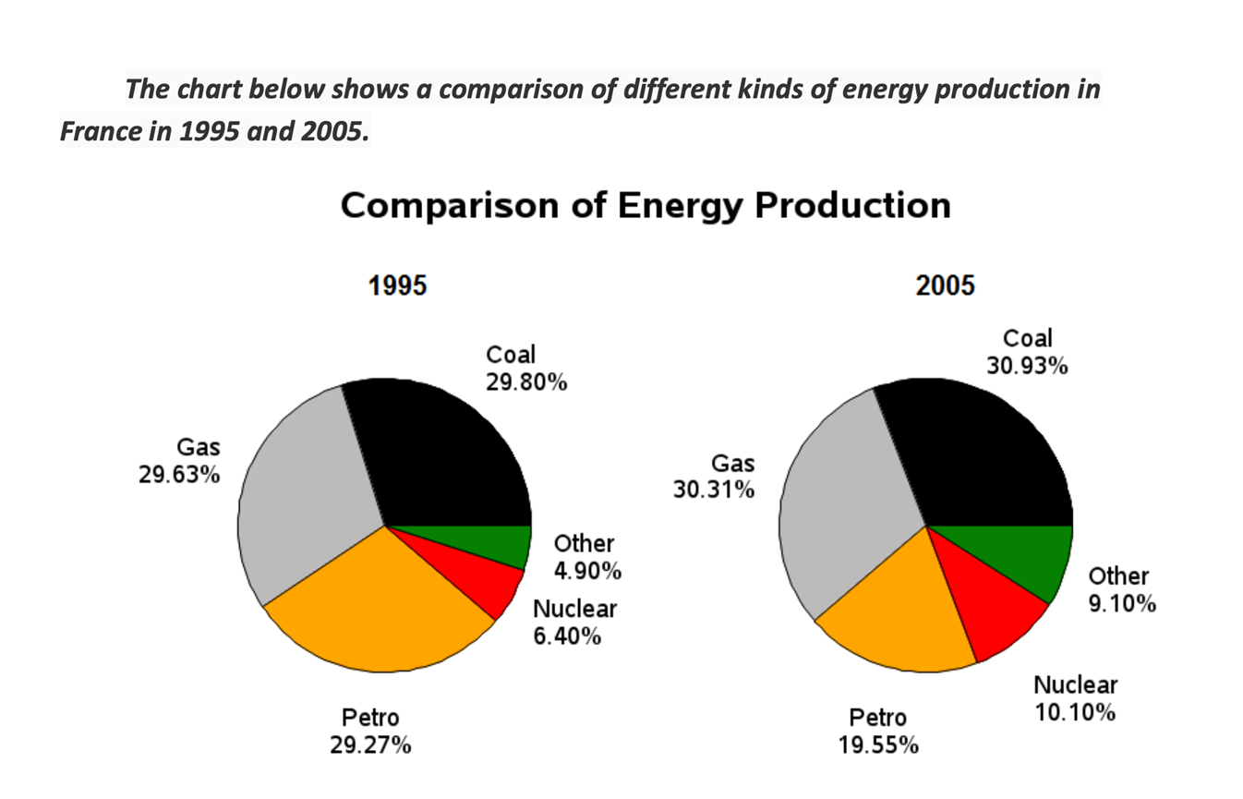
Given is the chart comparing divergent sources of energy generation in France in the years 1995 and 2005.
Overall, it is clear that the percentage of coal production made up the largest fraction throughout the time surveyed. Besides, while the amounts of energy produced from coal, nuclear, gas and the category Other witnessed upward trends, the figure for petrol production was an exception.
⇒ nói chung mình phân bố bố cục 2 đoạn thân bài như này cũng được tuy nhiên vì đây là biểu đồ có chứa sự thay đổi theo thời gian nên nếu tách mỗi body 1 mốc thời gian thì sẽ không so sánh được sự thay đổi qua thời gian năm 1995 & 2005 của từng đối tượng nhé, xem hướng dẫn thêm phía dưới
In 1995, energy generation from coal, petrol and gas contributed relatively similar percentages at 29.80%, 29.27% and 29.63% respectively. In addition, the rate of nuclear power produced registered 6.40%, which was over 1%higher than that of the Other.
In 2005, a slight increase of around 1% took place in the proportion of coal production compared to a considerable climb of about 4% belonging to that of the “Other”. Likewise, the contribution of nuclear power experienced a somewhat upward trend of nearly 4%, which was approximately 1% higher than that of gas. Finally, the percentage of petrol generated showed a substantial plunge to 19.55%.

IELTS TUTOR lưu ý:
  - Overall:
    - The proportion of energy generated by petrol decreased while the figures for the rest of energy sources had an opposite trend >> IELTS TUTOR hướng dẫn Cách dùng từ "generate" tiếng anh
    - The percentage of Coal being produced was highest in both years (HOẶC: the figure for Other types of energy was by far lowest)
  - Body 1: Viết về 3 số liệu nổi bật nhất (Gas, Coal, Petrol)
    - Gas
      - Gas generated 29.63% of energy in 1995, which rose marginally to 30.1% 10 years later.
    - Coal:
      - In 1995, energy produced by Coal accounted for the highest proportion, at 29.80% of the total energy production in France and this figure experienced a very slight increase of about 1% to 30.9% in 2005. >> IELTS TUTOR hướng dẫn Giải thích phrasal verb "make up of"
    - Petrol
      - Petrol experienced a decrease in its figure, from 29.27% in 1995 to around a fifth in 2005.
  - Body 2: Viết về các số liệu còn lại (Nuclear, Other)
    - The proportion of energy production from Nuclear power and Other sources grew by approximately 5%, to just over 10% and 9% respectively. >> IELTS TUTOR hướng dẫn Word form của "generate"
- IELTS TUTOR hướng dẫn cách chia 2 đoạn thân bài khác:
  - Body 1: Viết về số liệu tăng (Gas, Coal, Nuclear, Other)
  - Body 2: Viết về số liệu giảm (Petrol)

