Restoring Hope and Improving Lives: Janet’s journey out of underage sex work

Janet Kandiero is a 15-year-old beneficiary of the Action Hope Malawi program, “Improving Lives of Young Girls Who Have Been Removed from Sex Work.” supported by the Kirk Foundation through Aids Fondet. Janet was identified after Action Hope Malawi, together with the Malawi Police Service and the Machinga District Social Welfare Office, worked to develop a sustainable intervention to successfully remove underage girls from sex work. Past interventions only involved conducting sweeping exercises to remove the girls from hotspots, such as beer-drinking places and areas where older female sex workers reside.
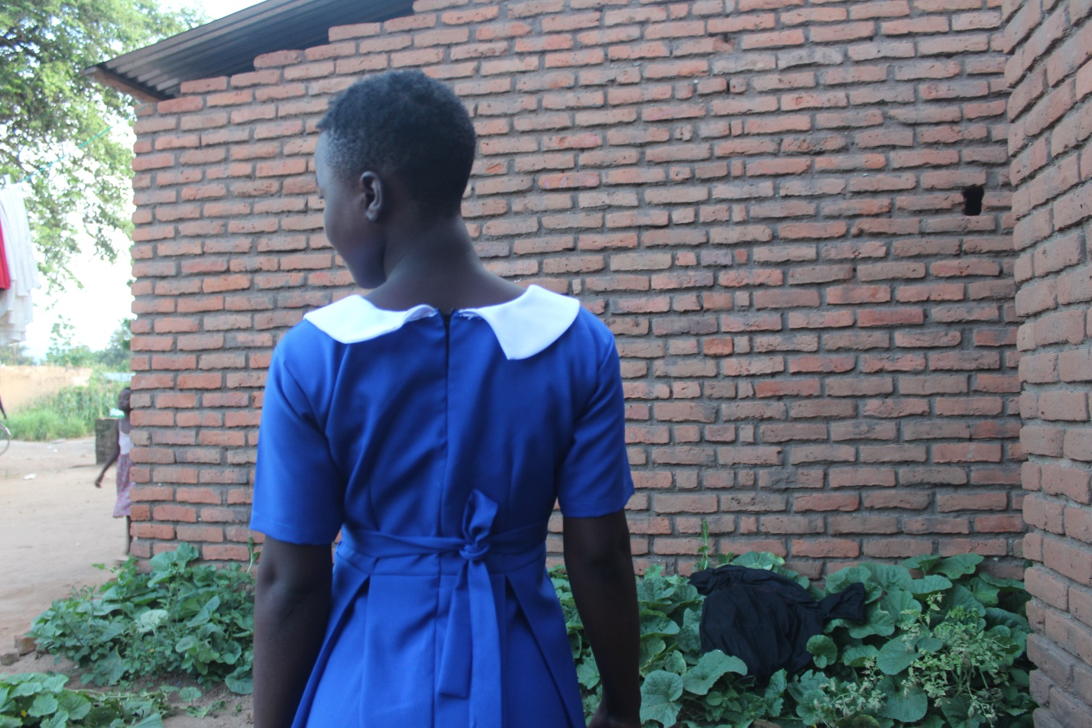
It was noted that the sweeping exercises were not effective because the underage girls often come from poor families and they often go back to the hotspots after sweeping exercises. Poverty within these families is a catalyst for underage sex work, as caregivers are unable to provide basic needs for the girls, especially for schooling. To address this, the project involves identifying underage girls engaged in sex work, locating their caregivers, and training the caregivers in vocational skills so they are able to support the children even in the absence of Action Hope Malawi.
Janet left school when she was in Standard 8 at Ferry Primary School. Her desire to complete her education prompted her to link Action Hope Malawi, the Malawi Police Service, and the District Social Welfare Office with her mother, Mary Namakwera. Mary, a single mother of three, used to run a seasonal business selling mangoes in the district. She explained that the responsibility of caring for her children had become overwhelming since the passing of her husband six years ago. She welcomed the program and the idea of being one of the beneficiaries.
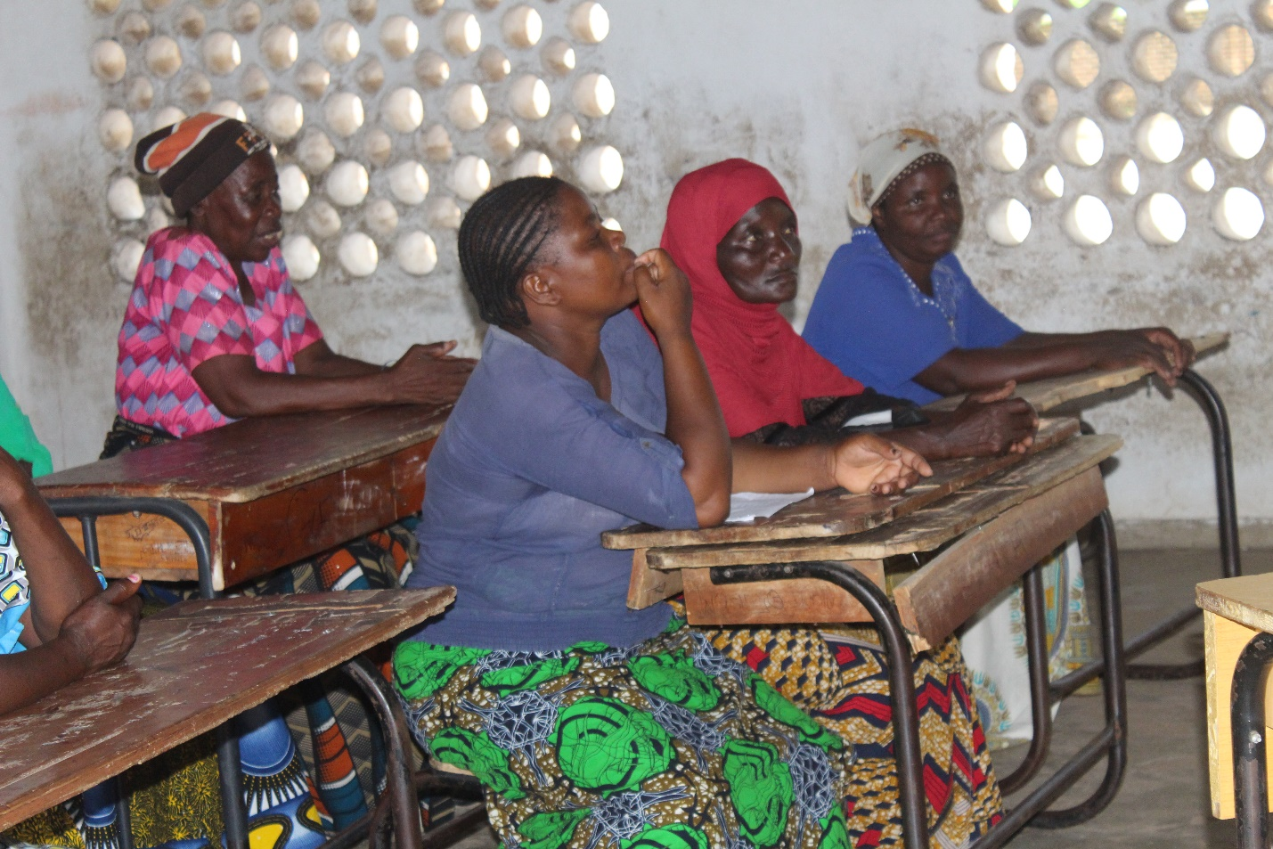

During a pre-vocational skills selection meeting, Janet’s mother, Mary, chose baking as the vocational skill she wanted to be trained in. She stated that she chose baking because “it is highly demanded in the area, as people cannot do without breakfast.”

Mental Health Session for students
To ensure that the psychological well-being of girls rescued from underage sex work is protected, the program conducted a mental health awareness session facilitated by the Ministry of Health and the District Social Welfare Office. The session targeted both boys and girls, as they are all prone to mental health issues at a young age.
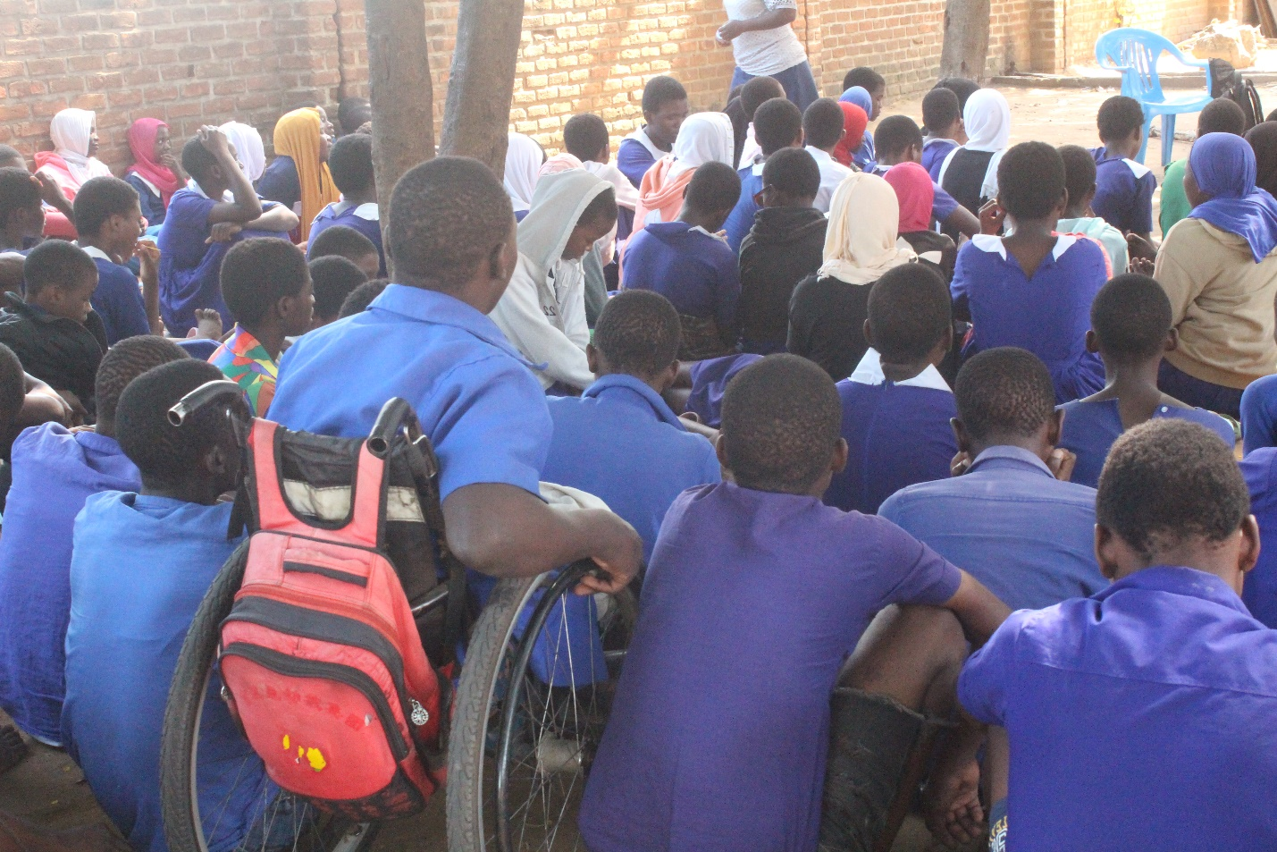

Currently, Janet is in Form 1 at M’manga Secondary School after passing her Standard 8 examinations, following her re-enrollment at Ferry Primary School. She is a testament that, given the necessary support, underage girls do not have to be forced into sex work for money,” says her current teacher, Mrs. Madalitso Chikhaza. The initiative continues to empower caregivers with vocational skills while simultaneously removing underage sex workers from sex work to ensure that the girl child receives an education.

