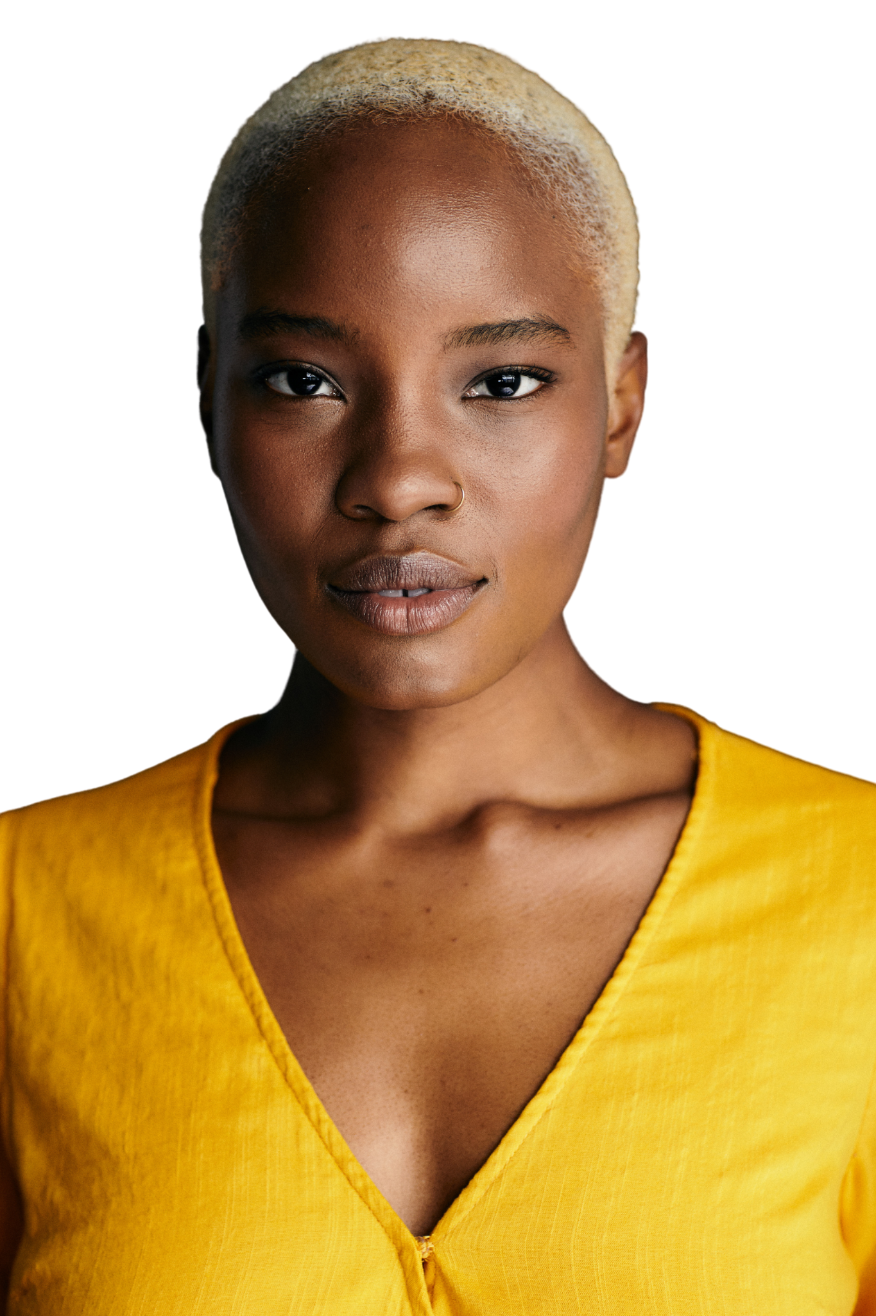
Firstname Lastname
Actor/Model
NonUnion
(201) 000-0000
email@email.com
indigoactors.com/melissa

Height: 5’6” - Weight: 130 - Eyes: brown - Hair: blonde - Region: USA-NY/NJ

Film
New Age | Ash | Rae Larz - 2022
So Are We All | June | Jon K Jones - 2020
Rebel | Mandy | Black Power Punk Girls - 2019

Theatre
Right Field of Dreams | Toni Stone | Mile Square Theatre - 2022

Commercial & Industrial
Who’s Your Acting Coach Campaign | Self (Melissa) | Coach Darius - 2021
Women's Multivitamin Campaign | Daily Woman | Love Wellness - 2020
Defy Tradition | Friend on Stoop | Hogwash Studios - 2019
Facetune | Party Girl | Creambo Productions - 2019

Training & Education
The Barrow Group | Acting | 2021 - Present
Darius A. Journigan | Private Acting Coach | 2020 - Present
Hudson County Community College | Theater | 2017 - 2019

Skills
Method Acting, Improvisation, Yoga, Rock Climbing, Running, Biking, Modeling, Acting techniques

