Margaret O’Mara—bio

Margaret O’Mara (pronounced O-mer-a) is the Howard & Frances Keller Professor of History at the University of Washington. She writes and teaches about the history of U.S. politics, the growth of the high-tech economy, and the connections between the two. She is the author of Cities of Knowledge (Princeton, 2005), Pivotal Tuesdays (Penn Press, 2015), and The Code: Silicon Valley and the Remaking of America (Penguin Press, 2019). O'Mara is a Distinguished Lecturer of the Organization of American Historians and a past fellow of the Center for Advanced Study in the Behavioral Sciences, the American Council of Learned Societies, and the National Forum on the Future of Liberal Education. She received her MA/PhD from the University of Pennsylvania and her BA from Northwestern University. Prior to her academic career, she worked in the Clinton White House and served as a contributing researcher at the Brookings Institution. She lives in the Seattle area with her husband Jeff and their two daughters. Website: http://margaretomara.com.

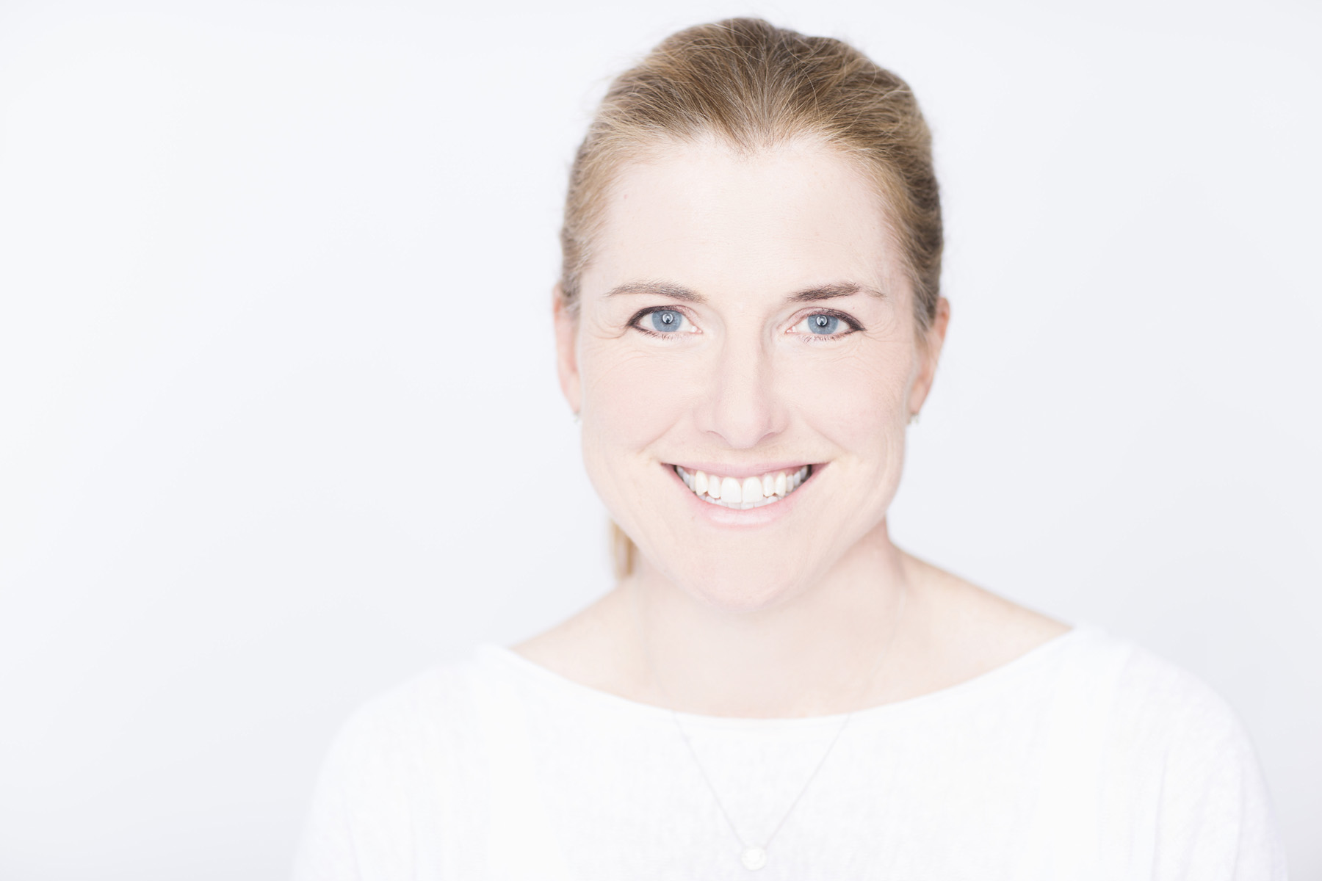
Jim Garner/www.jgarnerphoto.com

