


INVITATION FOR BID
NATIONAL COMPETITIVE BIDDING

June 2023

NATIONAL COMPETITIVE BIDDING
(READVERTISED)
Country: MALAWI
Name of Project: TRANSFORMING AGRICULTURE THROUGH DIVERSIFICATION AND ENTREPRENEURSHIP (TRADE) PROGRAMME
Procurement Title: Supply and Delivery of Motorcycles
Reference No. TRADE/GOODS/MC01/23/24

- The Government of Malawi has received financing from the International Fund for Agricultural Development (IFAD) towards the cost of Transforming Agriculture Through Diversification and Entrepreneurship (TRADE) Programme and intends to apply part of the proceeds for the procurement of ICT Equipment.
The use of any IFAD financing shall be subject to IFAD’s approval, pursuant to the terms and conditions of the financing agreement, as well as IFAD’s rules, policies and procedures. IFAD and its officials, agents and employees shall be held harmless from and against all suits, proceedings, claims, demands, losses and liability of any kind or nature brought by any party in connection with Transforming Agriculture Through Diversification and Entrepreneurship (TRADE) Programme.
This Invitation for Bids (IFB) follows the general procurement notice that appeared on the IFAD website on 17th March, 2022, TRADE Website on 17th March, 2022 and in the Nation and Daily Times newspaper on 17th March, 2022.
- The TRADE Programme Management Unit now invites sealed bids from eligible and qualified bidders for the supply and delivery of Motor Vehicles as follows:

Lot # | Description of Goods | QTY | Delivery Period | Location
Lot # | or Related Service | QTY | Delivery Period | Location
1 | Supply and Delivery of Bicycles | 16 | 6 - 8 Weeks | TRADE Offices, Lilongwe

- Bidding will be conducted through National Competitive Bidding (NCB) procedures specified in accordance with the Public Procurement Law and Regulations of the Government of the Republic of Malawi and IFAD Procurement Guidelines.
- Interested eligible bidders may obtain further information from TRADE’s Procurement Unit at the address indicated below from 08:00hrs - 12:00hrs, 13:00hrs - 16:00hrs local time (Monday to Friday, except National Public Holidays)
- A complete set of bidding document in English language and in soft copy shall be obtained from TRADE’s Procurement Unit upon request or downloading it from www.tradeprogramme.org
- Bids must be delivered to the address at 7b On or before 31st July, 2023, 14hrs local time. Electronic bidding will not be permitted. Late bids will be rejected. Bids will be opened in the presence of the bidders’ representatives who choose to attend at the address below at paragraph 7d on 31st July, 2023, 14hrs local time. All bids must be accompanied by a Bid Securing Declaration Form.
- The address(es) referred to above are as follows:
- For Clarifications, Inspection and collection of documents:
The Procurement and Contracts Specialist.
TRADE Programme
Area 9/328
Multi Choice Street
P.O Box 2135
Lilongwe
Malawi
tisungeni@tradeprogramme.org
- For Submission and Opening of Bids
The Chairperson, Internal Procurement and Disposal Committee (IPDC)
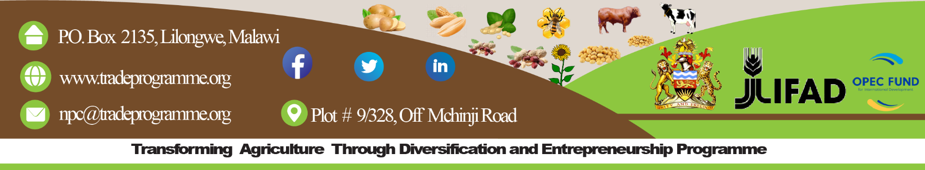
TRADE Programme (Tender Box), Area 9/328, Multi Choice Street, P.O Box 2135, Lilongwe, Malawi

