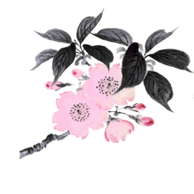

DID YOU KNOW?

Our San Diego Chapter has a long standing program with the Japanese Friendship Garden & Museum (JFGM) in which Chapter members create and display an ikebana arrangement each weekend for the JFGM’s Tokonoma located in the upper garden’s Exhibit Hall. This program allows arrangers the opportunity to gain more experience and expertise in creating ikebana for public display as well as promoting our Chapter’s presence in Balboa Park. JFGM in turn receives the benefit of our ikebana arrangements to promote their Japanese arts focus.

JFGM also provides a $30 stipend to each week’s arranger to help offset any personal expenses.

HOW DO I BECOME AN APPROVED TOKONOMA ARRANGER?

The general guidelines are:
* You and your sensei are Chapter members
* You have a teaching certificate (not required but very helpful)
* You are a student and your sensei agrees you are ready to be an arranger or provides prior approval for your arrangement design

Our Chapter wants to open this opportunity to as many members as possible so please consider volunteering in 2024 & 2025.

Deborah Warriner
JFGM Liaison
“Friendship through Flowers”

dswarriner.sd@gmail.com
619/665-3563

