Where is there Energy Around Us?

A Next Generation Science Standards (NGSS) curriculum for 5th graders

© Super Science Squad

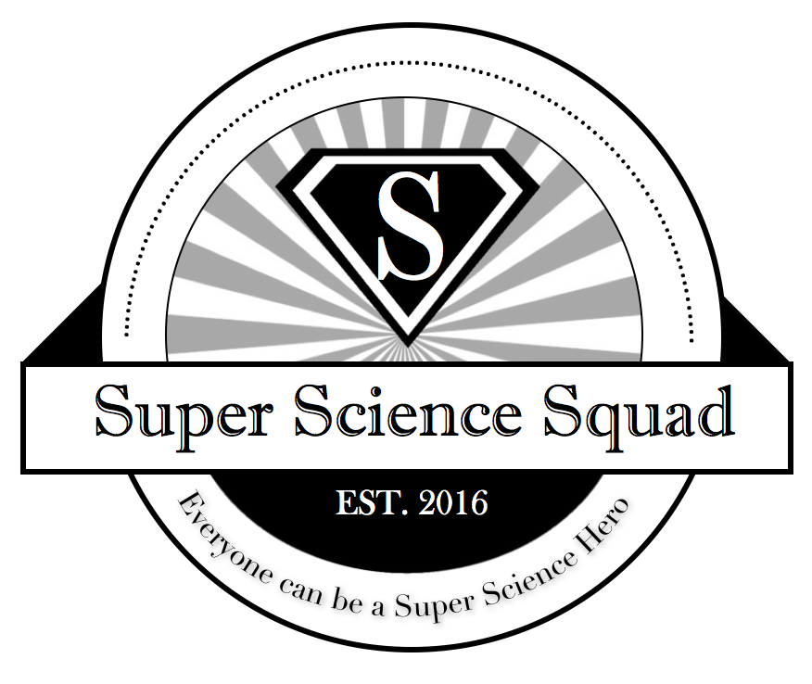

Visit us at SuperScienceSquad.com
Authors: David Liu, Alondra Villegas, Carlos Henriquez, Lourdes (Lulu) Galindo, and Tessa Pulido
Last edited January 2018

Big Question: Where do we see the energy around us?

Overview: Students will describe the different components that make up our food. Students will then describe the various ways in which energy is around us through cycles. Finally, students will share through a media broadcast about energy use.

Objectives:
-Students will be able to describe how energy is derived from the food we eat
-Students will be able to organize different types of energy such as chemical, kinetic, and electrical energy.
-Students will be able to create a broadcast of how different types of energy interact with each other.

NGSS Standards Addressed:
PS1.A as found in 5 -PS1 - 1. Matter of any type can be subdivided into particles that are too small to see, but even then the matter still exists and can be detected by other means.

5-PS1-2. Measure and graph quantities to provide evidence that regardless of the type of change that occurs when heating, cooling, or mixing substances, the total weight of matter is conserved. [Clarification Statement: Examples of reactions or changes could include phase changes, dissolving, and mixing that form new substances.] [Assessment Boundary: Assessment does not include distinguishing mass and weight.]

5-PS3-1. Use models to describe that energy in animals’ food (used for body repair, growth, and motion and to maintain body warmth) was once energy from the sun.

Conduct an investigation to determine whether the mixing of two or more substances results in new substances.

PS3.D: Energy in Chemical Processes and Everyday Life The energy released [from] food was once energy from the sun that was captured by plants in the chemical process that forms plant matter (from air and water). (5-PS3-1)

LS1.C: Organization for Matter and Energy Flow in Organisms Plants acquire their material for growth chiefly from air and water. (5-LS1-1)

Common Core Math Standards Addressed:
MP.2 Reason abstractly and quantitatively. (5-PS1-3)

MP.4 Model with mathematics. (5-PS1-3)

MP.5 Use appropriate tools strategically. (5-PS1-3)

Common Core Literacy Standards Addressed:
W.5.7 Conduct short research projects that use several sources to build knowledge through investigation of different aspects of a topic. (5-PS1-3)

W.5.8 Recall relevant information from experiences or gather relevant information from print and digital sources; summarize or paraphrase information in notes and finished work, and
provide a list of sources. (5-PS1-3)

W.5.9 Draw evidence from literary or informational texts to support analysis, reflection, and research. (5-PS1-3)

RI.5.7 Draw on information from multiple print or digital sources, demonstrating the ability to locate an answer to a question quickly or to solve a problem efficiently. (5-PS3-1)

SL.5.5 Include multimedia components (e.g., graphics, sound) and visual displays in presentations when appropriate to enhance the development of main ideas or themes. (5-PS3-1)

Description of Lessons:
Lesson 1: Students will be going over matter and how even though invisible to the naked eye, it still exists and can be measured through other methods. We will have the students think up of different food items and break them down into their smaller components: ingredients. Even if they cannot see the individual ingredients due to the transformation the ingredients have undergone, the students will be able to comprehend that the items still exist in a new form.
Lesson 2: First have students understand how matter is conserved through an activity on cooking. We will weigh ingredients for each food, then mix up the ingredients, “bake” (microwave), weigh the final product, and finally serve. After, we will do an exercise on reading nutrition labels and building representative bar graphs out of legos to show the amount of carbohydrates, sugars, protein, sodium and calories there are in foods from the school menu and one dinner meal of their choice.
Lesson 3: The goal of this lesson is to introduce the concept of energy in a broad sense before narrowing it down in the following lessons.
Lesson 4: Students will describe their school as an ecosystem by describing the living and nonliving things. They will assign roles for their documentary and work together in groups to record their respective school ecosystem. Students will film and edit their video documentaries.
Lesson 5: The goal of this lesson is to introduce the concept of energy in a broad sense before narrowing it down in the following lessons. By the second session, learn where we (as individuals) are in relation to the different energy cycles.
Lesson 6: The goal of this lesson is to introduce the concept of energy in a broad sense before narrowing it down in the following lessons. By the second session, learn where we (as individuals) are in relation to the different energy cycles.

Suggested Calendar
Monday | Tuesday | Wednesday | Thursday | Friday
Week 1  Lesson #1  Look up cookie ingredients | Lesson #1  Look up recipes for own recipes | Lesson #2  Measure ingredients | Lesson #2  Microwave ingredients | Lesson #2  Follow up nutirion and label recipe
Week 2  Lesson #3  Energy Poster | Lesson #3  Food Sources Activity | Lesson #4  Describe step by step process | Lesson #4  Finalize poster projects | Lesson #5  Discuss modes of communications
Week 3  Lesson #6  Figure out roles for news | Lesson #6  Record | Lesson #6  Record/Edit | Lesson #6  Record/Edit | Lesson #6  Presentations

Lesson 1

Activity Name: Hands on with Elements
Overview: Students will be going over matter and how even though invisible to the naked eye, it still exists and can be measured through other methods. We will have the students think up of different food items and break them down into their smaller components: ingredients. Even if they cannot see the individual ingredients due to the transformation the ingredients have undergone, the students will be able to comprehend that the items still exist in a new form.

Goals: The goal of this lesson is to understand matter can be detected even if not seen by the naked eye.

Materials:
- Snickerdoodle cookies
- Ingredient packets
- Ipads

NGSS standards:
PS1.A as found in 5 -PS1 - 1. Matter of any type can be subdivided into particles that are too small to see, but even then the matter still exists and can be detected by other means.

NGSS Practices: Introduce the concept of how different particles, whether we see them or not, are still existent. We will accomplish this by having the students think of different foods and brainstorming the ingredients that go into them. In doing so, they will understand that matter cannot be destroyed, but rather transform into other forms that can still be seen (5-PS1-1).

Procedure
- Introduce the Concept that food is made of different foods that we cannot see (10 minutes)
  - Ease into the snickerdoodle activity with a cookie survey and ask students what their favorite cookie is. Create a bar graph.
  - One snickerdoodle cookie→ but many ingredients
    - Pass out cookies to students
    - What ingredients can we see and which ones can’t we see (5 min)
      - Call on kids to speak to whole class
      - Share list of ingredients in cookie
    - List the ingredients while using the packets so the kids can follow along (5 minutes)
- What are students’ favorite foods? (30 minutes
  - Create a bar graph
  - What are the ingredients of food
    - Share your favorite food with group (3 min)
    - Have 2-3 kids share favorite food and why to the rest of the class (3 min)
  - What is inside (ingredients of food) by looking up recipes on iPad
    - Pick one favorite food at table (2 min)
    - Brainstorm ingredients in food (8 min)
    - Use ipads to look up ingredients and compare lists (12 min)
    - Have one group share all ingredients (2 min)

Lesson 2

Activity Name: Conservation of Matter and Looking at the Lunch Menu
Overview: First have students understand how matter is conserved through an activity on cooking. We will weigh ingredients for each food, then mix up the ingredients, “bake” (microwave), weigh the final product, and finally serve. After, we will do an exercise on reading nutrition labels and building representative bar graphs out of legos to show the amount of carbohydrates, sugars, protein, sodium and calories there are in foods from the school menu and one dinner meal of their choice.

Goals: To understand how matter is conserved, meaning that the weight of the ingredients will be the same as the weight of all product. Additionally, to understand that how to read nutrition labels and communicate the amount of the carbohydrates, sugars, protein, sodium and calories in different foods using legos to create a life-size bar graph.

Materials:
- GROCERY LIST (serves 15)
  - flour
  - Fine grain sea salt (pinch)
  - Nutmeg (pinch)
  - baking powder
  - 15 eggs
  - maple syrup
  - coconut oil (or butter), melted
  - vanilla extract
  - Soy Milk
  - sugar
  - Lemon juice
- Microwave
- Leggos
- iPads
- Nutrition labels for each food from August 31 meal on calendar
  - Should be in packets, a couple per table
- Hand sanitizer and napkins
- Plates and forks
- Mugs for microwaving
- Measuring utensils
- Food scale
Worksheets:
Part 1) Recipe guide + measurement chart
Part 2) Bar charts and daily recommended nutrients

NGSS standards:
- 5-PS1-2. Measure and graph quantities to provide evidence that regardless of the type of change that occurs when heating, cooling, or mixing substances, the total weight of matter is conserved. [Clarification Statement: Examples of reactions or changes could include phase changes, dissolving, and mixing that form new substances.] [Assessment Boundary: Assessment does not include distinguishing mass and weight.]
- Conduct an investigation to determine whether the mixing of two or more substances results in new substances.

NGSS Practices: Introduce the concept of how different particles, whether we see them or not, are still existent. We will accomplish this by having the students think of different foods and brainstorming the ingredients that go into them. In doing so, they will understand that matter cannot be destroyed, but rather transform into other forms that can still be seen (5-PS1-1).

Procedure

Pre Set-Up:
- Set out ingredients
- Set out legos

Procedure
- Ask students: What do you think happens to all the particles when Lulu baked those cookies last week? How much do you think all those individual ingredients weight? What about the weight of the batter? Do you think the weight of all those cookies are the same as the ingredients? What does it means if it does weigh the same? What does it mean when it doesn’t? So our Big Question of the hour is: Is the weight of all the individual substances added up equal to the weight of the final product? Does it change?
- Set out ingredients and say we are going to weigh them, mix them, bake them, and reweigh them to show that matter is conserved, or that things will maintain their weight, even if they are broken down differently
- Weigh ingredients and mix (recipe below, makes 1) (see below for David’s measurements)
  - In one DRY CUP
    - 2 tablespoons flour (16 g)
    - 1 teaspoon cinnamon
    - Pinch of fine grain sea salt (0g)
    - Pinch of nutmeg (0g)
  - In one WET CUP
    - 1 egg (55g)
    - 2 tablespoons milk (31 g)
    - 1 ½ tablespoons maple syrup (32 g)
    - 1 tablespoon coconut oil (15 g)
    - ½ teaspoon vanilla extract (4g)
- Add wet into dry. Then add ½ teaspoon baking powder (2g)
- For icing:
  - 1 tablespoons of coconut butter
  - 1 tablespoons milk
  - 1 tablespoons coconut sugar
  - ½ teaspoons lemon juice
- BREAK KIDS INTO PAIRS (each pair makes one)
- Have two cups
- Mix DRY cinnamon roll ingredients in mug,
- flour
- Fine grain sea salt (pinch)
- Nutmeg (pinch)
- Sugar
- Mix WET cinnamon roll ingredients in mug
- maple syrup
- coconut oil (or butter), melted
- vanilla extract
- Soy Milk
- Mix all together
- add the baking powder last
- Microwave on high for 2 minutes.
- In the meantime mix all the icing ingredients in a small bowl.
- Drizzle icing over hot cinnamon roll.
- Go to break. We microwave them in cups
BREAK
- Re-weigh cinnamon rolls and show that they did not lose any mass.
- Ask students: what is the total mass of all the raw ingredients (figure it out in a group)
- Ask students. Does the mass of the cinnamon rolls equal to the mass of the sum of ingredients? What does that mean? Mass conserved!
- Next activity: clear materials and set out legos and nutrition label packets
- Explain how we want to investigate how much of carbohydrates, proteins, sugar, sodium and calories are in each meal.
- The reason these micronutrients are important is because they give us energy but our body only needs certain amounts of each type. What happens if you eat too much sugar and candy? How do you feel? What happens if you eat too much salty food? How do you feel? What happens if you eat too much and consume too many calories? How do you feel?
- Have each group start with breakfast or break table groups in half and they can work on different meals (ask what they prefer/see what time permits for)
- Ask students: Look up the nutritional facts for each of those food items on school lunch. Ask students what they had for breakfast today and what they had for dinner yesterday. Look up those nutritional facts too. Did the student under each, meet the needs, or over exceeded those recommended nutrients?
ii. Ask students to graph using legos the amount of nutrients from their food they’ve consumed. Compare it to the graph of recommended nutrients
- Why are we only looking at carbohydrates, fats and sugars?
- These are the main building blocks of energy and make up most foods we eat. They are bolded on nutrition labels because of government regulation.
- Each leggo=1 gram. Have them complete each meal, take a picture of each graph

Appendix for Lesson 2

Measurements and notes done by David
In one DRY CUP
2 tablespoons flour (16 g)
1 teaspoon cinnamon
Pinch of fine grain sea salt (0g)
Pinch of nutmeg (0g)

In one WET CUP
1 egg (55g)
2 tablespoons milk (31 g)
1 ½ tablespoons maple syrup (32
g)
1 tablespoon coconut oil (15 g)
½ teaspoon vanilla extract (4g)

Add wet into dry. Then add ½ teaspoon baking powder (2g)

= 146 grams weighted in the cup
However, total weight when adding all parts = 155. I think this happened because I didn’t scrape the cup all the way down and there were clumps on the bottom before I moved to the next step. I would suggest adding it all into one dry cup and one wet cup.

In the mug, the mixture weighed 624 g. After microwaving, it weighed 616 g. I am assuming that it decreased in weight because of the water vapor.

Kitchen Chemistry
Name:___________
Name:___________
Date: ___________

Big Question of the Day: Is the weight of all the individual ingredients added up equal to the weight of the final product? Does it change?
Directions:
- Use one cup as a measuring cup, one cup as a dry ingredients cup, and another as a wet ingredients cup. Measure in the measuring cup and pour into the mixing cup. Anything in blue are instructions.
- When measuring the ingredients, measure the weight of the cup first and put TARE. The scale will balance to not include the weight of the cup.

1. In the measuring cup, measure the dry ingredients and then pour into the dry ingredients cup.
2 tablespoons of flour | The weight of the flour is _____ grams
1 teaspoon of cinnamon | The weight of the cinnamon is ___ grams
1 pinch of salt | The weight of the salt is ___ grams
1 pinch of nutmeg | The weight of the nutmeg is ___ grams
Using the numbers above, what is the weight of the dry ingredients?
Flour + Cinnamon + Salt + Nutmeg = _______ grams.

The weight of the dry ingredients in the dry cup is ____ grams.

Are the two numbers same or different? Are you surprised by these two numbers?
2. In the measuring cup, measure out wet ingredients and then pour into the wet ingredients cup.
2 tablespoons of milk | The weight of the milk is _____ grams
1 ½ tablespoons of maple syrup | The weight of the maple syrup is _____ grams
1 tablespoon of coconut oil | The weight of the coconut oil is _____ grams
½ teaspoon of vanilla extract | The weight of the vanilla extract is _____ grams
Using the numbers above, what is the weight of the dry ingredients?
Milk + Maple Syrup + Coconut oil + Vanilla extract = _______ grams.

The weight of the dry ingredients in the wet cup is ____ grams.

Are the two numbers same or different? Are you surprised by these two numbers?
3. Mix the wet ingredients well and pour into dry ingredients.
Weigh out ½ teaspoon of baking powder. Add to the wet and dry ingredient mixture | The weight of the baking powder is ____ grams.
Using the numbers, what is the weight of the mixture?
Wet ingredients + Dry ingredients + Baking soda = ___ grams.

The weight of the dry ingredients, baking soda mixture is ____ grams.

Are the two numbers same or different? Are you surprised by these two numbers?
After, we will then add heat to the mixture to cook it. What do you think will happen to the properties (state of matter, color, and hardness) of the mixture? Do you think the weight will change?
4.Icing recipe: In a clean measuring cup, weight out and add the ingredients into another cup which will be the icing cup.
Weigh out 1 tablespoon of coconut oil | The weight of the coconut oil is ____ grams.
Weigh out 1 tablespoon of milk | The weight of the milk is ____ grams.
Weigh out 1 teaspoon of sugar | The weight of the icing is ____ grams
Weigh out ½ teaspoon of lemon juice | The weight of the lemon juice is ____ grams.
Using the numbers, what is the weight of the icing?

Coconut oil + milk + icing + lemon juice = ___ grams.

The weight of the icing mixture is ____ grams.

Are the two numbers same or different? Are you surprised by these two numbers?

Nutrition Labels
Name:
Name:
Date:

Big Question: What makes up the food that we eat?
Directions:
- Read the sample nutrition label and gather the information on the gram amount of carbohydrates, sugars and fats. Record these amounts in the table below
- Search on the internet for nutrition labels that match the foods on the school lunch menu
- Once completed, look for nutrition labels on the dinner food you had last night

Nutrition Label of Bagel
How many of each of these nutrients does a bagel have in grams?

- Carbohydrates: ______grams
- Fats: ____ grams
- Sugars: ______grams

Nutrition Label for the School Lunch
How many of each of these nutrients does each item have in grams?

Breakfast: Breakfast burrito
- Carbohydrates: ______grams
- Fats: ____ grams
- Sugars: ______grams

Lunch:
- Chicken Tenders
- Carbohydrates: ______grams
- Fats: ____ grams
- Sugars: ______grams

Mixed Vegetable Crudites
- Carbohydrates: ______grams
- Fats: ____ grams
- Sugars: ______grams

Oranges
- Carbohydrates: ______grams
- Fats: ____ grams
- Sugars: ______grams

Milk
- Carbohydrates: ______grams
- Fats: ____ grams
- Sugars: ______grams

Dinner: Your choice!
What did you eat for dinner last night?

I ate:_______________

- Carbohydrates _____grams
- Fats: _____grams
- Sugars: _____grams

I ate:_______________

- Carbohydrates: ______grams
- Fats: _____grams
- Sugars: _____grams

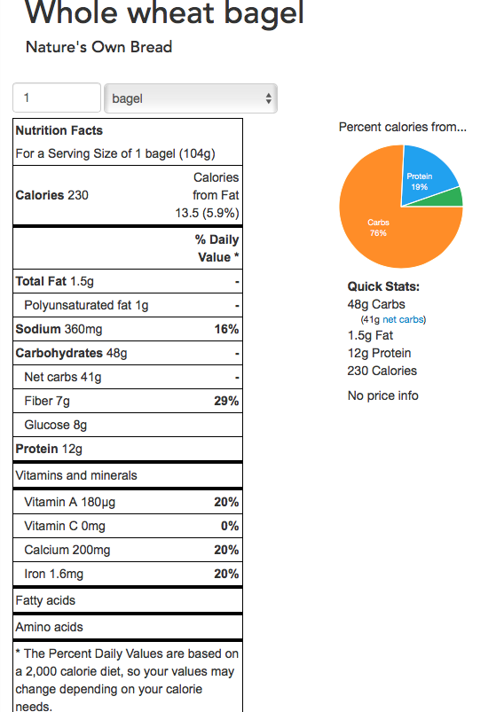
Lesson 3

Activity Name: What is energy? Where can we find it? Where does it go?
Overview: Defining energy and its existence in everyday life

Goals: The goal of this lesson is to introduce the concept of energy in a broad sense before narrowing it down in the following lessons.

Materials:
- whiteboard
- Whiteboard markers
- tablets/laptops

NGSS standards:
PS3.D: Energy in Chemical Processes and Everyday Life The energy released [from] food was once energy from the sun that was captured by plants in the chemical process that forms plant matter (from air and water). (5-PS3-1)

LS1.C: Organization for Matter and Energy Flow in Organisms Plants acquire their material for growth chiefly from air and water. (5-LS1-1)

NGSS Practices: Developing and Using Models Modeling in 3–5 builds on K–2 models and progresses to building and revising simple models and using models to represent events and design solutions. Develop a model to describe phenomena. (5-LS2-1)

Procedure
- Start the lesson with asking the class what examples of science they see in their everyday life and relate this to their work last week (2 minutes)
  - Transition into examples of energy in their everyday life (3 minutes)
    - Students will brainstorm what energy means to them and how they see it in their lives
- Have the students share with the rest of the class their examples of energy (3 minutes)
- Then tell them what energy is by the broadest definition: “the ability to do work” or “the resources for producing power” and have it relate back to all of the different examples they provided (2 minutes)
- Have the students work on an activity and draw up their own ideas of how the energy they see cycles through their environment (be it the body or ecosystem). (15 minutes)
  - Be sure to give them a 5 minute warning
- Write up the different examples on the board and sort them into categories (ex: ecosystems, electrical, nutrition, etc) (10 minutes)
  - Assign RAs to different categories
    - Tessa- Nutrition/Chemical Energy
    - Alondra- Solar Panel Energy/Electromagnetic Energy (mostly conversion of solar into electrical energy)
    - Carlos- Gravitational
    - Lulu- Electromagnetic Radiation (photosynthesis=conversion of electromag into chem energy)
    - David- Thermal Energy/Sound
- Create teams based on what examples the students provided; based on what type of energy without telling the students what category they fall under (10 minutes)
- Already have the laptops/tablets out for the groups that were created from the previous session (could be done during the break)
  - The objective is to identify and understand what type of energy the students are seeing in their everyday lives (30 minutes)
    - Use the tablets/laptops to research what type of energy their examples are (identify what category they fall under)
    - Describe what this type of energy is and what do we know about it
      - How does it get here? What is the energy source? Is this type of energy similar to another type?
    - Use powerpoint to create a slideshow of their findings
- Have the students share their powerpoints to the rest of the class (10 minutes)
- Have them discuss what they think the purpose of energy is (What is it used for?) (5 minutes)

Lesson 4

Activity Name: What is energy? Where can we find it? Where does it go?
Overview: Defining energy and its existence in everyday life

Goals: The goal of this lesson is to introduce the concept of energy in a broad sense before narrowing it down in the following lessons. By the second session, learn where we (as individuals) are in relation to the different energy cycles.

Materials:
- Whiteboard markers
- tablets/laptops
- markers/colored pencils
- Poster paper (large)
- Normal size printer paper

NGSS standards:
PS3.D: Energy in Chemical Processes and Everyday Life The energy released [from] food was once energy from the sun that was captured by plants in the chemical process that forms plant matter (from air and water). (5-PS3-1)

LS1.C: Organization for Matter and Energy Flow in Organisms Plants acquire their material for growth chiefly from air and water. (5-LS1-1)

NGSS Practices: Developing and Using Models Modeling in 3–5 builds on K–2 models and progresses to building and revising simple models and using models to represent events and design solutions. Develop a model to describe phenomena. (5-LS2-1)

Procedure
- Recap last week (5 minutes) : What did we learn about energy last week? What is one thing we remember from last week?
- Break up into groups from last week and continue working on the powerpoints (30 minutes)
  - The objective is to identify and understand what type of energy the students are seeing in their everyday lives
    - Use the tablets/laptops to research what type of energy their examples are (identify what category they fall under)
    - Set a timer to keep track of the time and give the students warnings of the time remaining
*Bolded text is main focus for first session
    - Describe what this type of energy is and what do we know about it
      - What are the stages?
      - What category is my kind of energy?
      - How does it get from one stage to another stage?
      - Name a specific example of this energy in your everyday life
    - Use powerpoint to create a slideshow of their findings
- Have the students share their powerpoints to the rest of the class (15 minutes)

Session 2: 5-5:45 PM

Pre-Setup: Have art supplies (poster paper, printer paper, coloring utensils, and laptops/tablets) ready at the tables before instruction. Can be set up during the break.

- Have students discuss what they think the purpose of energy is (What is it used for? The ability to do work) in a general sense? Alright how about in each of your group’s chosen category of energy? (5 minutes)
- Now that we have looked at different energies, we want to know how we use the type of energy you decided to research. We now know that energy is all around us in different forms, but we want to have a better understanding of how we use it.
- We are going to make posters, “draw-my-life” style projects or act it out to show ourselves using the energy we chose to research
  - For example: Let’s say I had chemical energy and I want to talk about what chemical energy is used in eating an apple
  - Apple Example (5 minutes)
    - Step 1: I eat an apple. I chew it in my mouth
    - Step 2: The apple bits are broken into smaller bits by my teeth
    - Step 3: The apple bits are broken down further into even smaller parts in my stomach, into nutrients
    - Step 4: These nutrients fuel my body. What can I do with these nutrients (run, jump etc)
- After presenting the example, have the groups work on their own chosen project to present how they fit in with their energy. (30 minutes)
  - Be sure to set a timer and give out warnings to the students of the remaining time
- Once completing their skits/drawings, have the groups present their final project to the class.
  - Only if time allows it

Lesson 5

Activity Name: What is energy? Where can we find it? Where does it go?
Overview: Defining energy and its existence in everyday life

Goals: The goal of this lesson is to introduce the concept of energy in a broad sense before narrowing it down in the following lessons. By the second session, learn where we (as individuals) are in relation to the different energy cycles.

Materials:
- Mac laptop for Facetiming (Session 2)
- iPhone: who has a good data plan/do we know if wifi reaches the pantry (Session 2)
- Art supplies (Session 1)
- Printed sheet of questions (Session 2)

NGSS standards:
PS3.D: Energy in Chemical Processes and Everyday Life The energy released [from] food was once energy from the sun that was captured by plants in the chemical process that forms plant matter (from air and water). (5-PS3-1)

LS1.C: Organization for Matter and Energy Flow in Organisms Plants acquire their material for growth chiefly from air and water. (5-LS1-1)

NGSS Practices: Developing and Using Models Modeling in 3–5 builds on K–2 models and progresses to building and revising simple models and using models to represent events and design solutions. Develop a model to describe phenomena. (5-LS2-1)

Procedure

Pre Set-Up: Have art supplies (poster paper, printer paper, coloring utensils, and laptops/tablets) ready at the tables before instruction. Can be set up during the break. *Troubleshoot Facetime for Session 2*

- Have the students discuss what they think the purpose of energy is (What is it used for? The ability to do work) in a general sense? Alright how about in each of your group’s chosen category of energy? (5 minutes)
- Now that we have looked at different energies, we want to know how we use the type of energy you decided to research. We now know that energy is all around us in different forms, but we want to have a better understanding of how we use it.
- We are going to make posters, “draw-my-life” style projects or act it out to show ourselves using the energy we chose to research
  - For example: Let’s say I had chemical energy and I want to talk about what chemical energy is used in eating an apple
  - Apple Example (5 minutes)
    - Step 1: I eat an apple. I chew it in my mouth
    - Step 2: The apple bits are broken into smaller bits by my teeth
    - Step 3: The apple bits are broken down further into even smaller parts in my stomach, into nutrients
    - Step 4: These nutrients fuel my body. What can I do with these nutrients (run, jump etc)

*Bolded text and onward is the main focus for first session

- Have two TA’s troubleshoot Facetime. (Carlos and someone else, during this time)
- After presenting the example, have the groups work on their own chosen project to present how they fit in with their energy.
  - Be sure to set a timer and give out warnings to the students of the remaining time
- Once completing their skits/drawings, have the groups present their final project to the class.
  - Finish by 4:20 PM (20 minutes)
- Wrap up end of Session 1 (10 minutes)
  - What have we learned about our energy use?
  - How has your view of energy changed since we learned about different types of energy and how we use them in everyday life?
- Introduce topic for Session 2 (10 Minutes). Pass out guiding questions on board for Food Pantry while Carlos introduces topic (under Session 2)
- Split them into groups (chem + sound; chem + PE,KE)
- Explain Session 2: what Carlos is doing and what Tessa and TA’s will be doing
- Carlos explains where he is videoing and the questions they have to answer while watching Carlos
- TA’s: assign students questions based on previous energy group (assign food based questions to people from chemical energy etc. Have a partner for questions)

Pre-Setup: Walk to Food Pantry and troubleshoot Facetime

- Guiding Questions and Food Pantry visit (30 Minutes) * Someone is facetiming in the Food Pantry*
  - What are similarities and differences between where your energy is used?
  - What foods do you see? Based on what you understand about healthy and unhealthy foods, which foods are healthy and unhealthy? How do you know?
    - What does healthy food provide for our bodies that unhealthy food does not?
    - How does healthy and unhealthy food affect our energy levels?
      - Think about how you feel after eating a sandwich versus candy
  - What energy is being used to learn about the food pantry?
    - How are we able to see Carlos in the food pantry right now?
    - What energy is Carlos using to move around the food pantry?
- I will ask the questions out loud to indicate what they should focus on
  - EX: Ask Carlos to go closer to a piece of fruit, and ask a food question. Indicate to kids the question on the board and prompt them to take notes
- Have students discuss their answers within their groups.
  - TA’s: have them discuss answers and relate back to the big question
- Putting it all together (15 Minutes)
  - Questionnaire
  - Ask questions and record answers on board

Food Pantry: Guiding Questions

Big Idea: Think of examples of how the two energies in your group interact

- What are similarities and differences between where your energy is used?
  - Similarities: work together by using the energy from the food to bat … there was a lot of food,
  - Difference: chemical energy = the person using it & the potential and kinetic =the object using the energy… there was healthy and unhealthy food… radio waves you don’t see with the naked eye
- What foods do you see? Based on what you understand about healthy and unhealthy foods, which foods are healthy and unhealthy? How do you know?
    - Sausage, potatoes, onions, seafood sauce, bread, corned beef canned, bananas, peppers, milk, salad
  - What does healthy food provide for our bodies that unhealthy food does not?
  - How does healthy and unhealthy food affect our energy levels?
    - How does healthy and unhealthy food affect the amount of physical energy
    - Think about how you feel after eating a sandwich versus candy
      - Do you feel energetic for a short or long time after eating healthy vs unhealthy food?
        - Feel the same
        - Healthy food → more energy to play outside,
        - Candy → not much energy
        - Tummy hurts with unhealthy but not with the healthy foods
3. What energy is being used to learn about the food pantry?
- Stored food energy ,
- How are we able to see Carlos in the food pantry right now?
  - Electrical energy, using camera and video chatting (laptop & cellphones)
  - Radio waves
- What energy is Carlos using to move around the food pantry?
  - Stored food energy
Questions
What are some modes of communications that you know? (ways you see people communicate)
- Online, with phones, verbally, news paper, sign language

What are some ways you best learn new information? (readings, seeing, etc)
- Faster in internet, but books are more helpful sometimes
- Media and internet
- experiences

What is some information about your different types of energy that you want others to know?
- Certain foods will affect your energy
- Some healthy foods have more nutritional value
- Staring at a screen for too long is bad?
- Soccer, rockets, baseball
  - Foods that you eat can affect the way you play sports. Bad food → will not do as well in sports.

What have we learned about the importance of food with relation to energy levels?

What is something you can create that shows knowledge about the two energies in your group?
- Broadcast
- Making a website
- tv/news show
- What to talk about
  - Food taste
- Powerpoint
- video
How can what you learned help others?

Lesson 6

Activity Name: Breaking News!
Overview: Broadcast the information about the type of energies that the groups have been studying & make everyday connections.

Goals: To have the students apply the knowledge they have gained from the previous lessons about energy and convey it through different modes (short broadcasting segment).

Materials:
- iPads
- Pencils & markers
- White paper
- Index cards
- Worksheets (instructions template )

NGSS standards:
PS3.D: Energy in Chemical Processes and Everyday Life The energy released [from] food was once energy from the sun that was captured by plants in the chemical process that forms plant matter (from air and water). (5-PS3-1)

LS1.C: Organization for Matter and Energy Flow in Organisms Plants acquire their material for growth chiefly from air and water. (5-LS1-1)

Energy and Matter: Energy can be transferred in various ways and between objects.
NGSS Practices:
5-PS3-1. Use models to describe that energy in animals’ food (used for body repair, growth, and motion and to maintain body warmth) was once energy from the sun.

Procedure:
- RECAP last week’s questionnaire (5 minutes)
  - Some modes of communication were:
    - Online, with phones,Verbally, News paper, Sign language
  - Some information about your different types of energy that you want others to know?
    - Certain foods will affect your energy
    - Some healthy foods have more nutritional value, Foods that you eat can affect the way you play sports.
- INTRODUCE two new mini project: news podcast (10 minutes)
  - OPTION 1: Explain what a podcast is to the students [5 min]
    - Give the examples of WTNV and TAZ (explain that they’re similar to radio talk shows but online)
  - OPTION 2: news segment [5 min] Alondra
    - For those that want to be in front of the camera, they can work in their teams to create a news segment
  - Make sure to notify the students that the segments should be 2 minutes max (less is fine)
- EXPLAIN assignment guidelines (5 minutes) lulu
  - Go over guiding questions
    - Must answer all the questions b. Go over roles
    - Assign tasks/roles
- WORK within groups on the final project (25 minutes)
  - Choose between option 1 or 2
  - Assign roles amongst yourselves
    - Notify the students that they have 5 minutes to decide on an option and assign roles
    - After the 5 minutes, notify the groups and have them start on the actual project
  - Start by answering the questions to help formulate their scripts
    - Do extra research if necessary
  - Based on responses, can begin their practice “skits” before the actual filming
    - Start the final product/filming
- FINISH working on mini project prep (15 min) a. For those who are “done” with their scripts, have them practice before the filming
- FILM/RECORD their mini projects (20 min)
  - Use iPads for recording/filming
    - Go over tech. Norms 1. Not a toy, be careful, only for project use
- PRESENT their mini projects (15 min)
  - Group Roles:
  - Take turns watching or listening to each others projects

MINI ENERGY PROJECT
Group Roles:
Name of Student | Role | Tasks

Instructions: Groups must answer all of the questions below

1. Give us some background on the two types of energies the groups have been studying.
2. How do the two types of energies apply to our everyday lives?
3. Where can we access these types of energy?
4. How can we improve the use of these energies?

