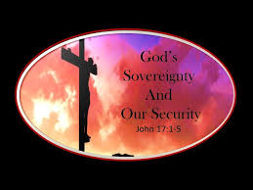\\\
Pastor: Brad Cox
Worship Leader: Jeff Haney
Special Music: Shonda Brewer and Chris Gortney
Piano: Deana Sceniak

Happenings: Wednesday evenings, Adult Bible Study 6-7
Youth Group Wednesday evening 5-6
Ice Cream Social immediately following the church service.
50 days of Prayer: Join Franklin Graham for 50 days of prayer for our country nationwide, beginning on May 14 and running through July 4th. A pastor from each of the 50 states will lead us in praying for our country. You can join this national prayer movement at OneNationUnderGod.com
Pray For: Francis Denton
Bill Musser
Mikki Hernandez
Our Country

Scripture Reading: Hebrews 11:1-3
1 Now faith is confidence in what we hope for and assurance about what we do not see. 2 This is what the ancients were commended for. 3 By faith we understand that the universe was formed at God’s command, so that what is seen was not made out of what was visible.
“Her children arise and call her blessed.” Proverbs 31:28
Happy Mother's Day to all women who encourage, pray, nurture and love with faithful hearts. Thank you for the love, sacrifice, prayers and strength that you share every day. May God richly bless, strengthen and encourage you as you continue to walk faithfully in His Grace.
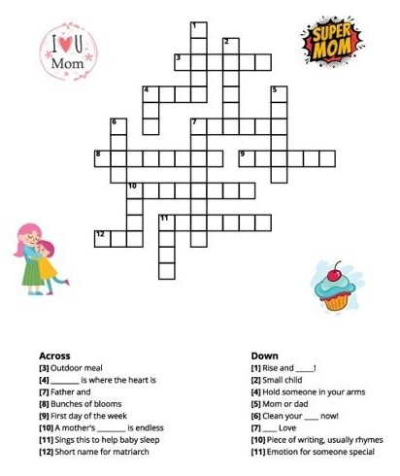

ORDER OF WORSHIP – 10 A.M.
May 3, 2026
Prelude Music

Call to Worship: Hebrews 12:14 Make every effort to live in peace with everyone and to be holy; without holiness no one will see the Lord.

Hymn: #581 Tis So Sweet to Trust in Jesus
# 526 The Solid Rock

Welcome and Announcements
If you are visiting here today, please fill out a visitor card and drop it into the offering plate.

Special Music: Shonda Brewer and Chris Gortney

Offering

Doxology

Affirmation of Faith
I believe that Jesus is the Christ, the Son of the Living God
And that He is the Savior of the world.

Prayer Time
(Children dismissed for Children’s Church)

Special Music: Shonda Brewer and Chris Gortney

Scripture: Hebrews 11:1-3

Sermon: “A Call for Unity”

The Lord’s Prayer

Blessing

Postlude Music

Nursery: Open for children 4 and under during Worship
Coffee Time: In the Fellowship Room after the service, join us!
Sunday school: Sunday school
Church website: wawaseelakesidechapel.org


Fish Fry – October 15
Do you have your tickets?
See --Linda Stuckman



