The Lodge Book
Information about the Lodge and the Hoedspruit area
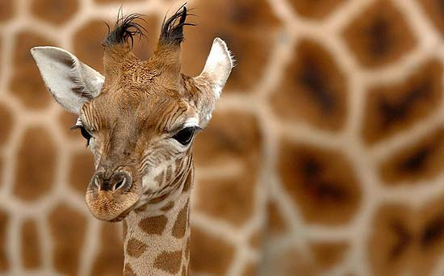
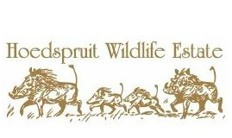

Welcome to Hoedpsruit Wildlife Estate
Your home in the African bush
Dear Guest,

We are pleased to share with you our love for South Africa!
We hope you will find your stay enjoyable and you will love the beautiful surrounding nature.
The house is regularly visited by hornbills, warthogs, gazelles, giraffes, kudus, zebras and monkeys. Please DO NOT FEED animals. It is forbidden from the Estate Regulation.

Do not leave any food outside or visible from windows. Baboons can become aggressive and rangers should be forced to eliminate dangerous animals.

Please be informed that a leopard is resident in the Hoedspruit Wildlife Estate but it is not usual to see him. Do not walk or run around the estate at sunrise and sundowner.

Please do not leave any rubbish outside and kindly bring it in the dedicated area, on the right just before the main gate exit.

When not at home, please keep doors and windows closed and kindly turn lights and air conditioning off.

Please feel free to live the house like yours and respect and take care of it.

In case of any need related to the house managing and maid service, you can contact our Lodge Managers:

Mrs. LISA : +27 (0)72 221 4042
Mr. REBERT: +27 (0) 79 696 7577

Enjoy your stay!!

Emergency Numbers

National Emergency Number: 10111

Hoedspruit Police Station: +27 015 799 4000

Fire Dpt: +27 015 793 0728

Hoedspruit Farmwatch: +27 072 31 000 32
The Hoedspruit Plaaswag or Farmwatch, was originally initiated as a anti-theft organisations dealing with crop theft on the farms, however, their efficient services and commitment to the community have resulted in the management and control of a wide range of incident management services and community support.

Hoedspruit Medical Rescue: +27 072 17 00864
Committed to assisting the community with extreme trauma situations such as Motor Vehicle Accidents and Life Threatening scenarios, Hoedspruit Medical Rescue (HMR) is primarily a subscription based and membership orientated organisation. HMR works closely with farmwatch in assisting the community with medical needs and scenarios.

Quemic Medical Response: +27 074 411 4444
Quemic medical offers paramedic and ambulance services for Hoedspruit and the surrounding community. Quemic are linked to major medical aid schemes and all transport is arranged according to Medical Aid Scheme guidelines.

Shops and Supermarket

Pick n Pay Centre, just outside Hoedspruit Wildlife Estate, on the left.
Tel: +27 015 793 0482

New Shopping Centre, Kudu Street, Hoedspruit
Tel: 015 793 2305 / 6

Shopping Centers: shops, pubs and restaurants

- Kamogelo Tourism Center – Main Street.
(with children playground)

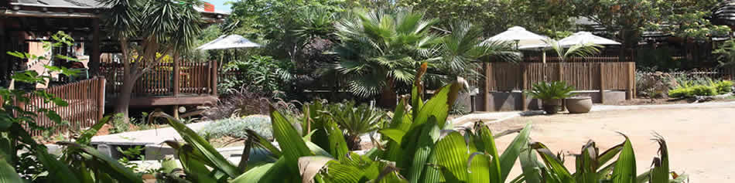

- Rock fig Lifestyle Centre – Wildlife Shopping Center

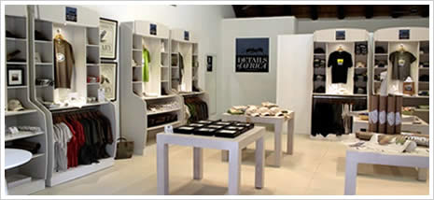

Restaurants

Sleepers: 1 Python Street | Hoedspruit Railway Station
Ph. +27 15 793 101
The Hat and Creek: 527 | Main Road, Hoedspruit
Ph. +27 15 793 1135

Cooked: Khaya Ndlovu Entrance, R40 (White River Road), Hoedspruit
Ph. +27 78 443 4068

The Fig & Bean, Rock Fig Center- Hoedspruit Wildlife Shopping Centre (closed for dinner)
Ph. +27 71 265 9787

Fast Food
Silver Wings Spur: Shop 20a, Hoedspruit Wildlife Shopping Centre

KFC: R40 (to South, on the right after Petrol Station)

Wimpy: Main Road | Kamogelo Tourism Centre

