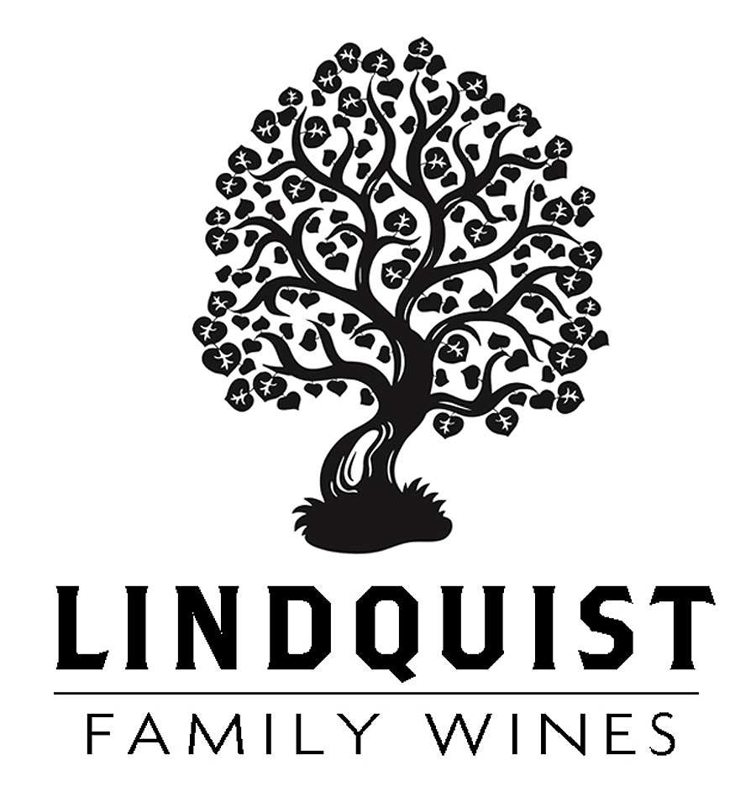
Lindquist 2023 Chardonnay – Christy & Wise Vineyard
Sta. Rita Hills

This wine is 100% Chardonnay from the Christy & Wise Vineyard near the city of Lompoc in the Sta. Rita Hills AVA. Unusual for Chardonnay in Santa Barbara County, these vines are small, head trained bush vines that naturally regulate crop size and ripening. Christy & Wise is a Demeter Certified Biodynamic vineyard, planted on well drained sandy soil.

2023 was a cooler than normal vintage, allowing for long hang time and maximum flavor development, an outstanding vintage! These grapes were hand harvested on October 5th at 24.4° brix, 3.18 pH and 9.4 acidity…textbook numbers for crisp, balanced and intense Chardonnay characteristics.

The grapes were whole cluster pressed, the juice chilled overnight in tank and then transferred to Francois Freres Burgundy barrels for fermentation and aging...67% new oak, 33% once used barrels, a mere three barrels were made. The aromas show a complex array of minerality, apples, pears and citrus, all wrapped up in a creamy French oak robe! The flavors carry those same notes forward, with mouthwatering freshness and acidity. This is a great wine for the cellar, as it will easily mature for another 10-15 years.

Cheers, Bob Lindquist – May 2026

