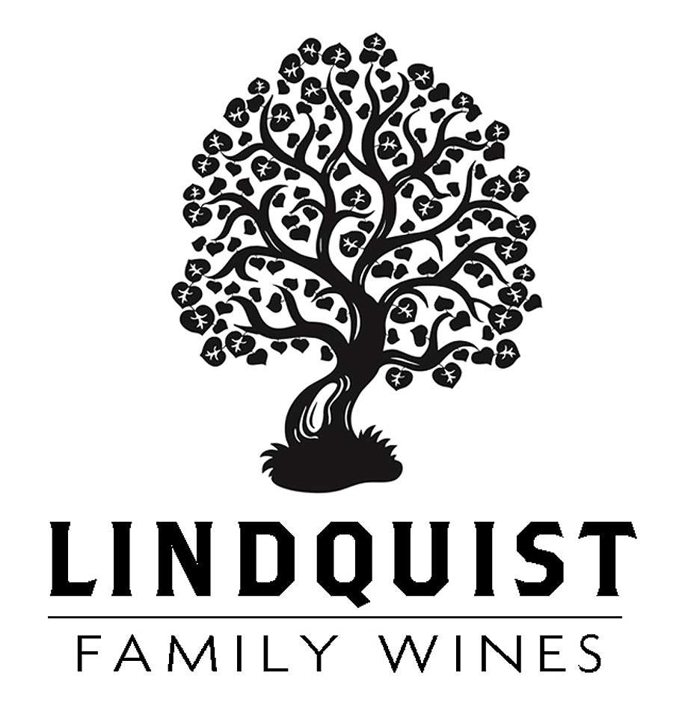

Lindquist 2023 Syrah – Bien Nacido X & Z Blocks
Santa Maria Valley
This wine is 60% Syrah from the Bien Nacido X Block and 40% from the Bien Nacido Z Block. I many ways, this wine is bittersweet for me, as it represents the last Syrah that I’ve made from the X Block. As a reminder, the X Block was originally planted to Riesling, on its own roots, as part of the original Bien Nacido plantings in 1973. In 1986, half of the 14-acre X Block was grafted over to Syrah…and in 1987, I got the first crop off of the grafted vines and made my first Bien Nacido Vineyard Syrah. In 2020 the X Block began to show signs of decline due to two different grapevine viruses, red blotch and leaf roll. Over the next few years, the vines continued to decline, and the grapes struggled to get ripe. Interestingly, the grapes had great complex flavors, just with declining sugar levels. After this 2023 vintage I decided to not continue making wine from the X Block, and after the 2024 vintage, the vines were finally pulled out.
The ‘Z Block’ was planted in 1992 and luckily has not been affected by these viruses (knocking on wood!). I’ve been making wine from the Z Block since its first crop in 1994.
In 2023, the X Block grapes were hand harvested on October 25th, physiologically fully ripe, but with only 20.5° sugar. The whole clusters were but into the fermenter and foot stomped. The next day, on October 26th, the Z Block grapes were hand harvested, and came in at a higher sugar than anticipated at 25.2° brix…we also got about half of the tonnage from Z Block that we had anticipated. So, I made the game time decision to de-stem the Z Block into the same fermenter as the X Block, making the best wine possible. It was aged for 20 months in Francois Freres Burgundy barrels, 50% new oak, and bottled without fining or filtration. It exhibits the cool, herbal, spicy and tea leaf notes of the X Block, along with the fruit forward deliciousness of the riper Z Block.

Cheers, Bob Lindquist – May 2026

