Nebraska City Community Foundation Fund
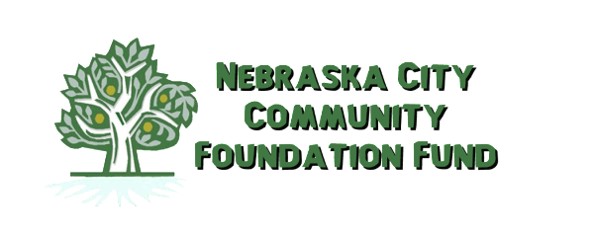
2021 Non-Traditional Student Scholarship
Application Form

Name: _______________________________________________________________________

Address: ______________________________________________________________________
Phone Number(s): ______________________________ E-Mail: _________________________

Previous Education: (include high school or GED and postsecondary education with dates of attendance)
____________________________________________________________________________________
____________________________________________________________________________________
____________________________________________________________________________________
Name of College or University in which you plan to enroll, or are currently enrolled:
____________________________________________________________________________________
Have you been accepted? ____________ Intended field of study: _____________________________
Community Service Activities: ___________________________________________________________
_____________________________________________________________________________________
_____________________________________________________________________________________
Employment History: ___________________________________________________________________
_____________________________________________________________________________________
_____________________________________________________________________________________
Essay: (Please attach a personal essay of how you feel this educational opportunity will benefit you as well as the community of Nebraska City.)
The information in this application will remain confidential and will be used only for its intended purpose.
Please submit this application by August 31, 2021 to:
Nebraska City Community Foundation Fund
Scholarship Selection Committee
PO Box 444
Nebraska City, NE 68410

