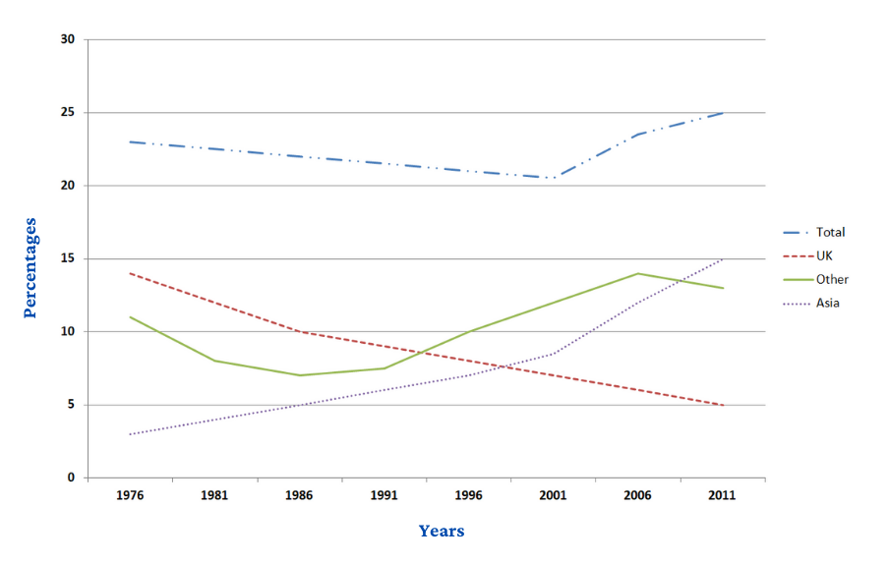
The chart below shows the percentage of Australian people who were born in different places of the world.
- Dạng gì : line chart
- Chủ ngữ của bài: the percentage of Australian were born in different places
- Đơn vị của bài: percentage
- Chia thì gì : past simple, past perfect
- Câu Overall :total line decline before 2001. Other rise, UK fall
- Bố cục cách viết 2 đoạn thân bài
- Body 1
- total percent decline, while in Asia increase
- In the following year, both climb at 25% and 15% respectively
- Body 2
- 1976-1986: are likely to drop slightly
- while UK continue to dip, other area, rocket to nearly 15% in 2006, followed by marginally going down
Tham khảo cách triển khai bài nhé: https://www.ieltstutor.me/blog/line-graph
Given is the line chart illustrating the proportion of Australian residents who live in other areas all over the world from 1976 to 2011.
It is clear that,before 2001, the percentage of Australian people all over the world constantly went down. Overall, there was an upward trend over the 35-year period in many places, excepting the UK.
By 2001, the total portion of Australian people slowly slumped to 20 percent, whereas in Asia, it significantly increased 3% to 8%. In the following year, both these figures climbed by 5%.
Over a period of ten years from 1976, according to the chart, the percentage had deteriorated to 10% in the UK. The same trend happened in other places, followed by a fluctuation in the next 5 years. Since 1991, in comparison with the percentage of Australian residents in the UK which plummeted from 10% to 5%, in other areas, it rapidly rise to 15%
⇒ Bố cục như mình cũng ổn có thể tham khảo thêm bố cục khác nhé
lưu ý:
- Với biểu đồ line này có nhiều cách phân bố bố cục, có thể cân nhắc phân bố 2 đoạn thân bài như sau (chia thì quá khứ):
  - Overall:
    - The total population saw a steady drop in the first 25 years but later rose sharply during the final 10 years of the given period.
    - The figures for people born in Asia and Other generally enjoyed upswings >> IELTS TUTOR hướng dẫn Cách dùng danh từ "figure" tiếng anh
  - Bài này có 2 cách làm:
    - Cách 1:
      - Body 1: Viết về total + UK
      - Body 2: Viết về Asia + Other
    - Cách 2: (cách này có thể so sánh cả 4 số liệu)
      - Body 1: Viết về giai đoạn 1976 đến 1996
        - In 1976:
          - Around 14% of the Australian people were born in the UK. This was followed by Other (roughly 12%), and Asia (3%).
        - Over the next 20 years:
          - While fewer Australians came from the UK, with its figure dropping to approximately 8%, the figures for Other and Asia rose steadily to 10% for each of them.
          - The total population of Australia, in the meantime, experienced a gradual decline from 22.5% in 1976 to its all-time low of 18% in 1996 >> IELTS TUTOR hướng dẫn CÁCH DÙNG TỪ "AMOUNT" TIẾNG ANH
      - Body 2: Viết giai đoạn còn lại
        - The total demographics at this particular time frame saw a steep growth to its peak of 25%.
        - The proportion of Australian people born in the UK went down to 5%, whereas opposite patterns are evident in the figures for Australian people of Asian and European descent, with the former rising to 12% and the latter to its high of 15%. >> IELTS TUTOR hướng dẫn Cách dùng THE FORMER - THE LATTER trong tiếng anh

