The charts below show the percentage of people aged 23-65 in different occupations in one UK town (Ashby) and in the UK as a whole in 2008.

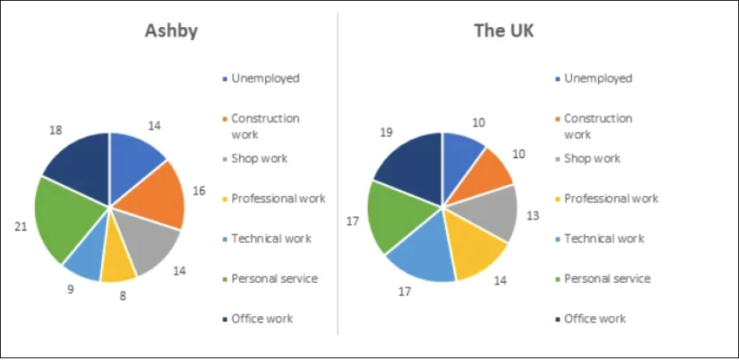

Giving is the pie chart giving the percentage of people who were 23-65 years old in various jobs in the UK and Ashby in 2008.

Overall, it is clear that personal service in Ashby occupies the highest percentage compared to other jobs, while the rate of office work is the largest in the whole UK. Furthermore, the proportion of people who have professional work is the lowest in Ashby, while the smallest rate is for construction work.
In Ashby, 21% of people worked in personal service, which is the highest percentage shown on the chart. The proportion of unemployment and shop work was the same, at 14%. A very trivial percentage of people who had professional work was 8%.
In the whole UK, people who worked in offices calculated the proportion of 19%. A similar rate was for the group of unemployed and construction work, at 10%, and another group of personal service and technical work, at 17%.
→ Bố cục như mình cũng ổn nha hoặc nội dung bài thì mình có thể cho thấy sự tương quan (so sánh) giữa Ashby & the whole UK nếu mình muốn bố cục kiểu khác
Thì bài ở đây một cách khác mình cũng có thể miêu tả cho thấy sự so sánh ở từng ngành nghề nè
VD:
Body 1. (so sánh Ashby > the whole UK)
Personal Service + Shopwork + Construction work + Unemployed
Body 2. (so sánh Ashby < the whole UK)
Những nhóm còn lại
Có thể tham khảo thêm cách triển khai mỗi body 1 biểu đồ nhé
- Một số cách paraphrase:
  - national figures: số liệu trung bình của cả nước, trong bài tương đương là "average UK employment patterns" "the nationwide average rates"
  - ngành làm việc: sectors, areas of work >> IELTS TUTOR hướng dẫn Cách dùng từ "sector" tiếng anh
- Overall:
  - while British people generally preferred office work, personal service was the most popular profession in Ashby.
  - the national unemployment rate was lower than the rate in Ashby >> IELTS TUTOR hướng dẫn Từ vựng topic Unemployment IELTS
- Body 1: Viết về biểu đồ 1
  - The most popular job in Ashby i.e. personal services constituted 21% of the workforce
  - The percentage of jobless people in Ashby was 14% >> IELTS TUTOR hướng dẫn Cách dùng Figure / percentage / proportion IELTS
  - The percentage of Ashby residents who were employed in office work and shop work were 18% and 14% respectively
- Body 2: Viết về biểu đồ 2
  - The largest proportion of the average UK working population did office work at 19%
  - The UK recorded a relatively high proportion of citizens employed in technical work, at 17% (IELTS TUTOR gợi ý cách diễn đạt khác: technical and professional workers make up 17% and 14% of the UK workforce respectively) >> IELTS TUTOR hướng dẫn Cách dùng danh từ "advance" tiếng anh
  - The smallest proportion in the UK was 10% (construction work)

