Target Speaking: 7.0

Chừng nào thi: Cuối tháng 9

Em đang yếu điểm gì so với target mà em đặt ra? Em nghĩ là ở vốn từ vựng, cách nói trôi chảy.

SAU KHI ĐÃ HOÀN THÀNH BÀI, EM TRẢ LỜI THÀNH THẬT NHỮNG CÂU HỎI SAU ( phải trả lời bằng mực đen, chữ in thường, kiểu chữ Arial size 11 )

- Đã đọc kĩ Hướng dẫn chung cách trả lời Part 1 (https://www.ieltstutor.me/blog/ielts-speaking-de-thi-mau-part-one) chưa? Và đã sắp xếp bài nói Part 1 của mình theo đúng bố cục chưa?
-Em chưa đọc kĩ. Em trước đó đã được học part 1 nên em nghĩ ở chừng mực nào đó, em nghĩ đã sắp xếp hợp lý.
- Đã đọc kĩ Hướng dẫn chung cách trả lời Part 2 (https://www.ieltstutor.me/blog/ielts-speaking-part-2) chưa? Và đã sắp xếp bài nói của mình Part 2 theo đúng bố cục chưa?
--Em chưa đọc kĩ. Em trước đó đã được học part 3 nên em nghĩ ở chừng mực nào đó, em nghĩ đã sắp xếp hợp lý.
- Đã đọc kĩ Hướng dẫn chung cách trả lời Part 3 (https://www.ieltstutor.me/blog/ielts-speaking-de-mau-part-three) chưa? Và đã sắp xếp bài nói của mình theo từng dạng của Part 3 chưa?
--Em chưa đọc kĩ. Em trước đó đã được học part 3 nên em nghĩ ở chừng mực nào đó, em nghĩ đã sắp xếp hợp lý.
- Đã đọc kĩ 4 tiêu chí chấm thi Speaking để nắm vững mình cần focus vào tiêu chí nào khi luyện chưa? https://www.ieltstutor.me/blog/tieu-chi-ielts-speaking
Em đã đọc đó là 4 tiêu chí: Lexical resource, fluency and coherence, Grammar Range & Accuracy, Pronunciation
- Cách tra Phát âm & Trọng Âm của một từ đã đọc kĩ chưa? https://www.ieltstutor.me/blog/pronunciation
Em chưa đọc kĩ.
- Trong khi nói bài này gặp khó khăn gì về mặt Fluency & Coherence không? Nếu có thì vì sao?
Em không gặp vấn đề gì nhiều.
- Trong khi nói bài này gặp khó khăn gì về mặt Lexical resource không? Nếu có thì vì sao?
- Trong khi nói bài này gặp khó khăn gì về mặt Pronunciation không? Nếu có thì vì sao?
- Trong khi nói bài này gặp khó khăn gì về mặt Grammar Range & Accuracy không? Nếu có thì vì sao?
- Em có câu hỏi gì muốn hỏi giáo viên về đề này không?

Link Đề bài:
Hướng dẫn trả lời chung cho Part 1: https://www.ieltstutor.me/blog/ielts-speaking-de-thi-mau-part-one
Tham khảo thêm bài mẫu về topic Work/ Study: https://www.ieltstutor.me/blog/work-study-ielts-speaking-part-1
Em đọc khá rõ ràng cần luyện thêm intonation nhé https://www.ieltstutor.me/blog/intonation

Transcript Bài Nói Part 1
- Do you work or are you a student?
Answer: Actually, I am studying at Le Qui Don high school for the gifted at grade 11 in Da Nang city and my specialized subject is history which is my cup of tea.
- If you could choose to study another subject, what would you choose?
Answer: I would definitely say that if I had an opportunity to select another subject, probably my option would be geography. Simply because I am a crazy fan of travelling, especially adventure trips so the valuable knowledge in geography will be my great support tool in recognizing the direction , topography, or weather.
- What was your first day at high school like?
Answer: From my perspective, my first day at high school hmm I have to say “memorable”. Mainly by virtue of a little bit nervous, I forgot the position of my class although I had read the class diagram not long ago, so I was quite worried because the first lesson was about to begin. I tried to imagine the way to my classroom but it was seem impossible and fortunately, one nearby student knew my class’s position and finally I found my class. That is unforgettable experience to me.
Hình Take note của Part 2:
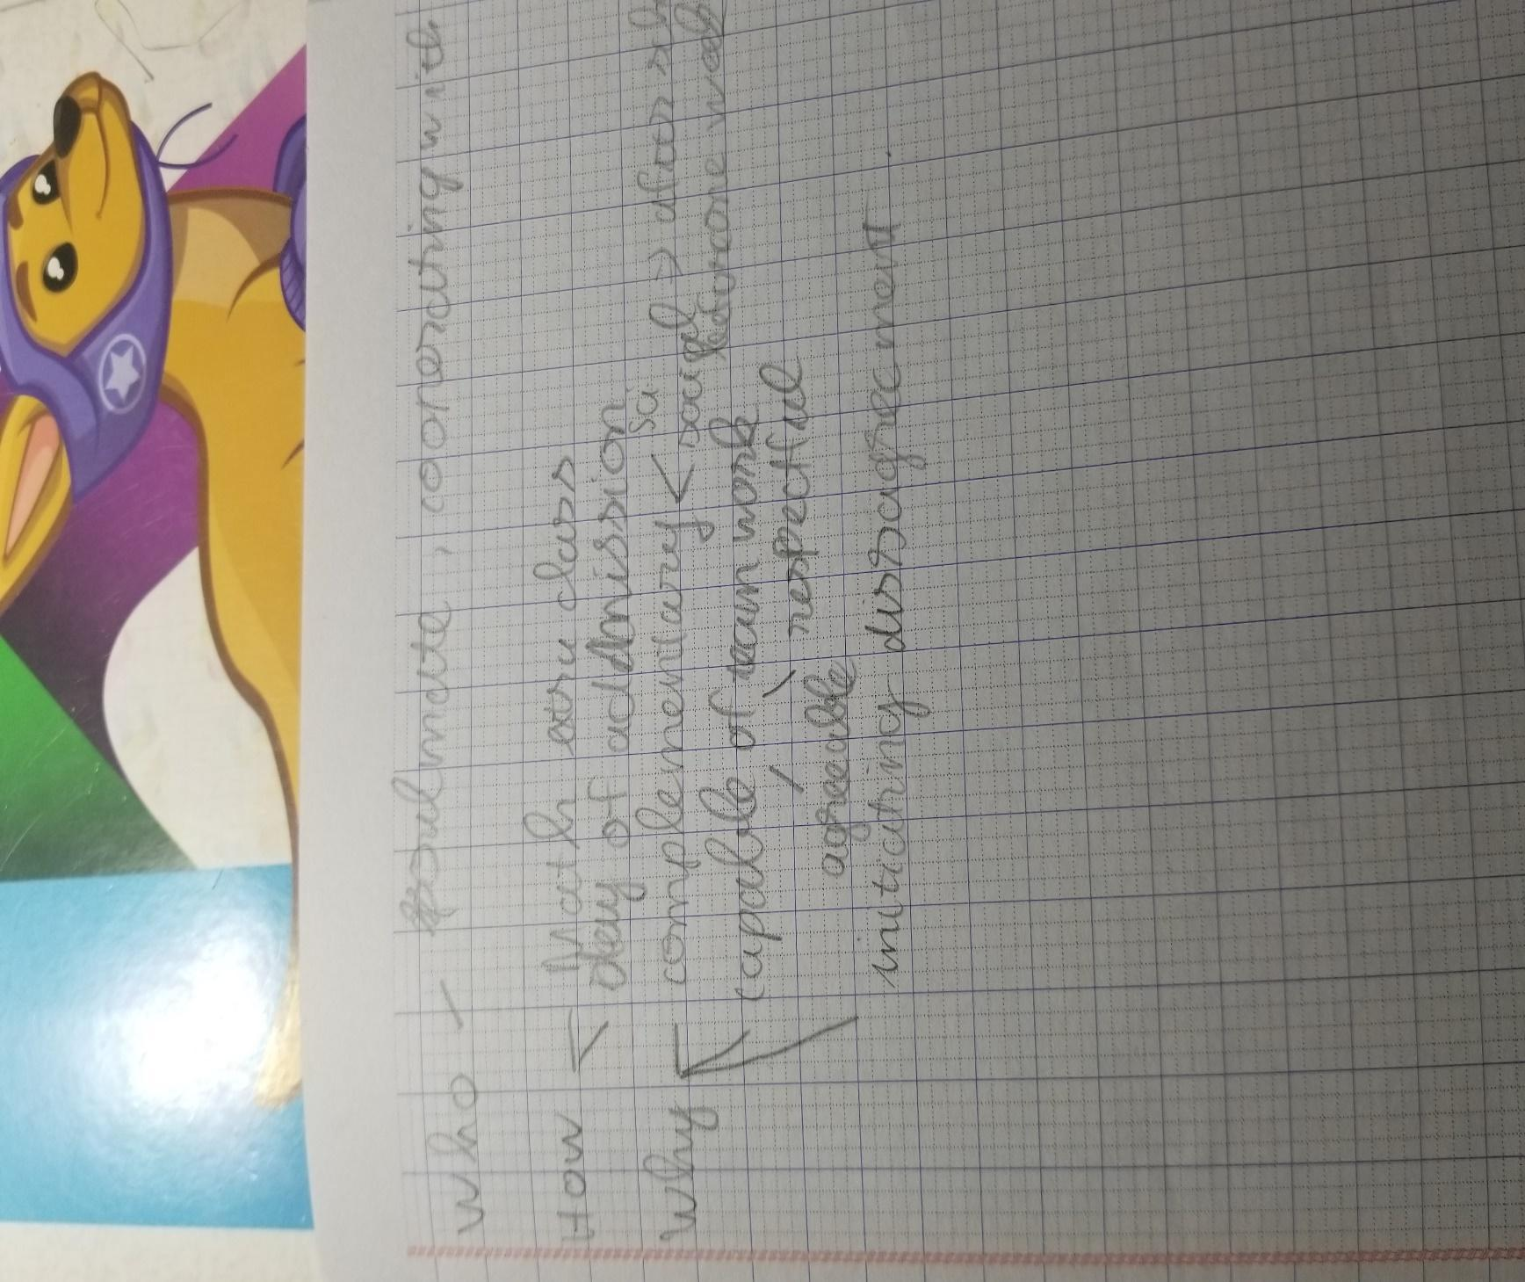

Hướng trả lời chung cho Part 2 Speaking tại https://www.ieltstutor.me/blog/ielts-speaking-part-2
Hướng dẫn take note: https://www.ieltstutor.me/blog/take-note-ielts-speaking-part-2
Template mở bài https://www.ieltstutor.me/blog/introduction-template-ielts-speaking
Cách làm dạng STUDY/ WORK:
https://www.ieltstutor.me/blog/cach-tra-loi-ielts-speaking-part-two-three-work
Transcript Bài Nói Part 2 :
1. Describe someone you would like to study or work with
- . Who this person is
Well, today I would like to tell you about my girlfriend who is my soul mate in co-operating with studying.
- . How you know him/her
- About the first time I met her, that is about last summer when both accidentally participated in the same extra Math class but I rarely engaged in face to face interaction with her. Astonishingly, on the day of admission, we were seatmate and from that moment, I and she try to help each other in studying.
- . Why you would like to study or do with him/her
Next. I will reveal why she is my reliable companion that I am really fond of studying with. Firstly I find that we are reasonable complementary for each other. While she is superb in subjects that I am atrocious at such as Math, Physic and Chemical, I possess wide range of knowledge about social subjects: literature, history and geography you name it, so you know normally after school we often have information exchange or discuss each other about questions or matters related to lesson. Especially, before every semester exam we will spend one week to concentrate on reviewing related knowledge and practicing tests and through this process, we will recognize our mistakes by examining and make effort in enhancing them. Thanks to this nonstop attempt, we have improved our academic performance. Besides, I also consider that she is capable of doing teamwork. I mean in every argument, I feel my opinions are appreciated simply because my companion makes sense of agreeable and respectful. At this point, I have to admire that she is good listener and an ideal model to me. Furthermore, when initiating disagreement, she said that we should calm down and think carefully the problem again. From this silent time, both actually realize what the issue is and finally the problem is solved. That are reasons why I like to study with her.
Transcript Bài Nói Part 3 :
1: Which one is more important, salary or job satisfaction?
From my perspective, I have to say that selecting one in these two factors is really a challenging question but if I had to choose, my more essential priority would be salary. Simply because, to follow job satisfaction, besides professional elements, seekers also need the fortune by virtue of severe labor market while salary plays an essential role to people’s life in sustaining financial stability to meet the basic needs and having sufficient life. So how can people maintain their expenses on a daily basis without steady financial platform . On the other hand, I admit that to climb the career ladder, having job satisfaction will motivate people to make effort in enhancing themselves more and more and definitely, when people will have more responsibility and enthusiasm for their work. In short, between salary and job satisfaction, I would rather select salary.
. What are the most popular jobs for young people in your country?
Well, it depends. In Viet Nam, my country, there are quite clear differences between boys and girls in their favorite subjects which affect directly their job in the future.
For boys, they usually tend to concentrate on science subjects such as Math, Physics or Chemical, so I feel that they are more likely to be concerned about areas being reasonable for them to pursue.IT, banking, business, construction, you can name it.
For girls, quite a number of girls are fond of social subjects: literature, history and geography and the arts, so it’s not astonishing when the majority have tendency to select jobs related to social, fashion, firm or artist including journalist, stylist, actor or painter.
For both, I think that in the general development of the world with the diversity of occupation, young generations have the plenty of choices and it’s not necessary to only decide their dreaming jobs depending on their favorite subjects simply because sometimes relevant jobs are not suitable to their capability, so they can do whatever they want.
3.How have people's ways of studying changed?
Well, in the past, people used to study in traditional ways. Probably the most popular method is attending a class and listening to teacher’s lectures or study through reading books or references, so it’s only reasonable to students that they don’t have to go to school by the long distance
But now, besides this traditional form, an increasing number of learners are studying on the Internet with the birth of online classes which meet the needs of students that don’t have the possibility to attend due to geographical distance and there is also remarkable tendency for today’s students to study in different countries. For instance, I am living in Da Nang city, if I want to study IELTS with native speaker, I only need access Internet and learn through Skype application.
4.What kinds of subject are useful?
From my perspective, I think history and geography are two valuable subjects which can be applied in real life. Simply because both equip learners for wide range of knowledge about the culture, lifestyle or even weather forecast skill which is really practical. For instance, if people have intention of migrating to one city or one country, obviously people have to possess certain knowledge about that location and instead of wasting of time to understand the culture or lifestyle of native people or even clime, history and geography will provide that amount of knowledge and people will easily absorb it naturally, using it reasonably for situations as I told you. In short, I believe that history and geography are useful types of subjects.
STUDY LẦN 3
Học về intonation nha em https://www.ieltstutor.me/blog/intonation; những từ 2 âm tiết cần đọc rõ trọng âm, có khác so với những bài đầu nhưng vẫn cần luyện nhiều hơn
Transcript Bài Nói Part 1
- Do you work or are you a student?
Answer: Actually, I am studying at Le Qui Don high school for gifted students at grade 11 in Da Nang city and my specialized subject is history which is my cup of tea.
- If you could choose to study another subject, what would you choose?
Answer: I would definitely say that if I had an opportunity to select another subject, my option would be geography. Simply because I am a huge fan of travelling, especially adventure trips so the valuable knowledge in geography will be my great support tool in recognizing the direction , topography, or weather.
- What was your first day at high school like?
Answer: From my perspective, my first day at high school was hmm I have to say “memorable”. To be more detailed, I forgot the position of my class although I had read the class diagram not long ago, so I was quite worried because
the first lesson was about to begin. Fortunately, one nearby student knew my class’s position and finally I found my class. That was such an unforgettable experience to me.
Em hay lên tông ở cuối câu/ cuối từ, vì các từ hầu hết trọng âm không phải âm cuối và cuối câu tường thuật thì cần xuống giọng; cuối câu hỏi Yes/ No question (Do you like___?) thì mới lên giọng nhé

Hình Take note của Part 2:
Transcript Bài Nói Part 2 :
1. Describe someone you would like to study or work with
- . Who this person is
Well, today I would like to tell you about my girlfriend who is my ideal study partner.
- . How you know him/her
- About the first time I met her, it was last summer when we both accidentally participated in the same extra Math class but I rarely engaged in face to face interaction with her. Astonishingly, on the day of admission, we were seatmates and from that moment, I and she tried to help each other in studying.
- . Why you would like to study or do with him/her
There are many reasons why I consider her as a reliable study companion. Firstly I find that we are reasonably complementary to each other. While she is superb in subjects that I am atrocious at such as Math, Physic and Chemist I possess a wide range of knowledge about social subjects like literature, history and geography you name it, so you know normally after school we often have information exchange or discuss questions or matters related to lesson. Especially, before every semester exam we will spend one week concentrating on reviewing related knowledge and practicing tests and through this process, we will recognize our mistakes by examining and make effort in enhancing them. Thanks to this nonstop attempt, we have improved our academic performance. Besides, she is a good team who always listens to other’s opinion carefully. To be more precise, when I perform my point of view in any arguments, she always has a writing pad and take not all remarkable details, she will base on these notes to help me enhance my ideas more.Those are reasons why I like to study with her.
=> 2 lí do khá chi tiết tuy nhiên thì cần cân bằng giữa độ dài hơn, ở đây lí do thứ 1 chi tiết hơn lí do 2 khá nhiều

Transcript Bài Nói Part 3 :
1: Which one is more important, salary or job satisfaction?
From my perspective, I have to say that selecting one in these two factors is really a challenging question but if I had to choose, my priority would be salary. Simply because I want an independent life with my own money to avoid parent’s allowance and the stability is a necessary factor letting me to achieve a bigger goal. In addition,to follow job satisfaction, besides professional elements, seekers also need the fortune by virtue of severe labor market while salary plays an essential role to people’s life in sustaining financial stability to meet the basic needs and . On the other hand, I admit that to climb the career ladder, having job satisfaction will motivate people to make effort in enhancing themselves more and more and definitely, people will have more responsibility and enthusiasm for their work. In short, between salary and job satisfaction, I would rather select salary.

. What are the most popular jobs for young people in your country?
Well, it depends. In Viet Nam, my country, there are quite clear differences between boys and girls in their favorite subjects which affect directly their job in the future.
For boys, they usually tend to concentrate on science subjects such as Math, Physics or Chemist, so I feel that they are more likely to be concerned about scientific areas such as IT, banking, business, construction, you can name it.
For girls, quite a number of girls are fond of social subjects: literature, history and geography and the arts, so it’s not astonishing when the majority have tendency to select jobs related to social, fashion, film or artist including journalist, stylist, actor or painter.
3.How have people's ways of studying changed?
Well, in the past, people used to study in traditional ways. Probably the most popular method was attending a class and listening to teacher’s lectures or study through reading books or references.
But now, the advent of the Internet has changed teaching method. Typically, that is the birth of online classes which meet the needs of students that don’t have the possibility to attend due to geographical distance. Studying online is also a remarkable tendency for today’s students to study in different countries. For instance, I am living in Da Nang city, if I want to study IELTS with native speaker, I only need access Internet and learn through Skype application.
4.What kinds of subject are useful?
From my perspective, I think history and geography are two valuable subjects which can be applied in real life. Simply because both equip learners with a wide range of knowledge about the culture, lifestyle or even weather forecast skill which is really practical. For instance, in situation if people have intention of migrating to one city or one country, history will provide valuable knowledge about the culture or lifestyle of native people. In terms of geography, it broads the mind about the surrounded world and helpful skills such as weather forecast skill or being aware of direction.In short, I believe that history and geography are useful types of subjects.

