APPENDIx B
Think Out Loud Thursday and Open House Results

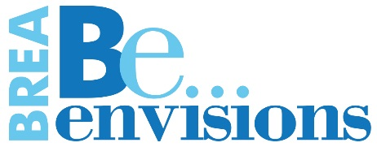
Think Out Loud Thursday
Data
Be…Informed (Management & Administrative Services)
July 28, 2016

: Informed:
Note: The following notes were from the flip charts taken during the discussion. Clarifying text is in italics.
- One group of 10 people
- All comments were listed
Ice Breaker
What do you like most about Brea?
- Small size (“smaller town”)
- Small town benefits: amenities, cultural benefits, theatre, art gallery museums.
- Green hills
- Hiking trails
- Number and quality of parks
- Community Center
- Movies

CUSTOMER SERVICE
Who can share an example of a really great experience that you’ve had? It doesn’t have to be with the City. (Warm-up question)
- Fire Dept. (Station 2) house fire—Participant gave personal example of how caring, compassionate and efficient the crew from Fire Station 2 was during a fire.
- Trash Pick-up (No Hassle)
- Trash Pick-up (Bin/Dump)—This person talked about needing an extra bin and how easy the process was for delivery and pick-up. Also mentioned that the people at the Dump were very nice.
- Street sweeping warning ticket—Newlyweds and new residents appreciated the warning when they unknowingly parked on their street on street sweeping day.
How about a really bad experience? Examples don’t necessarily need to be related to Brea. (Warm up question).
- Police Dept Corsican Village (traffic)—Mentioned additional enforcement needed.
- El Pollo Loco—Bad Service—Consistently bad service on Imperial in the Albertsons’ Center. Long waits, inaccurate orders, complete incompetency.
- Puente/Central-traffic calming (No right turn on red) need enforcement of regulations.
- Not getting quick response time—this was an example of what a bad experience would be regarding waiting too long to get information back to the customer re: any issue/question coming into Brea. This was not a comment about PD response times.
Let’s talk about specifics to the City.

What does good customer service mean to you?
- Live voice (answering the phone)
- Great police response—This comment did not imply that PD’s response time needed improving-- only that it’s an example of good customer service.
- Business License/Planning--friendly
- Personal attention to issues/concerns
- Be honest-treat residents well

What has been your experience when dealing with the City?
- Call from student instead of police officer. This was a comment from a man who said that he had a business in town for many years and had a break-in. After a certain period of time, he received a call from an Explorer (instead of a police detective) to let him know that there wasn’t enough evidence to investigate further. He thought that he deserved the respect of having an officer spend 5 minutes to call him back. (He may have meant a Cadet instead of Explorer.)
- Rude Dispatchers (Listen) (2)—Two people mentioned that they had rude interactions with Brea dispatchers. The first person said that she called to report a homeless person harassing a woman trying to get on a public bus. She said the dispatcher answered her explaining the rights of the homeless. She wondered about the rights of the woman being kept from taking the bus. The second person mentioned that she too had a negative experience with a dispatcher, but didn’t go into details.
- Take a phone number/call back w/answers
- Thorough with answers
- Info. on web w/Dept. information

FISCAL RESPONSIBILITY
We heard in phase I that the city’s financial health is of paramount importance. We heard that being able to fund the quality programs and services (and necessary staffing) that the community has become accustomed to is important. What are your thoughts? (Warm up question).
- Financial stability is important (lots of nodding heads).
What is your impression of Brea’s fiscal health?
- Good--finances providing: Examples of why Brea has good financial health because they can provide:
  - Better roads than other cities
  - Clean streets
  - The Community Center
What does a fiscally responsible city mean to you?
- Transparency
- Pension obligations (want more information)
  - Are services going to decrease? Because of these aging facilities
- Concern over aging facilities
- Water issues The drought
- Overall impression
  - Can regionalization save money? Some talk and discussion about Brea/Fire merger.

UNFUNDED PENSION LIABILITY

What is your understanding of unfunded liability? And what impact do you think it has on the City?
- Sounds like the City is going to run out of money.
- Someone else has to pay for it.
- Long-term paid overtime
- Residents don’t really understand
Do you think people understand this subject?
- Residents don’t really understand
- Residents don’t really know, they trust government to take care of things.
- Not unique to Brea, not a huge worry.
- How will increasing costs for pension impact services or taxes?
TRANSPARENCY
What does it mean it to you?
- City to be willing to be vulnerable. This person was saying that the city has to be vulnerable to be open to communicate all.
- Find info. quickly & easily
- City goals & info readily available
  - (i.e. general plan updates)
- Where the money is going and who is spending it.
- Q&A information sessions like this one
- Decision Process to be available
  - (i.e. Agenda..Closed Session)
How would you rate Brea in its efforts to be transparent?
- Good
- No major problem
What would you like to see Brea doing to be more transparent?
- Majority think it’s not an issue
  - Small group of the community may think an issue. A couple mentioned a few vocal people in town are making a big deal out of this. But said they do not speak for the community.
- The “Average Joes” think we are doing well.
- Want to know about changes as they happen.
  - (i.e. contracts, etc.)
- Contract issues during close session. What are the issues that can be discussed in Closed Session? Want to know why they can be discussed in closed session.
What does Transparency Mean to the City?
- Parking Structure—This was considered a good example of knowing what was going on with this topic.
- Cal Domestic water issue/concern. This issue is a complaint by a person in town about a former City Manager. An editorial in the OC Register had published that day and one couple wanted more information. City Russell, Administrative Services Director stayed after to explain the issue to her.
- Knowing where the money goes.
- Easy to understand graphics (budget)
- Info. in BreaLine
COMMUNICATIONS
Ongoing communication has long been a goal of Brea’s City Councils. We focus on using many ways to keep the community informed about our programs and services. (Refer to the display boards.)
We heard in Phase I that the top ways people want to be informed (about Brea) are:
BreaLine, the City newsletter
The city’s website
Facebook
(Referred to display)

How do you hear about Brea info? How would you prioritize?
- Direct mail
- Like Brea Line (city’s newsletter)
- E-mail blasts
- Website
- Chamber (small %) This person mentioned that she is a member of the Chamber of Commerce and Neighborhood Watch and she could tell people. Although it would be a very small percentage.
- Signs at the Community Center
- Marquee
- Website (phone numbers) This person visits the website to get phone numbers.
- Social Media—so/so
How do you want/expect to hear about something a little more serious or urgent like water rate increases or a change in your trash day?
- Preferred in person. This gentleman said he wants someone to knock on his door like Council candidates do when they want your vote. He knows that’s not reasonable.
- Also talk about such direct mail communication looking more official in an envelope with city logo and return address vs. a more full-color designed piece.
- Others said they’d be more likely to look a colorful eye-catching mailer.
What Other Ways can the City Communicate?
- Neighborhood Watch
- Senior Center
- Avoid mass mailing
- Keep simple and official
- Increase the size of the print
Knowing about all the communication avenues the city employs, why do you think it is that sometimes people will say they didn’t know about something?
- People are busy. This person said that people are busy with their lives—work, kids and their activities, home responsibilities, etc. They don’t pay attention on a regular basis. Just when something happens.

Note: Since the location was outdoor on the Plaza. There were Pokémon “trainers” in the vicinity. The City had actually bought lures to attract them. A staff member took the opportunity to engage the players.

What does transparency in government mean to you?
- Big government
- Public and online
- Everyone’s salary posted
- Record of all meeting
- Audio and written
- Who gives money to campaigns

Think Out Loud
National Night out Data
August 2, 2016

: Be Creative
What Type of Cultural Art Experiences Does Brea Need?
- Yoga in Downtown and/or in Park
- Art Museum
- Pottery
- More Dancing
- Water Stencils on Sidewalks
- Wine and Paint
- More Kids Cooking Classes
- Chalk Art/Festival
- Brand New Library
- Poetry/Spoken Word
- Bigger Community Center with Indoor Pool
- Year Round Swim Classes and Water Aerobics
- Oil Painting Classes
- Singing Classes
- Art Shows
- Art Classes for ages 8 and up
- Soccer Fest for the 4th of July
- Festivals
- Community Garden
- Kids Art Show
- History of Brea
- More Poke Stops and Gyms

: Be Active
What type of Recreation Programs Should Brea Have?

- Community Cleanup
- More Shade at Parks
- Dog Park *
- CPR/First Aid Classes *
- Splash Pad *
- Pet Zoo
- Community Garden *
- Country Club
- More EV Car Chargers
- Outdoor Yoga
- Christian Club for Kids
- Race Track
- Hip Hop Dance Classes
- Over 40 Basketball League
- Mosaic Art
- Toddler Meet Up
- Tap Classes for 3-5 year old boys
- Folk Dance Lessons
- Table Tennis
- More places to swim *
- Swimming Lessons
- Pre-School Sports
- Movies in the Park
- Mechanic classes
- Amusement Rides
- Sports *
- Special Olympics
- Fooze Ball
- Green House
- Bring Back the Jazz Concerts
- Chess Classes
- Yoga for Kids
- Spanish/Foreign Language Classes
- Seesaws at the Playground
- Concert in the Park/Community Night/BBQ & Games
- English Classes
- I want to see more Poke Ball
- Ice Skating *
- More Cleaning of the Community
- More Soccer and Volleyball
- More Dance & Cooking Classes
- Mommy Communication Board with Various Locations
- Swim Team
- Mario Art
- Classical Singing
- Toddler Marathon
- Water Park
- School Health Education
- Basketball
- Kids Interaction
- I want to see dogs
- Father/Daughter/Son Dance
- Indoor Swimming Pool at Community Center
- Lego Robot Classes
- Video Game Contest
- Fixing Cars
- Tutoring Program

*Denotes more than one response

Think Out Loud Thursday Summary
Be… Active & Creative (Community Services)
August 4, 2016

Six residents attended Community Services’ Think Out Loud Thursday Session on Thursday, August 4, 2016. In a fun, creative, educational and “high touch” manner, all attendees validated and provided additional input for the Be Active and Be Creative trends identified in Phase I. None of the attendees disagreed with the trends.

Validation of Phase I Trends:

Active: | Creative:
Continue offering affordable community services. | Events and festivals were identified as cultural arts opportunities and experiences.
Continue providing opportunities for residents to grow in all aspects of their lives by offering recreational programs at various public facilities. | Brea is identified as a destination for the arts, culture and entertainment, with programs and events being an integral part of that vision.
Public spaces such as parks, trails and facilities emerged as recreational priorities. | Brea should be known as the city of arts, with performing arts programs sponsored or supported by the City.
Desire for increased outdoor activities.
Other priorities included youth programs, fitness/wellness programs, recreational facilities and active senior programs.

After the Phase I trends were validated, attendees were engaged by City staff with supporting program education. Thereafter, the following questions were asked of attendees, producing several responses that expanded upon some of the Phase I trends:

Active:
What traditional or innovative recreation programs would you like to see in Brea?
- Adult kickball
- Pickle ball courts
- Mother/Son Dance
- Childcare for date nights
What do you want improved/added to City parks and trails?
- Paddle tennis courts
- Splash pad/water feature (mentioned 3x)
- Outdoor fitness equipment
- Synthetic turf fields
- More bike lanes/paths
- Enhanced/Innovative playground equipment
- Tennis courts
- Water stations/shady rest areas
What do you want improved/added to City recreational facilities (e.g. Senior Center, Community Center, etc.)?
- Larger or additional community center
- Larger Brea Fitness Center
- Pool at the Community Center
- New library
- Racquetball courts – play wallyball (volleyball played in a racquetball court where it is legal to hit the ball off the walls)
- Recreational/Active space between the Senior Center and Pioneer Hall
What additional youth programs would you like to see in Brea?
- Youth programs during times convenient for working parents
- Training and education for hiking safely in natural lands
What additional fitness/wellness programs would you like to see in Brea?
- Pool at the Community Center
- Dance on the Plaza
- Outdoor yoga
- Tai chi in the evening
What additional active senior programs would you like to see in Brea?
- Active senior amenities in parks
- Pickle ball
- More senior field trips/excursions
- Senior/Youth interaction (dances, etc.)
Creative:
Where in Brea do you want to gather for cultural arts events?
- Parks, trails, Civic Center and Community Center
- Arovista Park Amphitheatre for Shakespeare in the Park
- Civic & Cultural Center
- Near Art in Public Places (APP) pieces
- In our new library (assuming we get one?)
- Carbon Canyon Park
- Any place outdoors
- Brea Olinda High School
- Downtown Brea
- Civic Center
What types of cultural arts events and festivals would you like to see?
- Plays in the park (Tustin does this
- Art walks (mentioned twice) downtown, along the Tracks or at City Hall
- Comedy/Improv festivals
- Parade in conjunction with July 4th – historical & current military themed
- Outdoor music concerts
- Outdoor plays
What types of art classes would you like to see in the Brea Art Gallery?
- Pottery & mosaics
- Printmaking
- Lettering & calligraphy
- Glass blowing
- Sewing
What types of live shows would you like to see in the Curtis Theatre?
- Concerts
- Musicals & Traditional musical productions (separate)
- Performances for schools
- Dance (performances – mentioned 3x)
- Movies
- Gatherings on the Civic Plaza
- Improv comedy shows
- Sing a longs & movie sing a longs (separate)
- A hootenanny (informal gathering with folk music and sometimes dancing)
- Updated and enhanced Curtis Theatre – seats, carpeting, stage and curtains with a restaurant tie-in
How can the City enhance the Art in Public Places (APP) Program?
- Transportation to see art pieces
- Art tours (mentioned 2x) – to help promote the program
- History of art collection
- Use of hand-held devices to provide info on art piece
- Self-guided iPhone/Android app.
- Find new ways to tell the artist’s vision/story for the APP art pieces
- Provide self or guided tours

Think Out Loud Thursday
with Open House
Data
Be… Active & Creative (Community Services)
August 4 & 25, 2016

Active:
What traditional or innovative recreation programs would you like to see in Brea?
- Adult kickball
- Pickle ball courts
- Mother/Son Dance
- Childcare for date nights
- More festivals (mentioned 2x)
- More family activities (mentioned 2x)
What do you want improved/added to City parks and trails?
- Paddle tennis courts
- Splash pad/water feature (mentioned 3x)
- Outdoor fitness equipment
- Synthetic turf fields
- More bike lanes/paths
- Enhanced/Innovative playground equipment
- Tennis courts
- Water stations/shady rest areas
- Clean it up (the Brea Community Center)!!!
- Public facilities elsewhere in town (more balance)
- Brea needs a bowling alley!
What do you want improved/added to City recreational facilities (e.g. Senior Center, Community Center, etc.)?
- Larger or additional community center
- Larger Brea Fitness Center
- Pool at the Community Center
- New library
- Racquetball courts – play wallyball (volleyball played in a racquetball court where it is legal to hit the ball off the walls)
- Recreational/Active space between the Senior Center and Pioneer Hall
- Paddle tennis courts
- Larger, more updated parks
- Fitness equipment along the trail like elliptical/stationary bike
- Rubber/Foam ground at parks
- Completion of Tracks
- More “homey”
- Tennis courts
- More bike lanes
- More shade trees!
- Educational “facts” on trails
- Finish bike paths sooner
What additional youth programs would you like to see in Brea?
- Youth programs during times convenient for working parents
- Training and education for hiking safely in natural lands
What additional fitness/wellness programs would you like to see in Brea?
- Pool at the Community Center
- Dance on the Plaza
- Outdoor yoga
- Tai chi in the evening
- Bigger gym in the Brea Community Center
- Hiking groups, both urban and in the hills
- Fitness classes for kids
- More education on natural health alt.
- Lap swimming
- Bigger Community Center
- Nutrition – All ages
- Rehab for stroke victims
- Consistent fitness class schedule (i.e. MWF, 4:30)
What additional active senior programs would you like to see in Brea?
- Active senior amenities in parks
- Pickle ball
- More senior field trips/excursions (mentioned 2x)
- Senior/Youth interaction (dances, etc.)
- Easy walking for seniors (benches/shade)
Creative:
Where in Brea do you want to gather for cultural arts events?
- Parks, trails, Civic Center and Community Center
- Arovista Park Amphitheatre for Shakespeare in the Park
- Civic & Cultural Center (mentioned 2x)
- Near Art in Public Places (APP) pieces
- In our new library (assuming we get one?)
- Carbon Canyon Park
- Any place outdoors
- Brea Olinda High School
- Downtown Brea
- Civic Center
- Arovista Park
- Community Center
What types of cultural arts events and festivals would you like to see?
- Plays in the park (Tustin does this
- Art walks (mentioned 2x) downtown, along the Tracks or at City Hall
- Comedy/Improv festivals
- Parade in conjunction with July 4th – historical & current military themed
- Outdoor music concerts
- Outdoor plays
- Learn to dance
- Sidewalk art festival (Temecula)
- More affordable events
- International food fair
- Beer and wine festival
- More outdoor concerts, festivals, fairs and affordable events
What types of art classes would you like to see in the Brea Art Gallery?
- Pottery & mosaics
- Printmaking
- Lettering & calligraphy
- Glass blowing
- Sewing
- Watercolor class
- Senior friendly art classes – short, easy for old hands
- 3D art
- Art classes for young adults
What types of live shows would you like to see in the Curtis Theatre?
- Concerts
- Musicals (mentioned 2x) & Traditional musical productions (separate)
- Performances for schools
- Dance (performances – mentioned 3x)
- Movies
- Gatherings on the Civic Plaza
- Improv comedy shows
- Sing a longs & movie sing a longs (separate)
- A hootenanny (informal gathering with folk music and sometimes dancing)
- Updated and enhanced Curtis Theatre – seats, carpeting, stage and curtains with a restaurant tie-in
- Choral groups; more singing in general
- An international food party
How can the City enhance the Art in Public Places (APP) Program?
- Transportation to see art pieces (mentioned 2x)
- Art tours (mentioned 2x) – to help promote the program
- History of art collection
- Use of hand-held devices to provide info on art piece
- Self-guided iPhone/Android app.
- Find new ways to tell the artist’s vision/story for the APP art pieces
- Provide self or guided tours
- APP bike tours
- Stop the (APP) thefts!!
- Move the ugly bathroom tile sculpture from the corner of Kraemer & Lambert. UGLY – Doesn’t fit with anything Brea.

Be…Sustainable
Public Works
Think Out Thursday & Open House Data
August 11, 2016 (Sports Park) & August 25, 2016 (City Hall, Plaza Level)
: Sustainable
How do we keep Brea sustainable?
- Reduce outdoor water use
- Use drought tolerant plants
- Plant materials
- Develop w/in limits to sustain
- More shade & benches
- Teach sustainability course to Brea students
- Enforce conversation
- Build appropriately – no hillside development
- Give break on water bill
- Lower water rates
- Enforce conservation
- More shade and benches on walking trails

: Streets, Parks, Facilities & Public Areas
Why is Brea a clean and maintained City?

- People more aware
- More trash cans around
- Improve private property, maintenance
- No graffiti
- No loitering
- No trash
- Parks clean
- Neighbors help
- Great staff who care
- Regular street cleaning
- LED lights on stop signs & floor reflectors on crosswalks

What areas in Brea need more attention?
- Around city pool
- Older parts of city
- Improve Private Property Maintenance
- Bicycles for public use like Los Angeles, especially for high school students who don’t have other means of transportation to/from school
- More bicycle lanes
- More drought tolerant landscaping for water savings
- Slurry seal more often- streets showing wear & tear
- Cement the hill under the 57 Fwy and Birch to prevent erosion
Think Out Loud Thursday with Open House Data
Be…a Placemaker
Community Development
August 11, 2016 (Sports Park) & August 25, 2016 (City Hall, Plaza Level)

: Economic & Business Development:
What businesses do you visit outside of Brea?
- Wahoo’s
- Vegan, vegetarian restaurants
- H20 stores
- Specialty food stores
- Stack It
- The Packing House (4x)
- Bowling Alley, Dave & Busters, Family entertainment uses
- Hobby Lobby (2x)
- Walgreens
- In-n-out (2x)
- Costco (10x)
- Ethnic restaurants
- One of the better malls around, close to freeway, inexpensive shops – Brea is expensive
- Amazon style distribution warehouse
- New manufacturing distribution centers
- I hardly leave Brea
- City library

What does small & local business mean to you?
- Not chain business
- Like the little boutique shops in Downtown
- Boutique/antique stores
- Mom pop shops and restaurants (e.g. Heroe’s Restaurant
- They would like more police presence at schools
- I don’t know, independent businesses
- Mom & pop stores, small businesses

: Housing & Development:
What does affordable housing mean to you? Who is it for?

- Slow down on building pace
- Dense housing
- Not paying 50% of income on housing
- Single parents
- Everyone
- Retired workers, seniors, disabled persons
- Start-up/young families
- More housing options
- Affordable construction materials
- Government B.S.
- When you made the house/apartment, I wish you add Styrofoam on the walls and floors. It reduces the noises from outside. Styrofoam is not expensive but useful.
- We want cheap house/apartment. We don’t want fancy houses to live in. We want to have fun with our family.

What makes Brea feel like a small town?
- The people
- Neighbors
- Long property ownership
- Lots of youth programs
- One high school, one jr high school
- Safe & quiet neighborhood
- The streets “ you recognize when you’ve left Brea”

Be Active & Be Creative
Community Services
Brea Fest Data
August 19, 2016

: Active
What Youth Programs do you want to see in Brea?
- Roller Skating Rink *
- Self Defense Classes
- Reading and Writing Programs
- Cooking Classes *
- Fishing Run/Baseball
- Pedestrian Zone
- STEM Programs
- Community Basketball
- Sports Classes that are reasonably priced
- Community Garden *
- Intro to Music Class
- A New Skate Park *
- Water Bottle Filling Stations at Community Center
- Drinking Fountains on Trails
- More Lights on Trails
- Volleyball Courts *
- Lego Store
- Clean Up Club
- Puppy Days at City Hall *
- Create a List of Art Work throughout the City
- LA Fitness
- More Books for the Library
- More Rare Pokeman
- First Tee
- More Activities in the Library
- The Melting Pot
- Less Classical Music
- Singing
- Walking
- Housing Programs
- Brea Fest
- Keep Aqua Aerobics Year Round ~ Go Stacy, Best Instructor

: Creative
What types of Cultural Events and festivals would you like to see in Brea?

- 4th of July Parade
- Battle of the Bands *
- Japanese Summer Festival
- Organic Food Fests
- Cultural Food Festival
- Chinese New Year Event
- Asian Food Festival
- Muted Shock Program
- Family Fun Events
- Plunge Open Year Round
- Brea Fest
- Puppy Days
- Costco/Lowes
- More Movie Nights
- Old Tower Records:
- Dave & Busters
- Jamba Juice
- Local Bands
- Keep Old Navy
- More Starbucks
- Soccer Fest for 4yh of July

*Denotes more than one response

Think Out Loud Thursday
with Open House
Data
Be…Informed (Management & Administrative Services)
August 25, 2016

: Informed:
What is your primary source of information about the City of Brea?
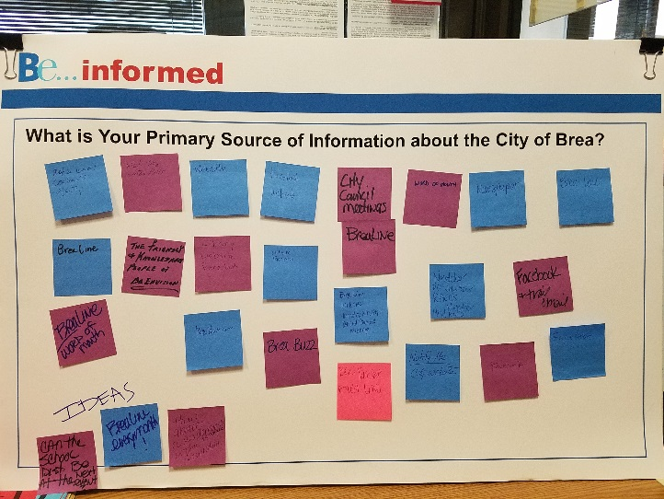
- Media email contacts with City
- Website, water bills
- Website
- Facebook, website
- City Council meetings
- BreaLine
- Word of mouth
- Newspaper
- BreaLine
- BreaLine
- The friendly & knowledgeable people of Be [sic] Envision
- Library, website, Facebook
- Website, Facebook
- BreaLine, Website,Word of Mouth, attend Council meetings
- NextDoor, PD Volunteer, RACES member, Hand radio
- Facebook, trail email
- BreaLine, word of mouth
- NextDoor.com
- Brea Buzz
- BCC Facebook
- BreaLine
- Notify Me, City website
- Facebook
IDEAS
- Can the school district be at the next event?
- BreaLine everyone month
- How about a readerboard or marquee in the downtown
Do you visit the City’s website? If so, what information do you expect to find?
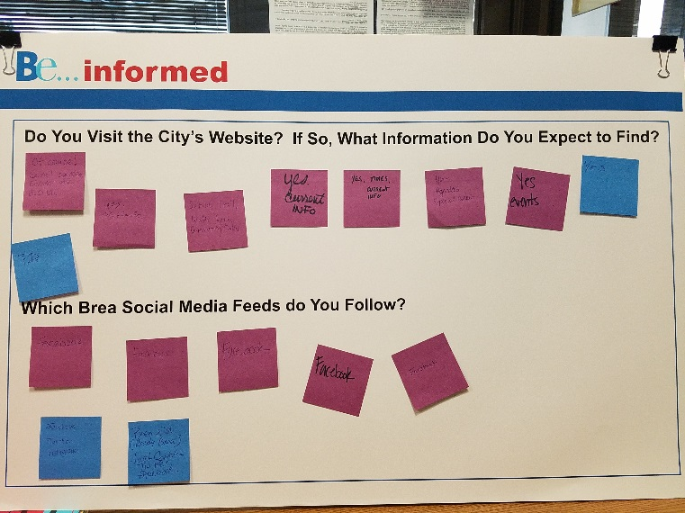
- Of course! Council agendas, Envision info, H₂O
- Yes. City info
- Senior, trail, water info, community center
- Yes. Current info
- Yes. Times, current info
- Yes. Agendas, special events
- Yes. Events
- Yes.
- P.D.
Which Brea social media feeds do you follow?
- Facebook
- Facebook
- Facebook
- Facebook
- Facebook
- Facebook, Twitter, Instagram
- Brea EM (Ready Brea), Jack Conklin Twitter, Facebook

City Clerk’s Office
What does ‘Transparency’ mean to you?
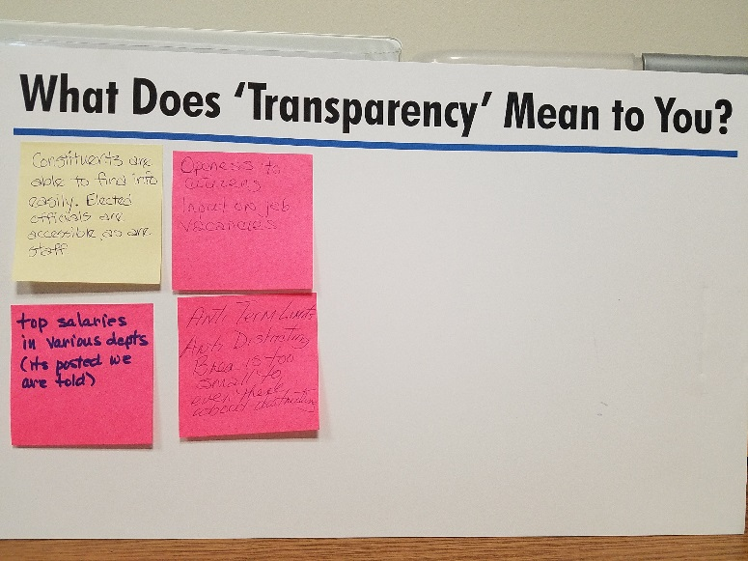
- Constituents are able to find info easily. Elected officials are accessible, as are staff.
- Openess to citizens. Input on job vacancies.
- Top salaries in various depts. (its posted we are told)
- Anti term limits. Anti districting. Brea is too small to even think about districting.

Administrative Services
[Note: The following notes were from the flip charts taken during the discussion. (See photos) Clarifying text is in italics. ]

UNFUNDED PENSION LIABILITY FLOW CHART
Q: Do you know what unfunded pension liability is? Yes OR No. If Yes, what is your understanding of unfunded pension liability?
- NO: Three (3)
- YES: Six (6)
  - How many they city owes to cover pension costs.
  - Brea’s pensions are not funded at a reasonable level – 85 to 100%
  - It’s the amount the City is responsible for future employee pensions to be paid over time
  - How much the City owe’s if everyone were lay off tomorrow or quit
  - Commitments City has made to employees in relation to retirement
  - Need to lobby California to be able to get out of CalPERS
Q: Is this an important issue for you? Yes OR No. If YES, how much (high, medium, low)?
- NO: One (1)
- YES: Eleven (11)

Category Vote
High Five (5)
High/Medium One (1)
Medium Two (2)
Medium/Low Two (2)
Low Zero (0)
Other General Comments:
- Received comments that there needs to be more education
- Couple requested that police and fire department phone number be on website home page
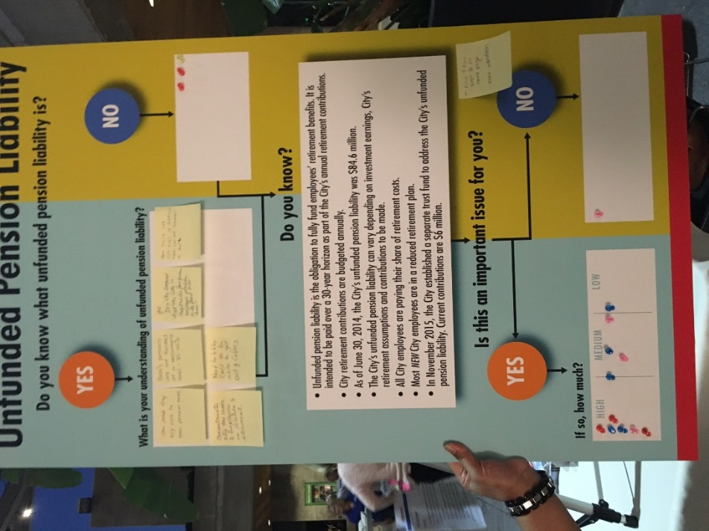

Think Out Loud Thursday
with Open House
Data
Be… (Planning Department)
August 25, 2016

: Economic & Business Development:
What businesses do you visit outside of Brea?
- Wahoo’s
- Vegan, vegetarian restaurants
- H20 stores
- Specialty food stores
- Stack It
- The Packing House (2x)
- Bowling Alley
- Dave & Busters
- Family entertainment uses
- Hobby Lobby (2x)
- Walgreens
- In-n-out’
- Costco (5x)
- Ethnic restaurants
- Better malls with freeway access

What does small & local business mean to you?
- Not chain business
- Boutique shops ‘
- Mom pop shops and restaurants
- They would like more police presence at schools

: Housing & Development:
What does affordable housing mean to you? Who is it for?

- Slow down on building pace
- Dense housing
- Not paying 50% of income on housing
- Single parents
- Everyone
- Retired workers, seniors, disabled persons
- Start-up/young families
- More housing options
- Affordable construction materials

What makes Brea feel like a small town?
- The people
- Neighbors
- Long property ownership
- Lots of youth programs
- One high school, one jr high school
- Safe & quiet neighborhood
- The streets “ you recognize when you’ve left Brea”

Think Out Loud Thursday
with Open House
Data
Be… Safe (Police Department)
August 25, 2016

Safe:
PD/Fire only Thursday:
- Traffic continues to be one of the most mentioned concerns, particularly red light violations
- Many of the traffic concerns with this group were in the Northwest area of town
- Concerns regarding increase in the amount of Homeless persons
- Opinion has been that the PD is doing a good job in communicating with the public through social media and traditional means. There was a particular mention of wanting more PD communication on Next-door
- The group felt the Emergency Preparedness Coordinator position is very important and they are concerned for the future of CERT once Anna Cave retires
- They would like to see more effort from the city in helping people prepare for disasters
- They like seeing officers/uniforms at events like Concerts in the Park
- There was one concern about dispatchers being “rude” on the phone

All hands on deck Thursday:
- More comments about the value of having police on school campuses, DARE program etc.
- Perception is that most people committing crime in Brea come from other cities
- Neighbors can have a big impact on crime…there needs to be more Neighborhood Watch groups
- Response by PD and city to clean graffiti is very good
- PD should pursue creation of a mobile APP and look into the use of Nixil (Social Media platform)
- There were a number of positive comments about our Facebook page
- Homelessness is a problem in Brea but “it is everywhere” – quite often the feedback we receive sounds like “get them out of here”…..I would say most of the homelessness feedback carries a very strict tone
- Continuing concerns about traffic, congestion, speed violations, and red light violation
- They would like more police presence at schools

Think Out Loud Thursday
with Open House
Data
Be… (Public Works)
August 25, 2016

: Sustainable
How do we keep Brea sustainable?
- Reduce outdoor water use
- Use drought tolerant plants
- Plant materials
- Develop w/in limits to sustain
- More shade & benches
- Teach sustainability course to Brea students
- Enforce conversation
- Build appropriately – no hillside development

: Streets, Parks, Facilities & Public Areas
Why is Brea a clean and maintained City?

- People more aware
- More trash cans around
- Improve private property, maintenance
- No graffiti
- No loitering
- No trash
- Parks clean
- Neighbors help
- Great staff who care
- Regular street cleaning
- LED lights on stop signs & floor reflectors on crosswalks

What areas in Brea need more attention?

- Around city pool
- Older parts of city
- Bicycles for public use like Los Angeles, especially for high school students who don’t have other means of transportation to/from school
- More bicycle lanes
- More drought tolerant landscaping for water savings
- Slurry seal more often- streets showing wear & tear

Think Out Loud
National Night out Data
October 14, 2016

: Be Active
What active senior programs would you like to see in Brea?

- Morning & Evening Walking Groups
- Hearing aid assistance – batteries, etc.
- Senior handyman services/referrals
- Brea already offers great senior programs
- More Zumba programs
- Senior ballroom dancing
- One day trips
- Remove speed bumps on Puente
- Senior Yoga
- Computer electronic classes (smart phones too!)
- Affordable day trips
- Level 1-2 yoga at the Senior Center

