Technical Communications Fact Sheet

Chair: Rajesh Sharma, PhD Student, ETH Zurich/Disney Research Studios, Switzerland

Program Schedule: Tuesday, 12 December – Friday, 15 December
Fast Facts

- The Technical Communications program serves as a hub for sharing ongoing innovative projects. Experts from academia and industry present fresh ideas from diverse fields, including graphics, AI, and more. These communications combine concise written documents with interactive oral presentations, fostering engaging discussions with international experts.

- This year’s program will include 29 Technical Communications, which will be presented in different themed technical sessions alongside related Technical Papers.

- There were 60+ valid submissions in total, which received more than 150 reviews from international experts. The selection committee chose 29 for inclusion in this year’s program.

Quote from Rajesh Sharma, Ph.D. Student, ETH Zurich/Disney Research Studios, Switzerland, SIGGRAPH Asia 2023 Technical Communications Chair:
“This year, we have increased the time that presenters have to talk about their work! The Technical Communications like in 2022, is interleaved with the Technical Papers program. This will make it easier for attendees to experience related content in the same location.”
SIGGRAPH Asia 2023 Technical Communications Program Highlights
- Title : Focus Range: Production Ray Tracing of Depth of Field
Contributors : Edoardo Alberto Dominici, Emanuel Schrade, Basile Fraboni,
Luke Emrose, Curtis Black

Description : Defocus blur adds realism to computer generated images by
modelling the restricted focus range of physical camera lenses.
The Focus Range model, described in this Technical Communication, extends the focus distance to a range. This allows artists to keep characters fully in focus and independently define the out-of-focus blur.


- Title : Combining Resampled Importance and Projected Solid
Angle Samplings for Many Area Light Rendering

Contributors : Ishaan Shah, Aakash K.T, P. J. Narayanan
Description : Direct lighting from many area light sources is challenging due
to variance from both choosing an important light and then a
point on it. Resampled Importance Sampling (RIS) can achieve low variance in such situations, however, it is limited to simple sampling strategies for its candidates. Specifically for area lights, the authors show that convergence can be improved by using their sampling strategy.
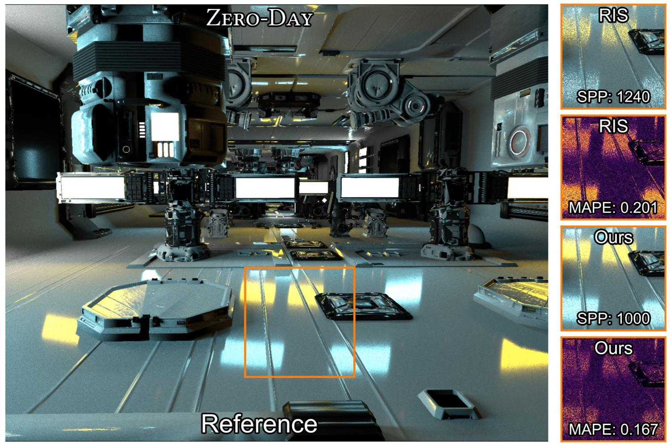

- Title : MicroGlam: Microscopic Skin Image Dataset with
Cosmetics

Contributors : Toby Chong, Alina Chadwick, I-Chao Shen, Haoran Xie, Takeo
Igarashi
Description : In this Technical Communication, the authors present a
cosmetic-specific skin image dataset. It consists of skin images from 45 patches (5 skin patches each from 9 participants) of size 8mm*8mm under three cosmetic products (i.e. foundation, blusher, and highlighter). They also described the novel capturing device they designed.
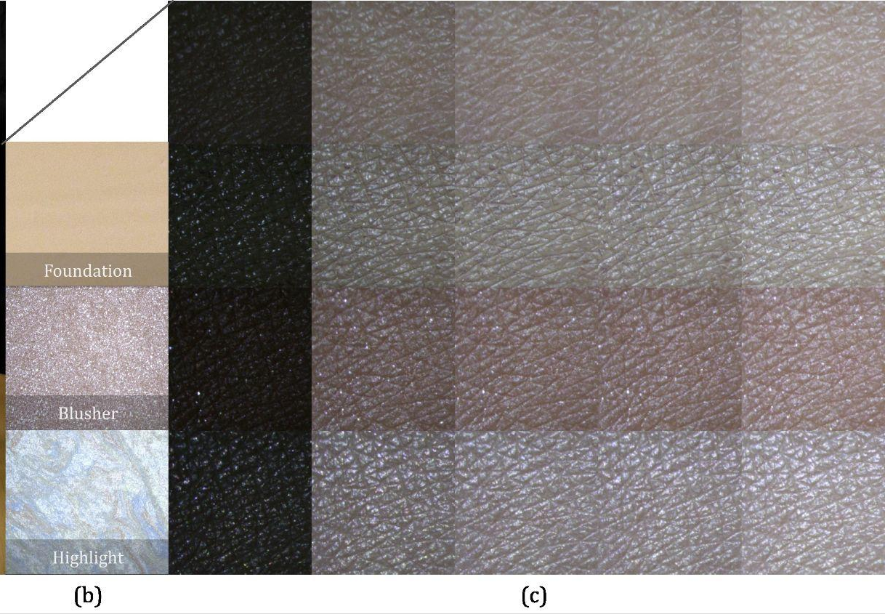

For full information about this year’s Technical Communications program, please visit https://asia.siggraph.org/2023/attend/technical-communications/

For the overall SIGGRAPH Asia 2023 program schedule, please visit https://asia.siggraph.org/2023/full-program

