Posters Fact Sheet

Chair: Rajesh Sharma PhD Student, ETH Zurich/Disney Research Studios
Switzerland

Program Schedule: Wednesday, 13 December – Friday, 15 December
Fast Facts

- The Posters program offers an interactive platform for sharing innovative ideas, including early-stage concepts, practical contributions, insights into new commercial and artistic endeavours, and problem-solving solutions.

- This collaborative environment welcomes students, researchers, artists, enthusiasts, and industry professionals to present their research, art, and ideas to the global computer graphics (CG) industry.

- The presentations take the form of visually appealing posters displayed at SIGGRAPH Asia, with authors on hand to elaborate on their findings, engage in discussions, seek feedback, and network with fellow attendees.

- This year, we received 131 completed submissions to the posters program, out of which our reviewers selected 44 to be featured at the conference.

Quote from Rajesh Sharma, PhD Student, ETH Zurich/Disney Research Studios
Switzerland, SIGGRAPH Asia 2023 Posters Chair:
“The SIGGRAPH Asia Posters program is a fantastic interactive forum for innovative ideas, high-impact practical contributions, behind-the-scenes views of new technical and artistic work, and solutions that help solve challenging problems. It is also a great venue to meet with the authors and learn first-hand about their process and techniques.”
SIGGRAPH Asia 2023 Posters Program Highlights
- Title : Efficient and Accurate Physically-Based Rendering of
Periodic Multilayer Structures with Iridescence

Contributors : Yoshiki Kaminaka, Toru Higaki, Bisser Raytchev, Kazufumi
Kaneda

Description : A method for rendering iridescence caused by periodic
multilayer structures by employing Huxley's approach.
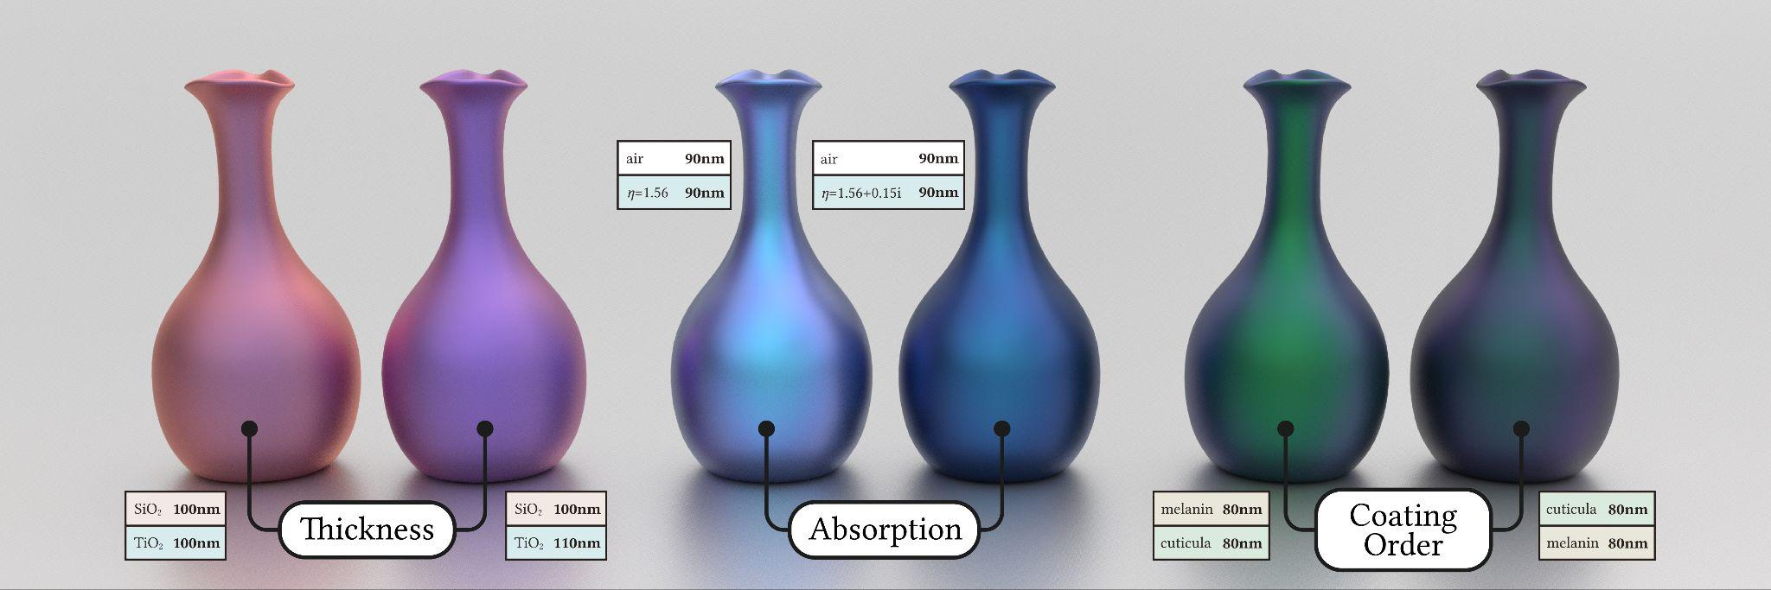
- Title : Room to Room Mapping: Seamlessly Connecting Different
Rooms

Contributors : Naoki Hashimoto, Yuki Inada

Description : A projection mapping technique designed to connect rooms in
disparate locations virtually, creating a continuous, immersive
space.
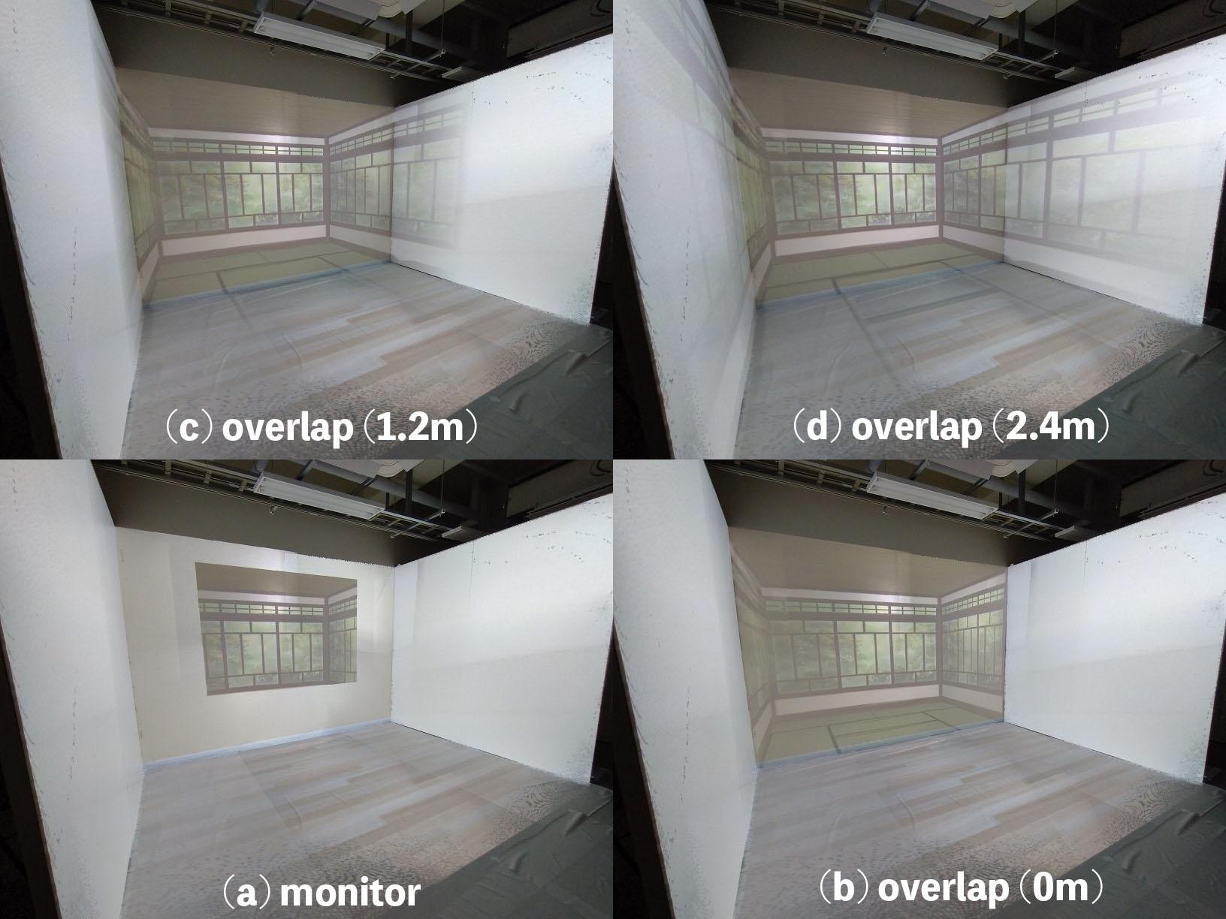

- Title : Learning to Generate Wire Sculpture Art from 3D Models
Contributors : HuiGuang Huang, Dong-Yi Wu, Hanh Le, Po-Chih Chen,
Shih-Syun Lin, Tong-Yee Lee

Description : Create a 3D wire sculpture that preserves the volume of
the original 3D shape given a user-specified template to the proposed curve generation network
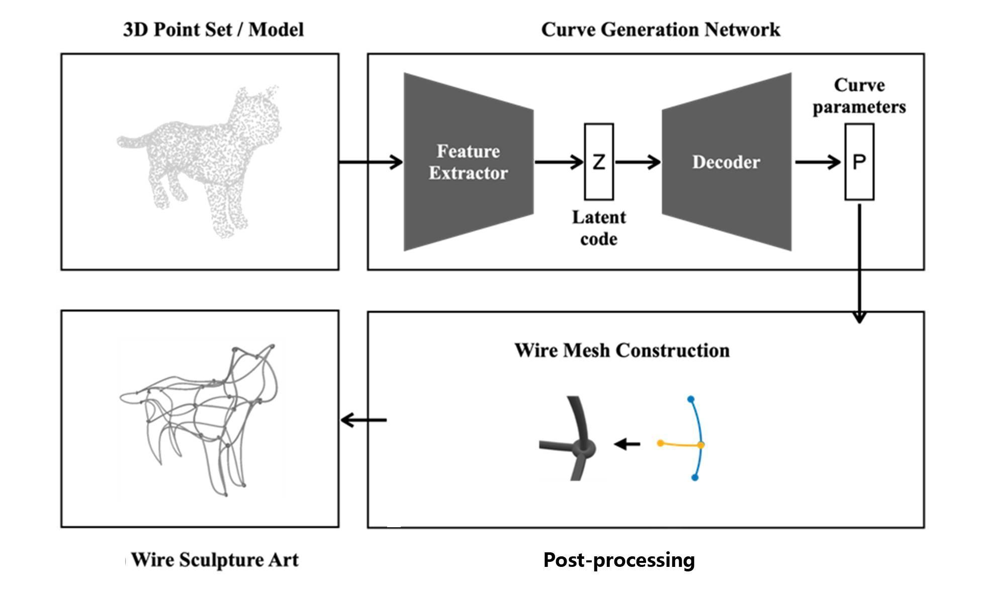

For full information about this year’s Posters program, please visit https://asia.siggraph.org/2023/attend/posters/

For the overall SIGGRAPH Asia 2023 program schedule, please visit https://asia.siggraph.org/2023/full-program/

