Đề bài: Compare the town of Brindell and local areas in 1800, 1900 and 2000​
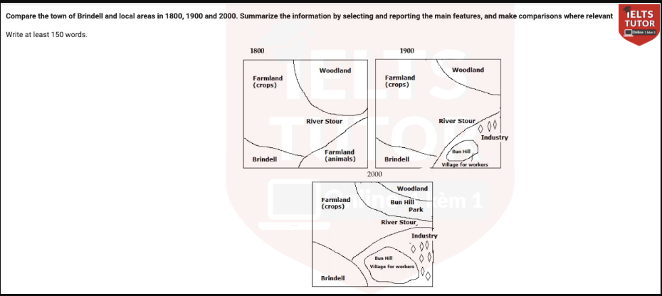
Body 1: 1800 and 1900
- 1800: area with vast expanses of farmlands, woodland to northern corner and brindell to southeast
- 1900: = north farmland = industries and residential areas for workers > < south farmland = expand to encroach former woodland
Body 2: significant changes
- Amongst them were expansion of industries and workers’ residence + brindell
- Newly constructed bun hill park located near the river stour
- => farmland = diminished due to such developments.

Cách làm dạng Map : https://www.ieltstutor.me/blog/map
Given are the maps illustrating the town of Brindell and surrounding sites through three separate stages, initiating from 1800.

Overall, whilst the town increased in size after two centuries, its local areas were significantly industrialized, leading to the use of former tracts of land. → Overall ổn nhé

In 1800, Brindell was a relatively minuscule area compared to its surroundings. There were vast expanses of farmland around the map as well as a sizeable area of woodland to the northeast and the river Stour to the center. The next 100 years witnessed the construction of industries and residential areas for workers in the southern farmland, whereas, to the north, woodland was diminished to make way for crop cultivation. → Với phần miêu tả này, thì mình có thể nhấn mạnh các phần thay đổi, rồi vẫn sẽ miêu tả các nội dung giữ nguyên nhé
VD:
. In addition, the rest of the area remained unchanged

The map underwent drastic alterations in the year 2000, with the expansion of industrial sites as well as Bridell being the most notable. Additionally, a newly-built Bun Hill Park was also erected in the northern corner next to the site’s woodland, and the spaces reserved for farming were also reduced to pave the way for the abovementioned developments. Notably, River Stour remained unchanged throughout the period. ⇒ Bài triển khai của mình ổn nhé.
  - Overall:
    - Brindell evolved from being primarily an agricultural-based town into an area with diverse functions and purposes.
  - Body 1: Viết về map 1
    - In 1800, the district was significantly divided by the presence of the River Stour, which was prominently situated in the center of the layout.
    - Brindell occupied the southwestern end of the river, with two distinct agricultural zones nearby – one to the north designated for crop cultivation and another to the east reserved for animal grazing.
    - In the northeastern part of the river, there was a wooded area.>> IELTS TUTOR hướng dẫn PHÂN TÍCH ĐỀ THI 30/5/2020 IELTS WRITING TASK 2 (kèm bài sửa HS đạt 6.5)
  - Body 2: Viết về map 2
    - By 1900, significant changes had occurred in the district, with the entire grazing area undergoing a notable transformation.
    - The upper portion of the grazing land was replaced with an industrial zone, and in the lower part, a village known as Bun Hill was established to accommodate workers.
  - Body 3: Viết về map 3
    - Fast forward to 2000, Brindell had expanded and nearly doubled in size. >> IELTS TUTOR có hướng dẫn kĩ SỬA BÀI IELTS WRITING TASK 2 ĐỀ THI THẬT NGÀY 22/8/2020 của HS IELTS TUTOR đạt 6.5 Writing
    - The farmland designated for crop cultivation had decreased in size as a result of the establishment of Bun Hill Park, and concurrently, Bun Hill had expanded, accompanied by the emergence of numerous new industries to the east of the village.

Bài mẫu

Dàn bài lần 2

Bài viết lần 2

Dàn bài lần 3

Bài viết lần 3

Dàn bài lần 4

Bài viết lần 4

