Gluten Free Dairy Free Chocolate Coconut Bars
by Raquel DeHoyos, comfortandheal.com, January 2020

Ingredients

1 ½ cup gluten free whole rolled oats
½ cup sweetened, shredded coconut
½ cup flax meal from ground flax seeds
¼ cup coconut oil
¼ cup honey
½ cup unsweetened, unsalted sunflower butter
¼ cup mini vegan chocolate chips, such as Enjoy Life brand
Makes 16 bars

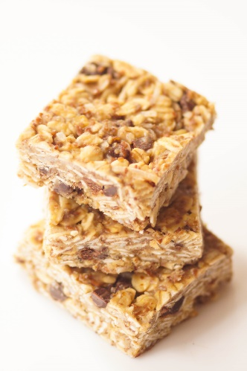

Instructions
In a microwave safe bowl, add coconut oil, honey and sunflower butter. Place in the microwave and melt for 30 seconds, stir, set aside and allow to cool.
In a large bowl, mix oats, shredded coconut and flax meal. Pour in sunflower mixture and combine. Press into a parchment lined 8x8 baking pan. Place in the refrigerator to set up for 1 hour. Remove from pan and slice into bars.
To store, keep in the refrigerator in an airtight container for up to 5 days.
Health Notes
Flax is a marvelous food that has many health benefits. It comes in seed, oil and ground meal varieties and can be used in numerous ways from toppings, to baked goods, to smoothies. It's highly regarded for being a good source of fiber and Omega-3 fatty acids which is a good fat that your body cannot naturally manufacture.
It's also great for those trying to supplement a plant-based diet or who may not want to load up on fish oil to get the same nutrients. Two tablespoons of ground flax meal has only 70 calories, 3 grams of protein and fiber, and 2 g of Omega-3's. If you've never tried it before, like all new ingredients, start with the recommended serving or half until your body and digestive system adjusts.
Flax is also a great substitute for those with egg allergies. Use 1 tablespoon of ground flax meal mixed with 3 tablespoons warm water and allow to stand for 5 minutes. The mixture will develop a viscosity like eggs and can be used in place of one whole egg in baking recipes. Because it contains oils, it's best to store flax in a cool, dry or refrigerated place. If you're looking for one simple way to add something healthy to your diet, flax is a great place to start.
Recipe Adapted From Real Food Whole Life

