

CME Evaluation for Physicians and Advanced Practice Providers
Youth Vaping and Tobacco Use: Screening, Counseling, Treatment, and Billing

Activity Code: YVT26

Use the link or QR code below to complete the CME evaluation on your smartphone, PC, I-pad, or other electronic device. Be sure to enter the above activity code to receive proper credit.

CME Activity Evaluation - 2026 – Fill out form

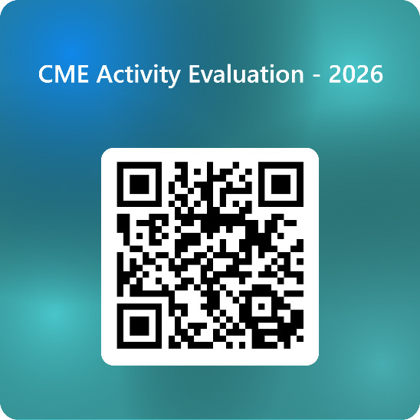

This evaluation must be submitted within 2 weeks of course completion to receive CME credit.
Please direct all CME reporting questions to Amy Bednar at amy.bednar@bmcjax.com.
CME credits will be reported directly to CE Broker within 30 days of program completion.
