Bài viết của em ( luôn nhớ max 300 words cho Task 2, max 160 words cho Task 1)

The graph below shows the information of communication technology about percentages of people using different devices in the UK between 1998 and 2008.
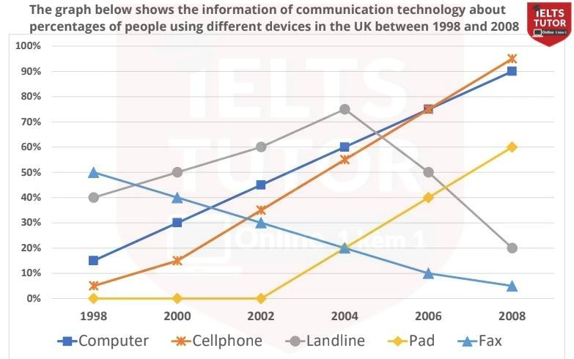

Line graph
Subject: percentages of people using diffearent devices in the UK
Overall: an increase in the proportion of users of different gadgets, with fax witnessing the dramatic decrease during the categories examined. In addition, landlines take up the highest percentage of scribers, while the lowest is seen in fax.
Body 1: computer - cell phone - pad
Body 2: landline, fax
Hướng dẫn làm line graph: https://www.ieltstutor.me/blog/line-graph

Given is the line graph illustrating how much percent of people using five specific categories in the United Kingdom in terms of communication techonology from 1998 to 2008.
Overall, there is an increase in the percentage of subscribers in most devices, with cellphone witnessing the most dramic rise during the years examined. In addition, landlines take up the highest percentage of users, while the lowest proportion is seen in fax.

The percentage of users in computers started at about 15% in 1998, after which it saw a sharp increase, before reaching exactly 90% at the end of the period. Moreover, similar changes can be seen in the figures for cell phone and pad, which increased from the range of about 5% to around 92% and 60% respectively.

About 40% of people made use of landline gadget, with a substancial rise in the next 6 years, before dropping dramatically to reach exactly 20% in 2008. Also, the figure for was 50% in 1998, which accounted for the highest percentage at the time, but later experienced a downward trend to reach nearly 3% at year end. → Ở thân bài này, thì 2 phần highlight là thông tin ở 1998 của 2 thiết bị.
Mình nên giới thiệu từ đầu và so sánh 2 dữ liệu này trước, rồi sau đó có thể tách ra miêu tả xu hướng theo sau nhé.
VD:
In 1998, there were 40% of landline users, 10% lower than the figure for … , with 50%.
- Landline : Tăng/giảm như nào sau đó
- Fax : Tăng/giảm như nào sau đó.

