Filomena Campus Quartet



Filomena Campus - vocals

Steve Lodder - piano

Charlie Pyne - double bass

Rod Youngs – drums

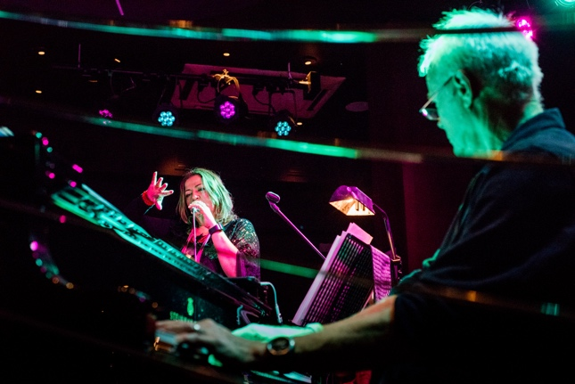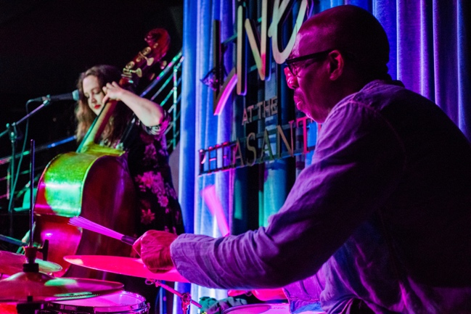

‘Healing, inspiring, cathartic, comedic, dramatic, political, fantastical, the Filomena Campus Quartet is truly irreplicable in the British jazz scene’. Jazzwise
Since its formation in 2010, the All-Star Filomena Campus Quartet has gained both audience and critical acclaim, performing regularly at major London venues, and appearing at international festivals and theatres across Europe, the Middle East, Africa and Asia. Following their first album, Jester of Jazz, and the subsequent project Italy vs England, created with the late Italian author and performer Stefano Benni, the quartet now presents Theatralia, recorded in London at World Heart Beat studios and scheduled for release by the British label 33Jazz Records in October 2026.
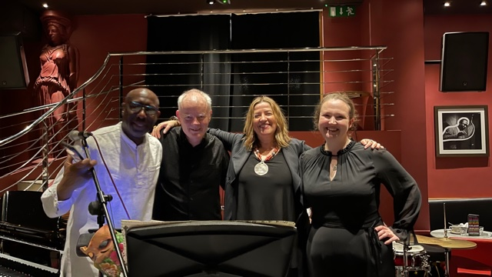

THEATRALIA

The title of the album refers to an ideal and utopian place of creativity in which music, theatre, literature and improvisation merge, creating a bridge between Sardinian roots, the multicultural energy of London and diverse artistic influences from around the world. From this emerges an original and innovative artistic language: an immersive experience that moves across word, sound and gesture, and also stands as a tribute to the artists who have marked Campus’ artistic path. As the magazine Jazzwise wrote:
“The performance intertwines fantastical and political elements, blending jazz, theatre and literature with great naturalness. Campus sings in multiple languages and builds a unique performative universe, in which the theme of female vocality is central. Through a strong stage presence, she continuously transforms, moving from mythical characters to contemporary narratives. The result is a cathartic, ironic, dramatic and visionary show, capable of regenerating and inspiring, a unique and irreplicable reality in the British jazz scene.

The repertoire includes original compositions, with music by Lodder and Pyne and texts by Campus, together with new arrangements drawn from the artist’s repertoire and her international collaborations, including a virtuosic arrangement for solo voice of a Jobim piece. The songs evoke imaginative worlds and celebrate real and mythical female figures, from Shakespeare’s Queen Mab to the Sirens of the Odyssey, up to the myth of Philomela reinterpreted by T.S. Eliot, and artists such as Niki de Saint Phalle and Franca Rame giving life to a sonic narrative rich in theatrical suggestions. Song of a Siren explores the power of female vocality also in the light of the thought of the philosopher Adriana Cavarero. E Mi Drommia recalls the Janas of Sardinian tradition, blending Mediterranean roots, contemporary jazz and electronic elements with the text of the Sardinian poet Antonio Maria Pinna, while Unsettled (Status) is a love letter to London despite Brexit. SHE pays tribute to the strength of migrant women, Per Franca gives voice to a poem by Benni written to Franca Rame, while Niki’s Dream, inspired by Niki de Saint Phalle, becomes a gesture of solidarity recalling the motto “Woman, Life, Freedom”.

The project also includes new arrangements of pieces written in the past by Campus with Sardinian musicians, including guitarist Massimo Ferra and pianist Paolo Carrus. In the live performance, the quartet also presents a new arrangement by Dudley Phillips of Creuza de Mä by Fabrizio De André, in Genovese dialect, with translation by Benni, who also wrote the text of the satirical piece God Save the Queen, on music by Lodder.
Reviews and Audience Feedback

"The four of you have created something quite unique and I can't wait to hear the results on the new album!" Jonathan Coe

“Her scat is literally something unique, with a distinctly modernist approach.” Jazz in Europe
“Campus seemed to improvise from deep within, as if she threw herself fearlessly into the unknown, taking the audience with her.” LondonJazz
“On stage Campus is a true shaman of music.” ANSA
“Attending a Filomena Campus concert is always a musical joy, but the latest went beyond all expectations… a truly memorable experience, capable of enriching those who live it.” Nicol Dynes
“The concerts of the Filomena Campus Quartet are pure jazz dream material… a real triumph.” Candace Allen
“A magnetic performer… an unforgettable experience.” Alessandra Rizzo

JAZZWISE review (March 2026)
Filomena Campus Quartet bring theatrical colour to the Vortex
By Alice Hill

The vocalist brings her multi-lingual, multi-faceted music for a night of fantastical and
political music making

Fusing jazz, theatre, and literature is a feat very few UK-based performers attempt, yet bandleader, vocalist, theatre practitioner, radio host, and academic researcher Filomena Campus blends the creative arts with ease.
She has collaborated with improvisation legends Evan Parker, Orphy Robinson, and Kenny Wheeler, and is established in London as a unique and sought-after performer.
Campus invokes her Sardinian heritage by including Sardinian poetry and performing in five European languages: English, Italian, Sardinian, Portuguese (for just one song: an a cappella cover of 'Águas de Março'), and Genovese.
The Filomena Campus Quartet was originally formed in 2010; while pianist Steve Lodder and drummer Rod Youngs have remained in the band, Charlie Pyne is now the band's double bassist. Throughout the performance, the "power of female vocality" was a central theme. The quartet performed songs dedicated to artist Niki de Saint Phalle; theatre actress Franca Rame; "naughty fairies" from Sardinian folklore; Shakespeare's fairy midwife, Queen Mab; women migrants; sirens; and Philomena, the Nightingale in Greek mythology. Bassist Pyne's song 'Daughters of Water' built on the quartet's feminist rhetoric, involving satirical, humorous, and lamenting elements. Across this array of feminine representations, Campus' theatrical presence allowed her to morph in and out of each story. The vocalist
transformed into Queen Mab, the fairy midwife in Romeo and Juliet, in an almost operatic sense by wearing a mask, waving her arms as if they were delicate wings, before singing her emotions to a captivated audience. Similarly, in 'Song of a Siren', her initial spoken word ascended into technically impeccable portamentos, projected so strongly that the microphone was held far away from her face.
Healing, inspiring, cathartic, comedic, dramatic, political, fantastical, the Filomena
Campus Quartet is truly irreplicable in the British jazz scene.

www.filomenacampus.me

