Đề bài
The bar graph shows the global sales (in billions of dollars) of different types of digital games between 2000 and 2006.
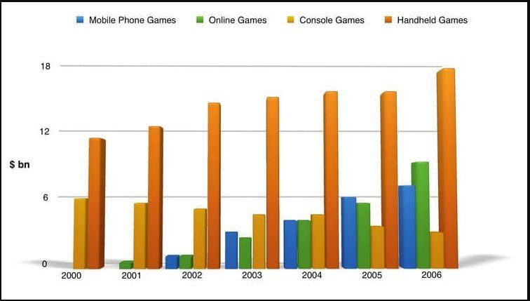

Presented is the bar chart exhibiting the changes in the sales from over the world in four different digital games from 2000 to 2006.

As transparent from the chart, the global sales of all platforms of digital games demonstrates an upswing trend over the surveyed seven-year period. Also noteworthy is that the sales of most of the types is on the upturn, but sales figures for Handheld Games take a nosedive.

In 2000, worldwide sales of Handheld Games stood at around $11 billion, while Console Games earned just under $6 billion. No figures are mentioned for Mobile Phone and Online Games at that time. Over the next three years, there was a surge to roughly $14 billion for Handheld Games, but the figure for Console Games shrank by approximately $2 billion. Mobile Phone Games and Online Games became popular at this time, with sales reaching around $3 billion.

In 2006, sales of Handheld Games accounted for the lion's share, with practically $18 billion. Besides, Mobile Phone and Online Games reached peaks of around $7, $9 billion respectively. By contrast, the figure for Console Games registered a fall to under $3 billion.

⇒ Mình chia bố cục như này cũng được nha hoặc tham khảo cách chia bố cục như phía dưới nhé
Tham khảo
  - Overall:
    - Sales of games for three out of the four platforms rose each year (IELTS TUTOR gợi ý cách diễn đạt khác: the sales of mobile phone games, online games and handheld games increased while console games saw a decrease)
    - Handheld games were the best-selling category.
  - Body 1: Viết về Handheld Games + Console Games
    - Handheld games
      - In 2000, its revenue stood at about 11 billion dollars.
      - Handheld games showed steady sales in the years 2004 and 2005 with approximately 15 billion dollars. (IELTS TUTOR gợi ý cách diễn đạt khác: From 2000 to 2004, this figure saw a steady rise to 15 billion dollars before remaining stable over the next year)
      - In 2006, handheld games’ sales surged to approximately 18 billion dollars.
    - Console games
      - Console games showed almost the same sales of around 5 billion dollars in the first two years of time. (IELTS TUTOR gợi ý cách diễn đạt khác: in 2000, the revenue from the sales of console games was about 6 billion dollars)
      - In 2006, console games witnessed a gradual drop to only 2.5 billion dollars,
  - Body 2: Viết về Online Games + Mobile Phone Games
    - Online games + Mobile Games
      - There was no sale of online games recorded in 2000, and only about .5 billion online games were sold out in the next year. (IELTS TUTOR gợi ý cách diễn đạt khác: No figures were given for mobile phone games and online games)
      - Mobile phone games and online games drastically increased to approximately 7 and 9 billion dollars, respectively in 2006 (IELTS TUTOR gợi ý cách diễn đạt khác: Online game sales recorded at 9 billion, whereas mobile phone games sales were crossed billion in 2006)

