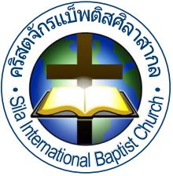
OBEYING THE GREAT COMMISSION
Going – Discipling – Baptizing - Teaching

d

Matthew 28:19-20
Go therefore and make disciples of all nations, baptizing them
in the name of the Father and of the Son and of the Holy Spirit,
teaching them to observe all that I have commanded you. And
behold, I am with you always, to the end of the age.”

SIBC VISION: LOVE GOD, LOVE THE CHURCH AND LOVE OTHERS

g them in the name of the Father and of the Son and of the Holy Spirit, 20 teaching them to observe all that I have commanded you. And behold, I am with you always, to the end of the age.”

Edition: September 2023

All people must know Jesus.

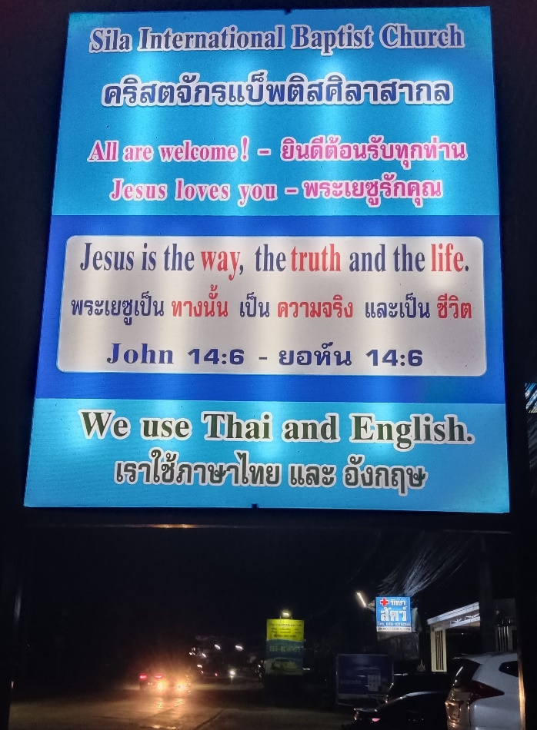

Our new sign can be seen by thousands of people.

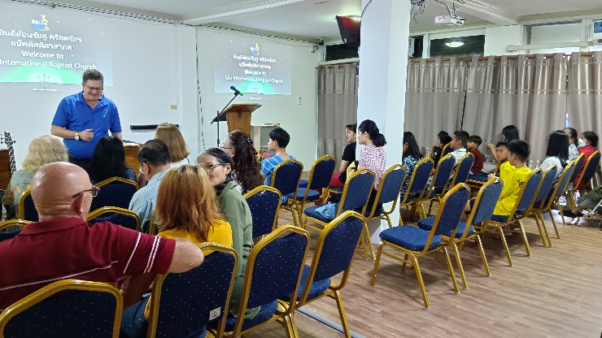

We are happy to welcome our members and visitors.

We

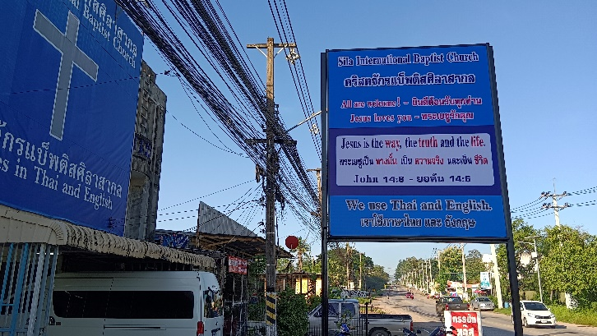

The Good News must be preached to all passers-by.

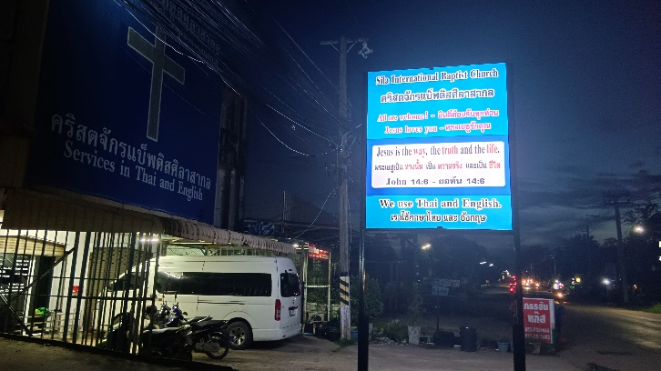

LED sign of God’s Word will be hung up next month.

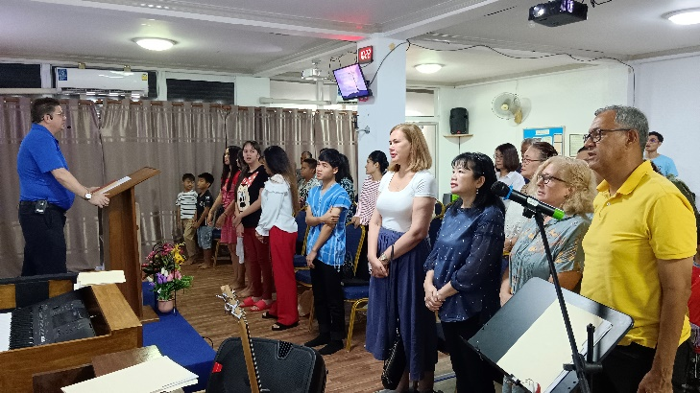

We learn to pray from Psalms before we worship God.

We serve God together.

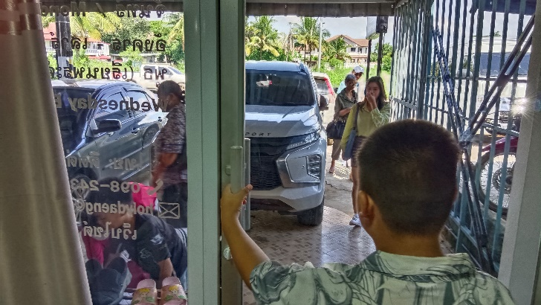

Some members are picked up by our van on Sunday.

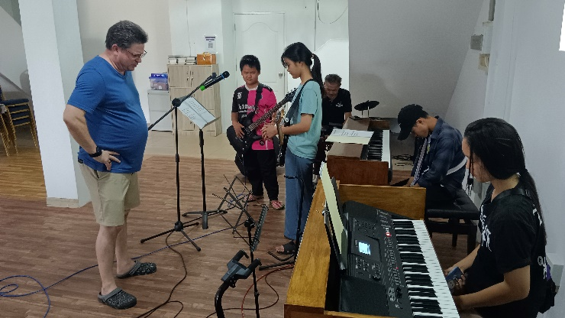

Our pastor prayed before the worship practice started.

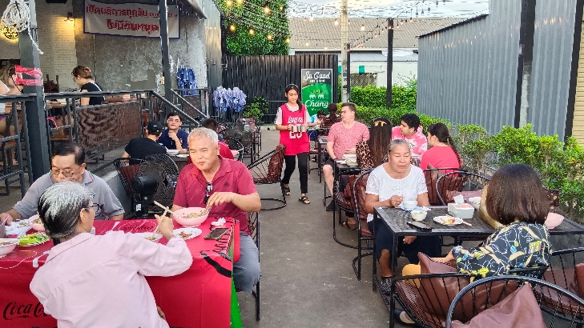

We celebrated Cailee’s birthday happily as one family.

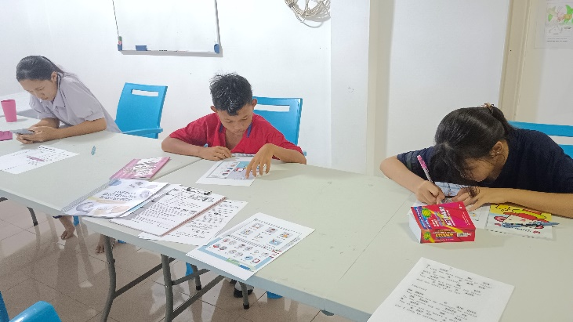

Our 3 students study English 4 hours a week at church.

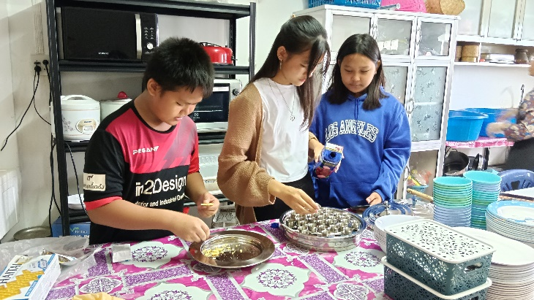

Our youths can help us prepare for the Lord’s Supper.

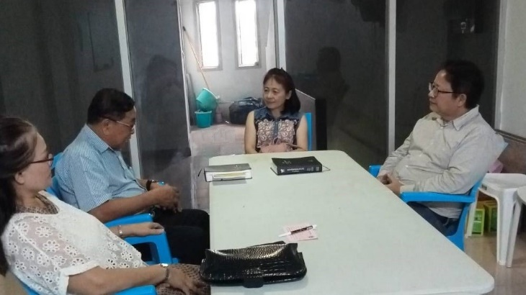

The visiting couple accepted Jesus on their first visit.

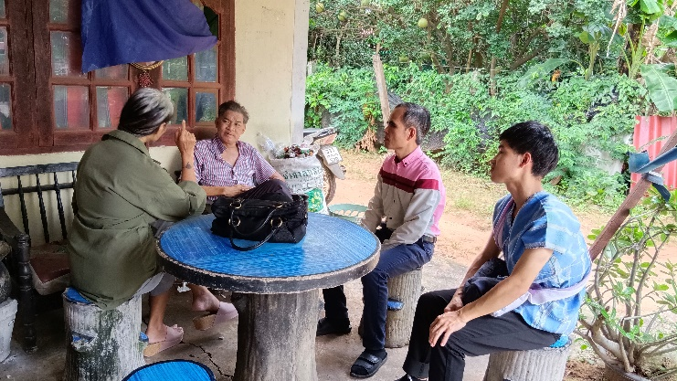

Members visited our sick musician who needs help.

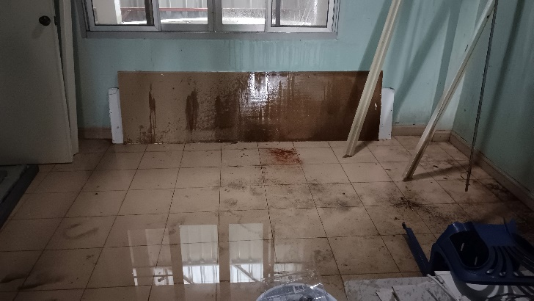

The roof leaks and the owner needs to fix it for us.

Prayer Requests:

1. SIBC to be accepted into Thailand Baptist
Convention. (We are very close!)

2. More financial support to pay for repairs at church.

3. For the people of Khon Kaen to be receptive to the
Gospel.

4. For Pastor Curt to complete all paperwork for
501(3)c status.

A note from the Pastor:

A warm greeting to all of you who are reading this newsletter. It has been a very hot and wet September here in Khon Kaen but God has continued to bless all of the work here at SIBC.
We have averaged just over 33 in attendance each Sunday for the month of September and almost 16 on Wednesday night Bible Study! We also had 26 visitors for the month! We are excited about the number of people hearing the Gospel each week. Pray that God will continue to work on the hearts of those who have not yet come to Christ. One married couple who came from about 30 miles away had a daughter who was saved, and they saw the change God had made in her life. One of our members invited them to come and hear more about Christ. The couple came and heard the message and then fellowshipped with us for lunch. After lunch they were shown the plan of salvation and accepted Christ! Praise God!
My son Cody had a large abscess in his hip and had to go to the hospital to have it removed. It left a large hole in his skin, and he had to stay two days in the hospital. He is feeling much better but must go to the clinic to have it treated each day for a month. Please pray for him!
Your servant in Christ,
Curt Mathis
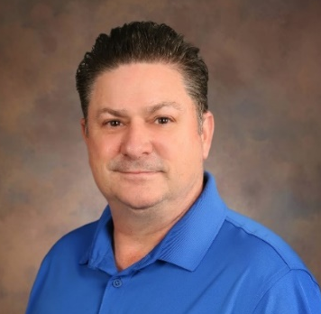

How to give to Thailand Missions

GIVE BY CHECK:
1. Make check out to: Kingwood First Baptist Church
2. In the memo section write: Thailand Missions

3. Mail to:
Kingwood First Baptist Church
3500 Woodland Hills Drive
Kingwood, Texas 77339

GIVE ONLINE:
Scan the QR code and select Mission – Thailand then follow the prompts to complete how you would like to give.
Current Supporters

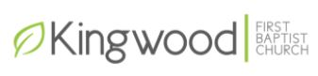
If you would like to become a monthly or one time supporter, our church would be very grateful. If you do send money to Kingwood First Baptist Church, please email me, and let me know. It will help in planning future projects for fulfilling the Great Commission.
Personal contact information

Address: Curt Mathis
445 M1
Tambon Sila, Muang Khon Kaen
Khon Kaen, Thailand 40000
Phone: +66 65-226-1073 or (Skype) 802-546-0276
Email: silainterbc@gmail.com
Facebook: @SIBCKhonKaen
Website: www.silainterbc.com
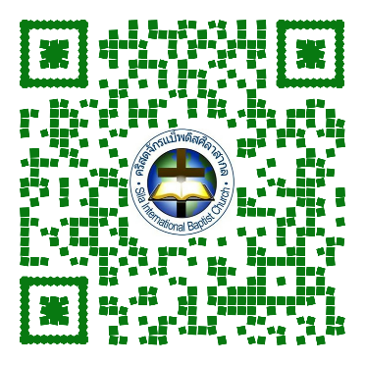

Website

