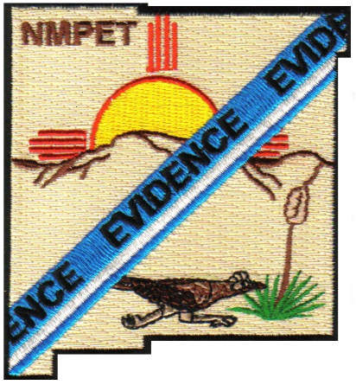
New Mexico Property & Evidence Technicians
Mary Jo Apodaca, President
Chris Eisenberg, 1st Vice President
Sonia Evaro, 2nd Vice President
Gabriel Andujo, Secretary
Michelle McConnaughy, Treasurer

N. M. P. E. T Application for the Property Technician of the Year

Date: ___________________

Information on the person being nominated

Directions: This application must be filled out completely, accurately and must be received no later than July 31. Application received after that date cannot be considered.
The Nominee must be a current member of N.M.P.E.T

Please print or type all information:

Nominee’s Name: __________________________________________

N.M.P.E.T Member #: ________________________________________

Address: __________________________________________________

Phone Number: _______________ Agency: ____________________

Nominee’s Email Address: ___________________________________

Job Title: _________________________________________________

How long in present position: ________________________________

- Did the nominee attend any training/seminars during last year? Yes/No
(If yes, describe the training (In house or External Training)

- What did the nominee do that went above and beyond in the following fields that made you think he/she is worthy of special recognition?

- Please give details on the nominee’s:
  - Professionalism:

  - Work Ethics:

  - Customer Services:

  - Support to the Agency / Organization’s Goals & Objectives:

  - Job Skills:

  - Other (be specific):

Information on the person making the recommendation and / or the endorsement of the N.M.P.E.T Member Nominee:

Name: ____________________________________________________________

Address: __________________________________________________________

N.M.P.E.T. Member Number (if applicable) ________________

Job Title: __________________________________________________________

Agency: __________________________________________________________

Note: PLEASE GET A RECOMMNDATION LETTER FROM THE HEAD OF THE DEPARTMENT OR SUPERVISOR. ADDITIONAL LETTERS OF SUPPORT OR RECOMMENDATIONS CAN BE PROVIDED. SUPPORTING DOCUMENTATION MUST BE PROVIDED WITH THE APPLICATION

Mail to:
Mary Jo Apodaca
N.M.P.E.T. President
2816 Ancho Ave
Las Cruces, NM 88007
nmpet2022@gmail.com

