- Dàn bài mà em lập cho đề này
Bài viết của em ( luôn nhớ max 300 words cho Task 2, max 160 words cho Task 1)
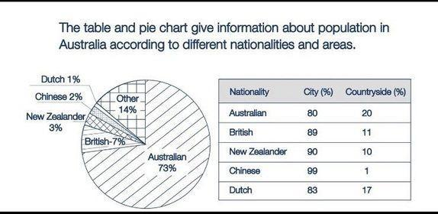
Tham khảo cách triển khai bài nhé: https://www.ieltstutor.me/blog/mixed-chart
Tham khảo cách nhóm dữ liệu trong bài nhé: https://www.ieltstutor.me/blog/nhom-so-lieu-ielts-task-1
Given is the table illustrating how many people residing in Australia based on different nationalities, and the pie chart delinates the demograph in this country in rural and urban areas.
Overall, the percentage of Australians who dwell in this country dominates the pie chart. By contrast, when it comes to the table, city dwellers accounts for a vast majority of australia’s population.

According to the pie chart, the proportion of Australians stand at the top position, at 73%, followed by that of the British with 7%. Simultaneously, the next position belongs to the figure for New zealanders, at 3%. At the same time, around 2% was recorded for the figure of Chinese and Dutch, compared to 14% that of other nationalities.

As seen from the table, regarding the cosmopolitan area, the share of Chinese people ranks first at 99%, which was approximately 9% higher than that of NewZealander and British. In the meantime, a mere 82% of Dutch and Australians choose to live in this area. In terms of the countryside, while the proportion of Australian residents is highest, at 20%, the figures for British, NewZealander and Dutch were comparable, at around 15%. However, Chinese people only have 1% of its population living there, which also occupies the lowest share in the table.
Lưu ý dạng mixed này có thể bố cục bài như sau:
- Overall: Australian chiếm lớn nhất (the vast majority of Australian people claim their ancestry to be of Australian origin) & các quốc tịch đều sống phần lớn ở city (most Australian people, regardless of their ethnicity, are city dwellers)
- Body 1: Viết biểu đồ tròn mô tả những điểm sau (lưu ý nên có so sánh - đối chiếu & nêu số liệu):
  - Số liệu lớn nhất: Australia (Australian ethnicity makes up nearly three fourths of the total population)
  - Số liệu nhỏ nhất: Dutch 1% (People of Chinese ethnicity made up a negligible 1-2%)
  - British & Other
- Body 2: Viết table
  - Chinese lớn nhất
  - Chinese & British xấp xỉ (roughly 90% of people from China and the UK live in cities, whereas only around 10% lived in the countryside)
  - Dutch thấp nhất

