The bar chart shows the different modes of transport used to travel to and from work in one European city in 1960, 1980 and 2000.
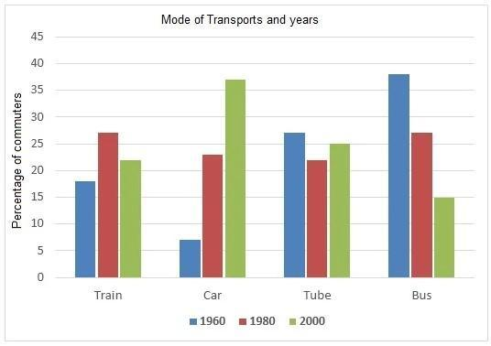

Dàn ý:
Overview: -1960: bus highest
2000: Car highest
- Car increase Bus decrease over years, yet Tube and Train not much gaps
Body 1: Car, bus
2: Train, Tube
Bài làm:
Hướng dẫn làm bar graph: https://www.ieltstutor.me/blog/bar-chart

Given is the bar chart illustrating the percentage of commuters going by 4 different means of transport in a certain European city in 3 years, namely 1960,1980 and 2000.
Overall, the highest proportions of people using transport were in 1960 and 2000, specifically went on Car and Bus mode. Moreover, while it can be seen that there was a dramatic increase in car users and a noticeable decrease in Bus commuters, the ratio of people traveling by train and car didn’t change too much over 40 years.
It is clear that it was witnessed a significant climb in Car commuters in 2000, at nearly 37% and in Bus travelers in 1960, at almost 38%. Besides, in 1980, the statistics of individuals using car was drastically higher than one in 1960, at nearly 23%, and reached a peak at 37% in 2000. The opposite trend can be seen in Bus users that there was far less commuters going to work by Bus over a 40-year period, and got the lowest percentage in 2000, at 15% exactly. → Nhớ xem lại mô tả chỗ đoạn chữ đỏ còn thiếu hợp lí nhé
The figures for the public moving by train and tube showed a slight modification among 3 years. Particularly, with train mode, the largest proportion was in the year 1980, at around 27%, yet in 1960, tube eventually made a same attribution as train, at approximately 27%.
IELTS TUTOR lưu ý:
  - Overall:
    - The proportion of commuters who used cars increased steadily over the period shown, whereas the percentage of people who travelled by bus fell dramatically. >> IELTS TUTOR hướng dẫn Cách dùng trạng từ "consistently" tiếng anh
  - Body 1: Viết về số liệu hoặc tăng đều hoặc giảm đều
    - Car: Số liệu tăng đáng kể qua các năm
    - Bus: Số liệu giảm đều qua các năm >> IELTS TUTOR hướng dẫn Paraphrase từ"stable"(Diễn đạt"sự ổn định"tiếng anh)
  - Body 2: Viết về số liệu fluctuate
    - Train: Số liệu biến động, tăng ở năm 1980 sau đó giảm
    - Tube: Số liệu gần như không đổi nhiều, giảm rồi lại tăng

