Describe a quiet place you like to spend your time in
You should say:
Where it is
How you knew it and how often you go there
What you do there
And explain why you like the place
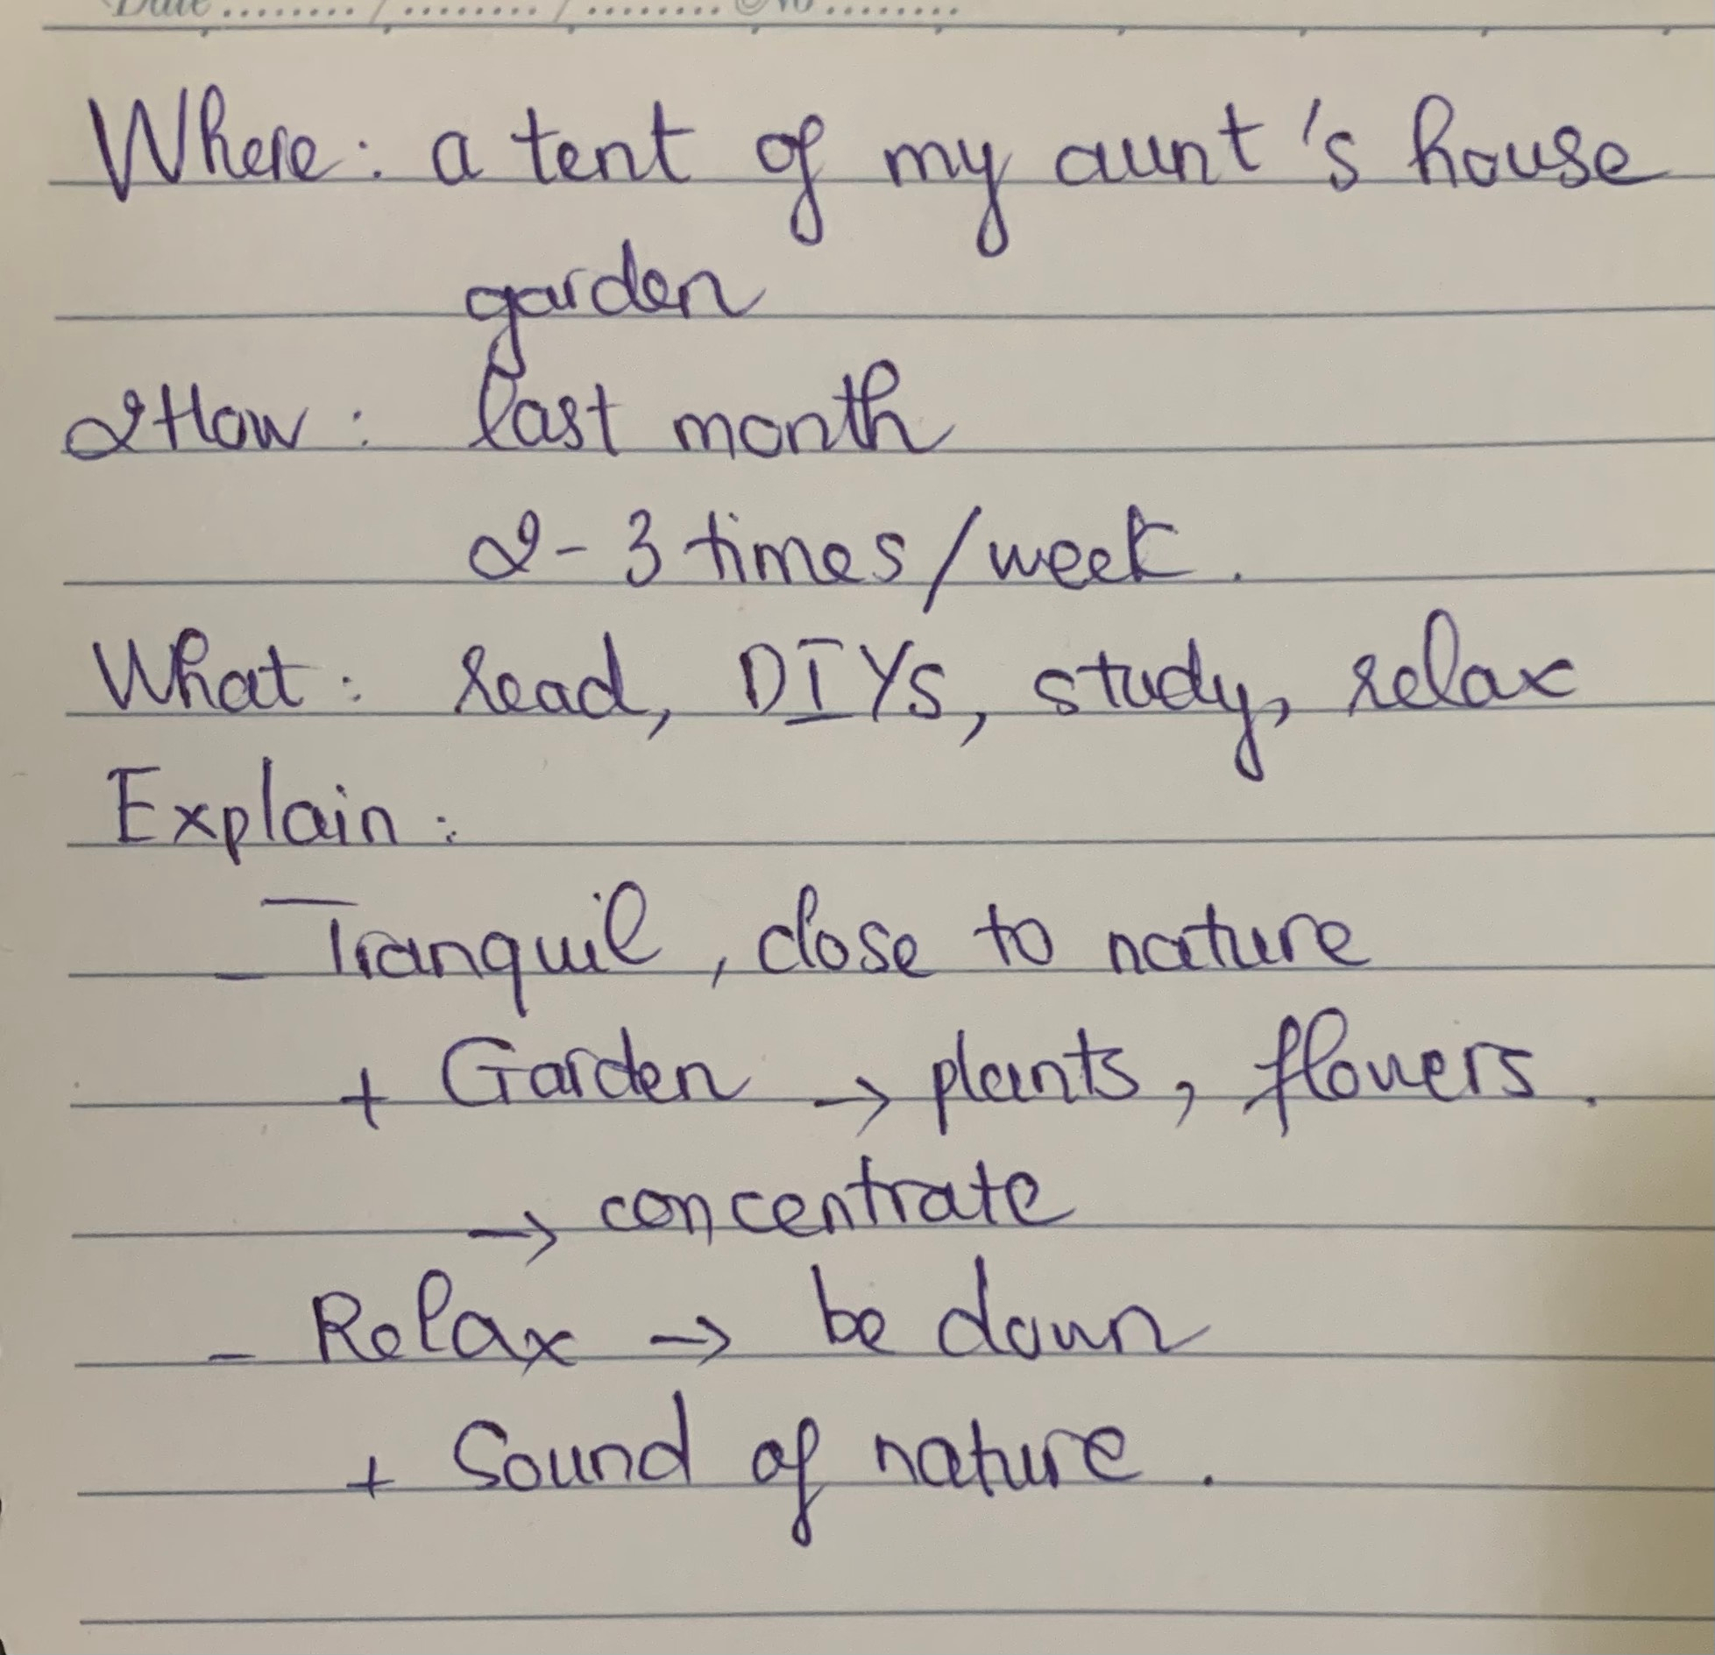
Where it is
I would like to talk about a peaceful place that I love spending my time in, and it is a tent of my aunt’s house.
Recently, I live in my hometown which is a countryside, and my aunt has a small tent in her garden. My aunt’s house is about 1 km away from my house, and it is a quiet place, and I really love spending time there.
How you knew it and how often you go there
Last month, my aunt came to my house to chat with my mom, and she told me that the tent in her garden had been redecorated, and then she asked me to come to visit. In fact, after the first visit, I go there very often about twice or 3 times a week.
What you do there
Although it is called a tent, I personally find it quite comfortable and relaxing to spend free time there. I do different activities such as reading, doing some DIYs, studying and relaxing. Sometimes, I enjoy planting flowers with my cousins and going fishing together.
And explain why you like the place
There are many reasons why I’m into spending time there. First of all, it’s quite tranquil and close to nature. This is because the tent is situated in the garden, so there are many plants and flowers around. In addition, I love the quiet place since it favours my studying, and the tent’s atmosphere obviously facilitate my concentration on studying and working. The next reason is it helps me a lot on relaxing myself whenever I’m down. Indeed, the quiet atmosphere makes it easier to listen to the sounds of nature such as birdsong, rustling leaves and so on, that’s why it turns to chill out, so it actually clears my mind. ⇒ bố cục ổn
lưu ý bám sát vào cue card để trả lời nhé:
- Where it is?
  - Library - located in …. & not far from my house (hoặc Since the library is not too far from my home, so I travel on foot to reach there)
- How you knew it?
  - The first time I set foot in this building was … years ago when I was still a first year students and was preparing for my final exam >> IELTS TUTOR hướng dẫn Cách dùng động từ "prepare" tiếng anh
- How often you go there?
  - The library has become my haven of peace and tranquility, and I pay a visit to this place on a daily basis (hoặc This library is my go-to place whenever I need some peace and quiet to focus on my important work)
- What you do there?
  - I go to this place whenever i need to do my homework assignments or review for an exam. >> IELTS TUTOR hướng dẫn Cách dùng "whenever" tiếng anh
- And explain why you like the place?
  - Main idea 1: The tranquility of the library drives deep thinking, and hence I am able to contemplate on my career/studying goals
    - Supporting idea: Librarians always try to make sure that nobody is making any loud noises which may affect other people >> As a person who is sensitive to noise, that is the best i could ask for (hoặc There is always a pin-drop silence, so you can sit and study in peace) >> IELTS TUTOR hướng dẫn Cách dùng tính từ "sound" tiếng anh
  - Main idea 2: As a fanatical book lover, this library is a treasure trove for me (hoặc có thể cân nhắc ý khác: there is plethora of opportunities for social interaction)
    - Supporting idea: I also visit it when I want to find a good book and to immerse myself in it >> IELTS TUTOR hướng dẫn Cách dùng động từ "immerse" tiếng anh

