To what extent are modern economies shaped by networks rather than markets? In a world increasingly influenced by artificial intelligence, will human connections become more or less economically important?

Scholar of Tomorrow Essay Competition — Economics
Author: [Zhize Li]
School: [Borong Ten Thousand Miles Silver Beach School] Grade: [Grade]
Word count (body text): 1,492

Abstract
AI is widely expected to enhance markets and diminish the economic significance of human relationships. Contrary to this belief, this essay asserts that this will not be the case in strategic industries. The paper outlines three nested barriers to entry based on tacit knowledge, incomplete contract theory, and transaction cost economics. The outermost barrier relates to the power to define what constitutes meaningful data, as exemplified by TSMC’s 93,000 certified IPs, representing over three decades of failed tape-outs and agreements made through discussion, all of which cannot be accessed through the use of an AI algorithm. The second barrier is connected to the ineffectiveness of complete contracting in the event of high asset specificity and uncertainty, as was the case in lithium supply agreements during the 2021-2022 price spike. These two barriers are nested within each other: having been granted legal access to a network does not guarantee concrete access to vital assets, as it is not possible to instantly buy trust. AI has made the codifiable aspects of service provision to come close to zero marginal costs but has increased the value of the uncodifiable, including issues such as the importance of judgment, accountability, and the shared experience of challenges between individuals. This will lead to human relations becoming increasingly important. Nonetheless, AI will reduce the costs involved in coordinating with other parties.
Introduction
Markets allocate standardized goods using price signals (Polanyi 46). Networks regulate transactions through the use of trust, historical precedent, and shared risk (Granovetter 487; Uzzi 35). Personal relationships retain the information of prior crises (Zelizer, "How I Became" 149). Although AI can accelerate market transactions (NVIDIA), it cannot replicate human decision-making power—situated judgement, relational accountability, and contextual reasoning—embedded in networks (Milvus; Biswas). This paper provides evidence that networks create three barriers to entry for strategic industries (chips, energy, and medical certification): the power to determine what constitutes valid input, the ineffectiveness of complete contracts in situations of extreme uncertainty, and the interaction between the two barriers. These blocks have a structural nature. On the other hand, AI provides opportunities for the use of open standards, on-chain reputation, and AI-native organization enabling new entrants to overcome barriers. Whether or not entrepreneurs create lasting value through applying the knowledge gained from the AI window will determine the outcome.
1. Counter-argument: Why AI Is Expected to Weaken Human Ties
Artificial Intelligence can reduce interpersonal relations in transactions that are low-risk and simple when algorithms create a link between demand and supply and systems can replace the need for trust (Granovetter 487). Nevertheless, in crucial sectors such as semiconductor industry, medical certificates and long-term energy transactions, Artificial Intelligence does not eliminate networks but rather shifts intangible connections to structures that both parties will have to utilize (Uzzi 57).
Furthermore, markets use prices to distribute goods in a standardized way and work as effective ways of permitting anonymous trading (Polanyi 46). By contrast, networks manage transactions through trust, tradition, and shared risk, all of which develop through repeated relationships and mutual accountability instead of through formal contracts (Granovetter 487; Uzzi 35). People have memories of previous crises that allow them to develop flexible solutions in situations that cannot be codified through formal institutions. AI will be able to make market transactions faster by lessening the effects of information asymmetries and finding solutions more quickly; it cannot build the situated judgement, accountability, and community understanding needed to make decisions embedded in the human connections that exist through networks (Granovetter 490).
Although AI has the ability to create markets through transactions that are time-sensitive, it will not be able to replace the power of human decisions in networks, which requires ongoing interpersonal relationships. This argument will be fully proven by three layers of network rule below.
2. The Cases for Networks：Three Layers for Gatekeeping
2.1 Layer 1: The Power to Define Data Labels
Though AI can analyze data, it does not understand the meaning of a definition. According to the TSMC OIP Knowledge Iceberg diagram below, there are 93,000 certified IPs under TSMC’s OIP and this includes technical standards (SemiAnalysis, qtd. In Sina News). But beneath the surface of the iceberg, 30 years of unsuccessful tape-outs are included where each tape-out represents somebody that disagrees with the acceptable variations. What is the cause? How do you reach compromises when you have no common understanding? From 2010 to 2025, there has been a rise in the number of certified intellectual properties from 3,000 to 93,000 which is a thirty-fold increase; however, this has only occurred due to existing precedent (TSMC, “Celebrating 15 Years”). The new persons are looking at these decisions without any idea of what negotiations actually mean.
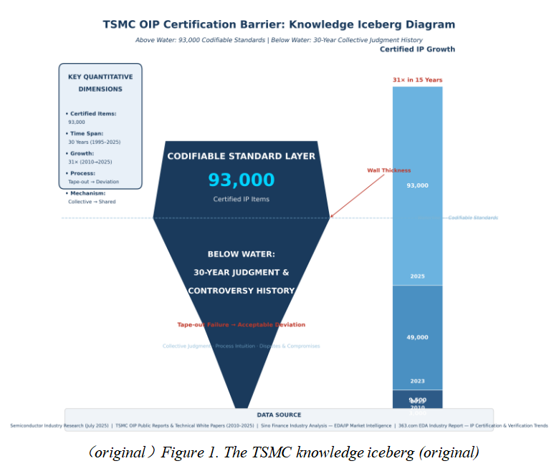
Polanyi’s tacit knowledge means it will never be fully defined. As he states, “we can know more than we can tell ”(4). This is because previous parties provided their opinions as unquestionable standards and therefore, standards created by previous parties of choice become the standard to be lived by for anyone which are considered right by the culture. AI can produce the results but does not know the process which led to agreement. This is about who is who; it is instead about who has relevant definitions. More importantly, those people who have defined the standards are only those who have gone through the process. As a result, this becomes an issue of legitimacy since only through one’s own voice can an idea be accepted.

2.2 Layer 2: Incomplete Contracts – Market Bidding Fails
The label was ineffective, and therefore the mechanisms of price fail; however, signature theory shows that no contract may cover all possible contingencies – not due to lack of information, but rather because all such situations are known to be uncertain (Williamson 1981, 66). Williamson's principle of specific assets illustrates that if the value of an asset is highly specific to one transaction, that value may be lost during any different transaction (Williamson 1985, 52). In cases of high specificity three basic concepts cannot be applied:
- Free disposal fails because there is a form of simultaneous contract where switching costs are substantial, i.e., if no market exchanges were completed;
- Since complete contracts do not exist, rigid terms in the contract can have a negative consequence because unexpected events may take place;
- Judicial enforcement fails as there is the possibility of adjusting the existing contracts based on specific circumstances (Williamson 1985, 61–62).
For example, in 2021 Ganfeng Lithium entered into a three-year supply agreement with Tesla that constituted approximately 20% of Ganfeng's battery-grade lithium production capacity (Exliporc Power, 2021). This case demonstrates that because lithium hydroxide production is capital and labor-intensive, the result is a situation in which a firm becomes reliant on a supplier that does not have the capability to search out cheaper options (Exliporc Power, 2021). In addition, as evidenced by figure 1, there was a significant increase in the cost of lithium carbonate from ¥53,500 per metric ton in December 2020 to more than ¥600,000 per metric ton during the period of 2021-2022 (Lyth Battery, 2025).
Moreover, as evidenced by figure 2 below, uncertainty leads to the default option of entering fixed-priced contracts with low breach costs; therefore, breaches resulting in a larger profit than contract performance will be the regular outcome. Likewise, the results confirm that relational contracts enforceable through the threat of high breach penalties will be self-enforcing because of credible commitment (Macneil, 1980; Williamson, 1985). Consequently, AI is highly suitable for situations with defined problems but is incapable of solving undefined problems.
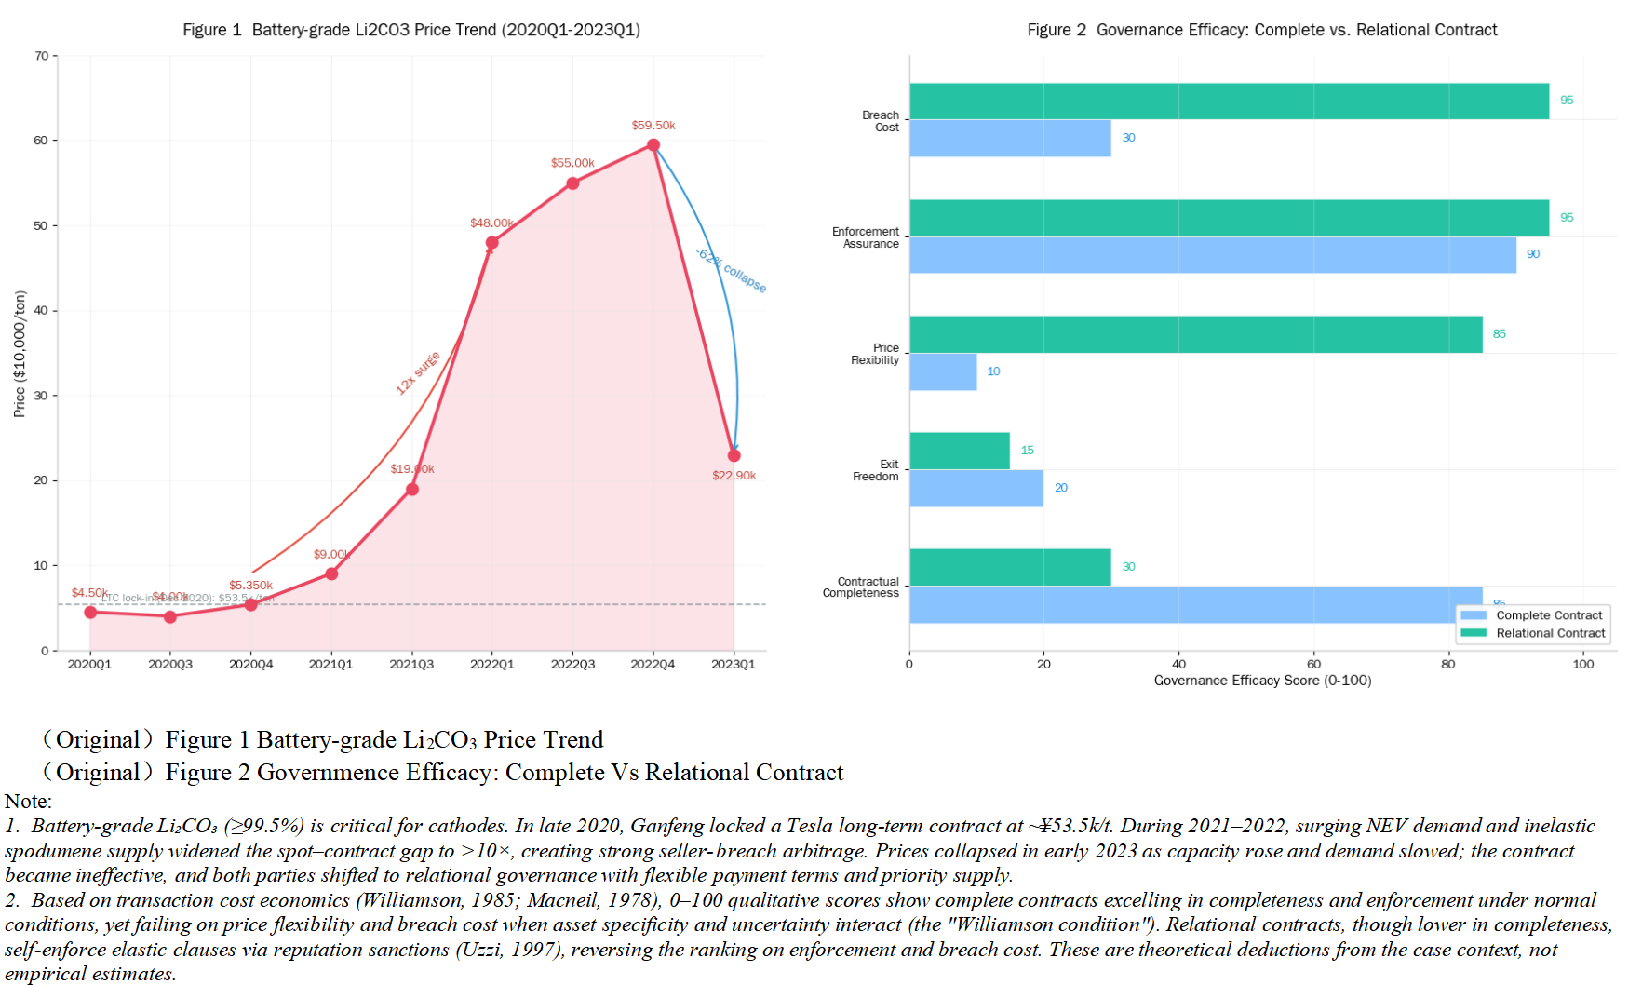
For this reason, the only applicable form of governance is a form of relational contract (Macneil theory) which relies on continuous communication, human connections embedded in network and changes in the enforcement mechanism (Macneil 1980, 10).
、

2.3 Layer 3: Nesting – Networks Define Real Boundaries
Screens in Layer 1 refer to technical certifications that reflect a "capability." The resource allocation in Layer 2 is a different screening dimension involving previous experiences between parties with similar crises. The two layers are connected: one cannot move directly to Layer 2 without first completing Layer 1; however, the reverse is also true.
Layer 2 connections result because of more specific interactions. It is important to note that Layer 1 does not determine Layer 2 connections. The first question in Layer 1 is operational in nature, based on technical ability to respond to a potential crisis. The second question in Layer 2 is interactive and involves elements of personal faith in other individuals regarding future behavior. Essentially, the first screening is bureaucratic in nature.
In the new definition of "nesting," the legal forms that describe such interactions are not essential; rather, it is the history of trust that defines membership. Access to services is legal, but services will be denied unless a prior trust record exists (Granovetter 1985, 487). Further, the power of the network renders enforcement of contracts ineffective (Macneil 1980, 4).
3. How to Break Through
There are three ideas resting on newcomers. Firstly, open source: With RISC-V, the chip design sector can move away from proprietary models associated with Arm and x86 (Waterman et al. 2014, 1), while Hugging Face is utilizing community-based methodologies for data labeling and management and setting standards for the newcomer's participation to be as a co-author rather than following an established path set by someone else (Wolf et al. 2020, 1). Secondly, the utilization of on-chain reputation systems enabled by blockchain technology to produce credit scores and credit history based on verified transactions without having to rely on existing models (Buterin 2014, 1). Finally, AI-native communities where decentralized autonomous organizations (DAO) employ blockchain technology as a means for enabling token-based governance systems, allowing machines to transact with each other using established algorithms (Liu 2019, 1).
Conclusion
The marketplace and its price mechanism, as such, are still there. However, it has taken a backseat by becoming the fundamental protocol layer for exchange standardization. Nevertheless, the actual allocation power has been delegated to the network entry rules. As a result, the network of human connections are more economically significant than market alone. The ultimate question facing institutional entrepreneurs is whether they can harness the lesser coordination costs delivered by artificial intelligence to evolve open standards and on-chain reputation as merely market instruments into the political constitution of the new networks of the future.

Works Cited
Buterin, Vitalik. "A Next-Generation Smart Contract and Decentralized Application Platform." Ethereum White Paper, 2014, ethereum.org/en/whitepaper/.
Exliporc Power. "Take Tesla's Big Order Again! The 200 Billion Lithium Mining Giant Officially Announced That the Industrial Chain Layout Has Been Continuously Improved!" Exliporc Power, 18 Nov. 2021, www.exliporcpower.com/5149530764771578.html.
Granovetter, Mark. "Economic Action and Social Structure: The Problem of Embeddedness." American Journal of Sociology, vol. 91, no. 3, 1985, pp. 481–510, doi:10.1086/228311.
Liu, Yong. "Research on the Governance Mechanism of Decentralized Autonomous Organization (DAO) Based on Blockchain Technology." Proceedings of the 2019 2nd International Conference on Blockchain Technology and Applications, ACM, 2019, pp. 1–5.
Lyth Battery. "Policy Expectations and Demand Recovery Drive Lithium Carbonate Prices Back to 72,900 Yuan/Ton." Lyth Battery, 28 July 2025, lythbattery.com/policy-expectations-and-demand-recovery-drive-lithium-carbonate-prices-back-to-72900-yuan-ton/.
Macneil, Ian R. The New Social Contract: An Inquiry into Modern Contractual Relations. Yale UP, 1980.
Milvus. "How Does AI Reasoning Differ from Human Reasoning?" Milvus AI Quick Reference, 2024, milvus.io/ai-quick-reference/how-does-ai-reasoning-differ-from-human-reasoning.
NVIDIA. "AI Algorithmic Trading for Faster, Smarter Investment." NVIDIA, 2026, www.nvidia.com/en-us/use-cases/ai-algorithmic-trading-factories/.
Polanyi, Karl. The Great Transformation: The Political and Economic Origins of Our Time. 1944. Beacon Press, 2001.
Polanyi, Michael. The Tacit Dimension. Doubleday, 1966.
SemiAnalysis. "TSMC's True Moat: EDA/IP Ecosystem." Sina News, 8 July 2026, tech.sina.cn/news/detail/5318472643118940.html.
TSMC. "Celebrating 15 Years of Innovation Enabled by OIP Ecosystem Collaboration." TSMC Blog, 6 Oct. 2023, www.tsmc.com/english/news-events/blog-article-20231006.
Uzzi, Brian. "Social Structure and Competition in Interfirm Networks: The Paradox of Embeddedness." Administrative Science Quarterly, vol. 42, no. 1, 1997, pp. 35–67, doi:10.2307/2393808.
Waterman, Andrew, et al. "The RISC-V Instruction Set Manual, Volume I: Base User-Level ISA." EECS Department, UC Berkeley, 2014, riscv.org/technical/specifications/.
Williamson, Oliver E. "The Economics of Organization: The Transaction Cost Approach." American Journal of Sociology, vol. 87, no. 3, 1981, pp. 548–577.
Williamson, Oliver E. The Economic Institutions of Capitalism: Firms, Markets, Relational Contracting. New York, Free Press, 1985.
Wolf, Thomas, et al. "Transformers: State-of-the-Art Natural Language Processing." Proceedings of the 2020 Conference on Empirical Methods in Natural Language Processing: System Demonstrations, ACL, 2020, pp. 38–45.
Zelizer, Viviana A. "How I Became a Relational Economic Sociologist and What Does That Mean?" Politics & Society, vol. 40, no. 2, 2012, pp. 145–74.

