SUNSHINE COAST TRAIL TRIP
B.C. Canada. 6-12 September 2018 (on trail 7-11th Sep)
180km multi day trail event in self-sufficient style

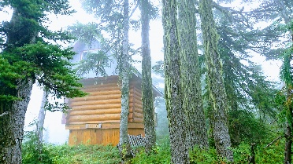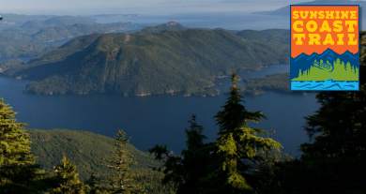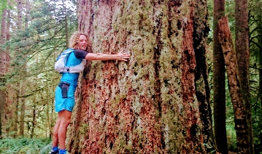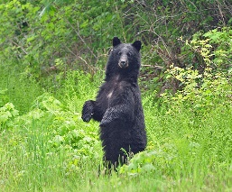

Location
Southern coast of British Columbia. Bordered by mountains and the Pacific Ocean the Sunshine Coast is only accessible by air / boat despite relative proximity to Vancouver. With old growth forests, fjords, marine parks, lakes, and green mountains it is an area to explore - on foot, canoe, or kayak.
Our base Powell River is a National Historic District, a place that was known for logging/mills (largest in the world). It is the territory of the Tla'amin Nation who continue their cultural traditions.

Terrain
Variety of vegetation and landscapes, passing impressive old growth trees. We start next to the ocean, go through thick forests, pass freshwater lakes, up small mountains, and finish at the ocean.

Sunshine Coast Trail: Canadas longest hut to hut hiking trail. 180km w/6,000m total elevation gain

Trip Overview:
- 5 days / 4 nights on trail
- Timed stages, teams of two people (if you don’t have a teammate, we can pair you)
- Self-sufficiency: carry your own (between the team) tent, camping gear, food.

Wildlife: bears (black and grizzly), cougars, deer, seals, whales…

Weather: September has had beautiful weather in the past years but in Coastal B.C. you have to plan for variations. A kit list will be provided.

Team / Staff:
Tiffany Saibil - trail runner and event organiser originally from North Vancouver
Christophe Le Saux - trail running adventurer and organiser of international running trips
Seb Lagors – Powell River local (French), event organiser and ski patroller

Program 2018

Thursday 6th September – Powell River
- Participants arrive Powell River
- Transfer to campsite
- Trip Briefing + Welcome Dinner

Stage1 / Friday 7th Sep: Trail Start at Sarah Point to Riveley Pond
- 33km / 1500m+
- Set up camp (near a lake). Evening Briefing.
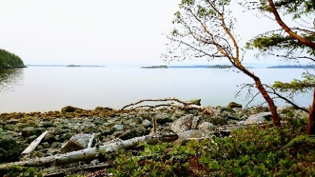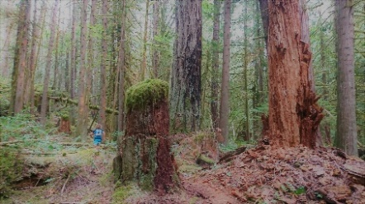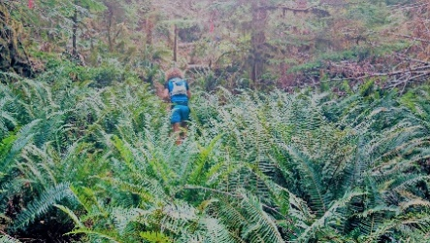

Stage 2 / Saturday 8 Sep: Riveleys Pond to Confederation Lake Hut
- 42km / 1000m+ (distance from the start = 74km)
- Set up camp at Confederation Lake (near the lake). Evening Briefing.
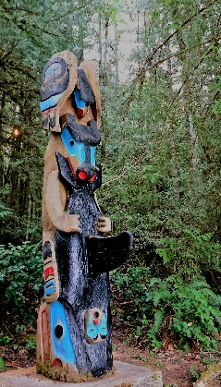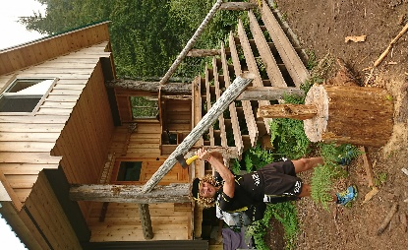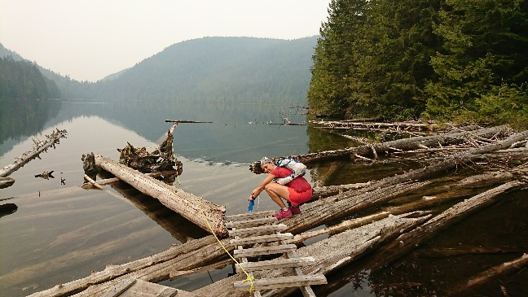

Stage 3 / Sunday 9 Sep: Confederation Lake to Elk Lake Hut
- 35km / 2000m+ (distance from start = 110km)
- Spring Main at ~105km: food drop + Exit point for people doing ‘half-trail’.
- Set up Camp at Elk Lake Hut (access to lake). Evening Briefing.
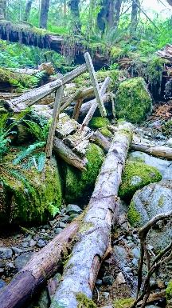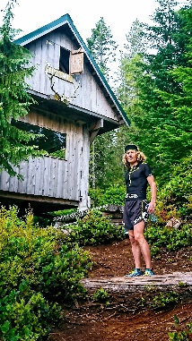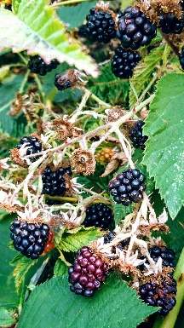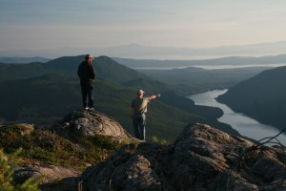

Stage 4 / Monday 10 Sep: Elk Lake to Golden Stanley Hut
- 35km / 1000m+ (cumulative = 145km)
- Set up camp at Golden Stanley Hut. Evening Briefing.
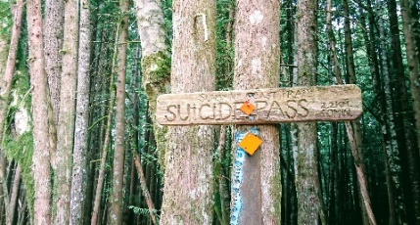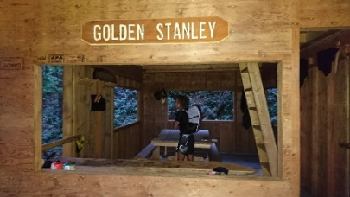

Stage 5 / Tuesday 11 Sep: Golden Stanley Hut to Trail Finish at Saltry Bay
- 35km / 2000m+ (TBC)
- Trail Finish at Saltry Bay Ferry. Snack/drinks provided at arrival.
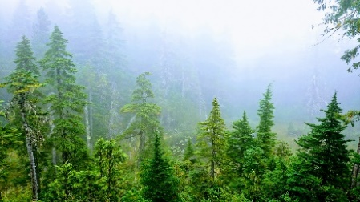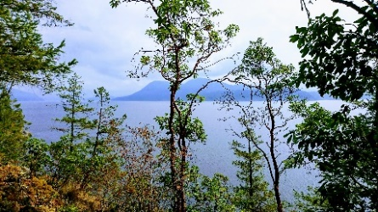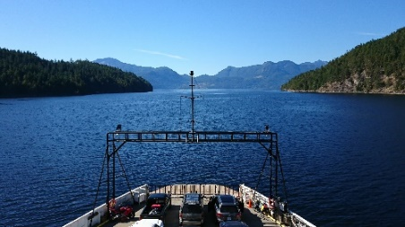

Tuesday 11 September
- Ferry from Saltry Bay to Earls Cove ferry terminal. Group transfer Earls Cove to Gibsons.
- Check-in at hotel in Gibsons (for those staying)
- Closing /awards, drinks and group dinner (dinner cost not included in package)
Those not staying in Gibsons can still join the awards on the 11th evening and catch the ferry after (price will be adjusted accordingly)

Tuesday 12 September
Ferry from Gibsons/Langdale to Horseshoe Bay. From there people can either take a bus or your own transportation.

Trip Package

Accommodation:
- Participants will sleep in tents (to be shared between teams of 2 people) from the night before the trail until the trail finish. Tents can be rented in Powell River if organised in advance.
- Hotel night is provided in Gibsons after the trail finish (Sep.11th)

Price
Full Trail: $300.00 if providing your own transportation and no hotel night on 11th
Full Trail :$500.00 CAD/pp (includes hotel night 11th Sept. & transport back to Horseshoe Bay)
Half Trail : $250.00

$25 added to each registration for the local trail/cabin building organisation PAWS – option to do a trail maintenance day instead

*Team Globetrailers Active Members get $50CAD discount
**Locals rate – contact us for info /to see if you qualify.

Package includes:
Transportation
- Pick up from Powell River airport (September 6th)
- Transfer to trail head (4x4 or boat)
- One food drop (planned for Day3)
- Transfer from trail finish back to Horseshoe Bay Ferry terminal
Accommodation
- September 6th (camping) and 11th (hotel in Gibsons)
- On the trail participants will carry their own tents (1 per team of 2
Meals
- Welcome dinner (6th Sep), breakfast 7 &12th , picnic 11th at arrival, aperitifs 11th evening
- Participants responsible for their own meals on the trail (snacks & main meals)
Staff
- experienced event management /trail runners, working with local partners
Coaching
- Advice during the trip on trail running and race / or general trip preparation
Prizes, Gift Bags, Celebrations
- Welcome Dinner / Closing drinks
- Gift bag & prizes
Donation to PAWS (Powell River Parks and Wilderness Society)
- $25pp goes to PAWS to support their efforts in maintaining the trails and cabins

Not included:
- Individuals are responsible for having adequate personal travel and medical insurance in case of emergency

REGISTER on:
www.lifewithoutacar.com or www.teamglobetrailers.com

