Hình Take note của Part 2:
Test 1

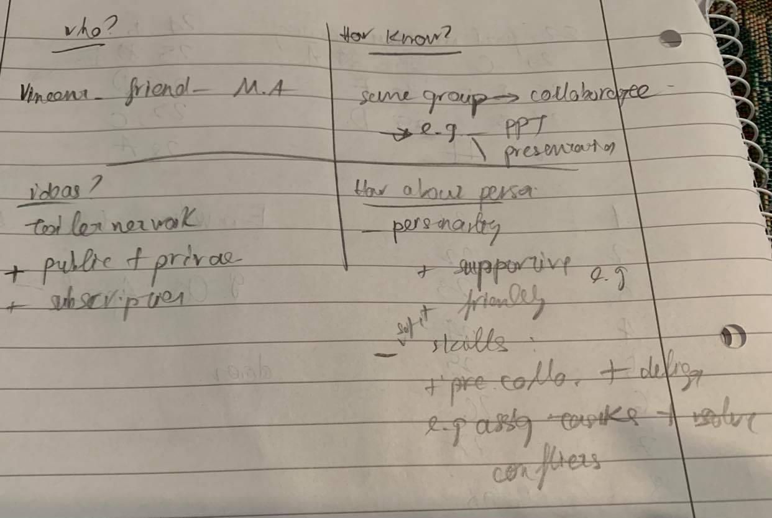

Test 2
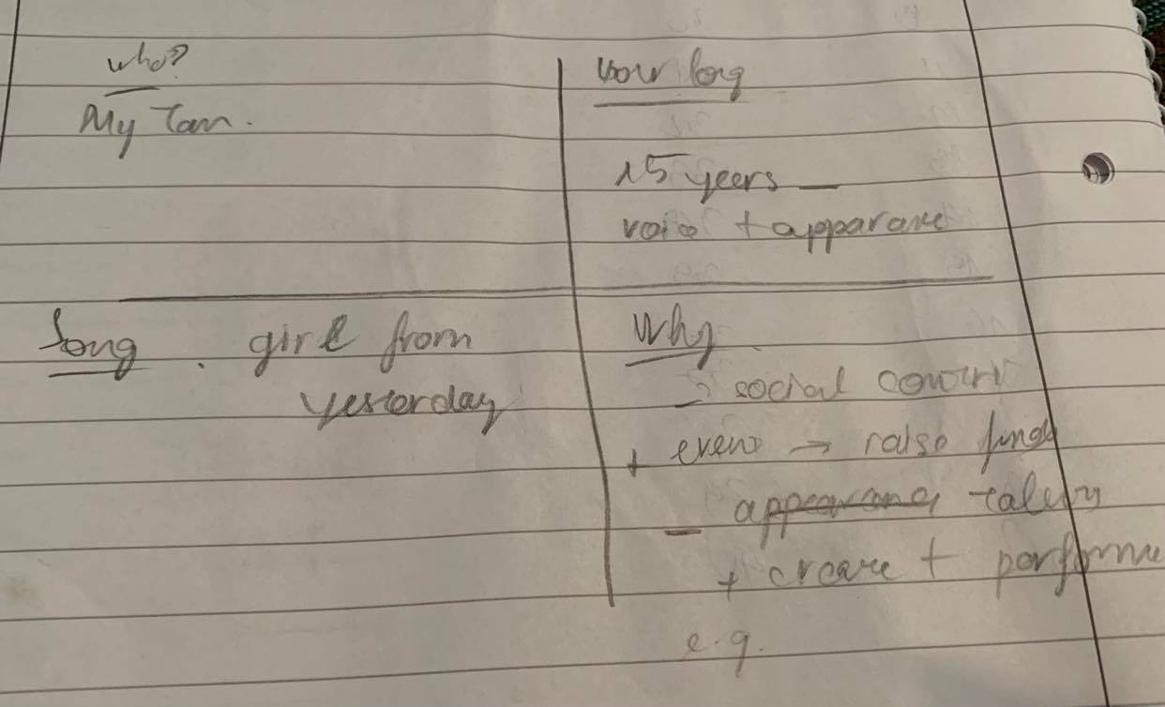

Test 3
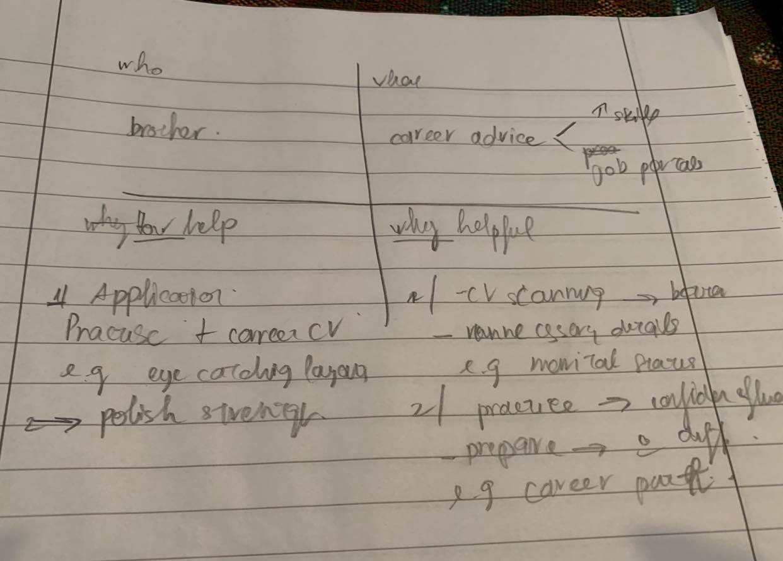
Hướng dẫn take note: https://www.ieltstutor.me/blog/take-note-ielts-speaking-part-2

Transcript Bài Nói Part 2 (Sắp xếp theo từng câu hỏi của đề)
Ví dụ:
Đọc hướng dẫn chung cho part 2 nhé:
https://www.ieltstutor.me/blog/ielts-speaking-part-2

Xem đề mẫu để tham khảo template với vocab nha: https://www.ieltstutor.me/blog/describe-a-person-ielts-speaking
Test 1:

Đọc lại hướng dẫn chung cho part 2 nhé
Xem qua bài mẫu để có template và từ vựng cho đề này nha:
A person you think has interesting ideas and opinions.

- Who this person is
- how you know this person
- What kinds of ideas and opinions he has
- How do you think of this person

Lan 4:
- Who this person is
The person I’m going to talk about is Vincent, who is my closest friend in my master’s program.
- how you know this person
Speaking of how I know him, we worked in the same groups for several subjects such as Marketing or Enterprise resource planning. When we were in the same team, he was usually responsible for creating slides and animations, and I was in charge of presenting our findings in front of the class.
- What kinds of ideas and opinions he has
As for his ideas, Vincent usually has interesting and creative ideas, which surprise not only our classmates but also our professors. For example, he suggested that our team should develop a platform of the toilet network in the city. More specifically, we will develop an application to connect all of the public and private toilets to show to the visitors, and users have to pay the subscription fee to use the web-based application.
- How do you think of this person
Actually, I’m interested in working with Vincent because of two reasons. Firstly, he has an adorable personality which is loved by everyone. In fact, he’s very friendly and supportive of everyone no matter who they are or where they come from. For example, he used to lend me his notes before the marketing exam so that I could pass the exam successfully.
Secondly, he has excellent soft skills which i usually admire. The thing is, he can make up proper plans and delegate the tasks very skillfully. Particularly, he used to break down the projects we were working on and assign the tasks to each member so that we could keep the deadline.

Test 2:
Describe your most favorite music band or singer you enjoy listening to
You should say

- What’s the name of the band and the band members?
- How long do you listen to their song?
- What is some famous song from this band?
- And explain why you like this singer

Lan 4:
- What’s the name of the band and the band members?
The singer I’m going to talk about is My Tam, who is a high-profile singer in the Vietnamese entertainment market.
- How long do you listen to their song?
Speaking of how long I’ve been listening to her songs, I first knew her in 2006 when my friend invited me to watch her performance. On this occasion, I was captivated by the attractive performance style and her eye-catching appearance.
- What is some famous song from this band?
Regarding the notable songs My Tam has performed, she has plenty of hits and my favorite one is “The girl from yesterday”.
Particularly, the song has meaningful lyrics and a slow melody, which is my favorite genre.
- And explain why you like this singer
As for the reasons why I adore her, there are many characteristics that distinguish her from other celebrities.
Firstly, she has made great social contributions to underprivileged people who suffer poverty and financial difficulties. More specifically, she has organized many events annually to raise public funds and donated a lot of money for them. For example, she just donated more than 10 billion VND to support the people in the middle of vietnam this year.
Secondly, she has outstanding innate musical talents, which is indescribable. Indeed, she has written and performed many songs, which are loved by a large number of fans, in her career. To illustrate, she was the composer and the singer for more than 10 songs in the last decade.

Test 3:
A person who encouraged and helped you to achieve a goal

- Who this person is
- What this person encouraged you to do
- How this person helped you
- And explain why this encouragement helped you to achieve the goal

Lan 4:
- Who this person is
The person I’m going to talk about is my elder brother, who is 8 years older than me.
- What this person encouraged you to do
As for what he encouraged me to do, when I graduated from my bachelor’s program, he gave me a lot of advice about how to get a well-paid job, which was my ultimate goal at that time.
- How this person helped you
Regarding his support, to help me achieve this ambitious goal, he provided plenty of support to improve my competencies in the application process. To illustrate, he spent a lot of time correcting my CV and practising interviews with me in his free time.
- And explain why this encouragement helped you to achieve the goal
Generally speaking, his encouragement is definitely very useful and meaningful to me for two reasons.
Firstly, I seriously lacked many critical skills and knowledge at that time since it was my first time to apply for a job, so his guidance played a vital role in the success of my application documents in the CV-scanning round. Particularly, he suggested that I should only keep the relevant skills and put them on the top of my CV to attract the attention of the readers and avoid unnecessarily excessive information.
Secondly, he offered me many trial interviews to increase my practical experience. In fact, he prepared various questions, which are commonly asked in a real interview, to test my skills, logical thinking, and career goals. As a result, I felt more confident, and I answered all of these questions fluently when I met the real interviewers.

Transcript Bài Nói Part 3 (Từng câu hỏi bắt buộc phải có Takescript)

