2. Describe an activity you usually do that wastes your time
You should say:
What it is
When you usually do it
Why you do it
And explain why you think it wastes your time
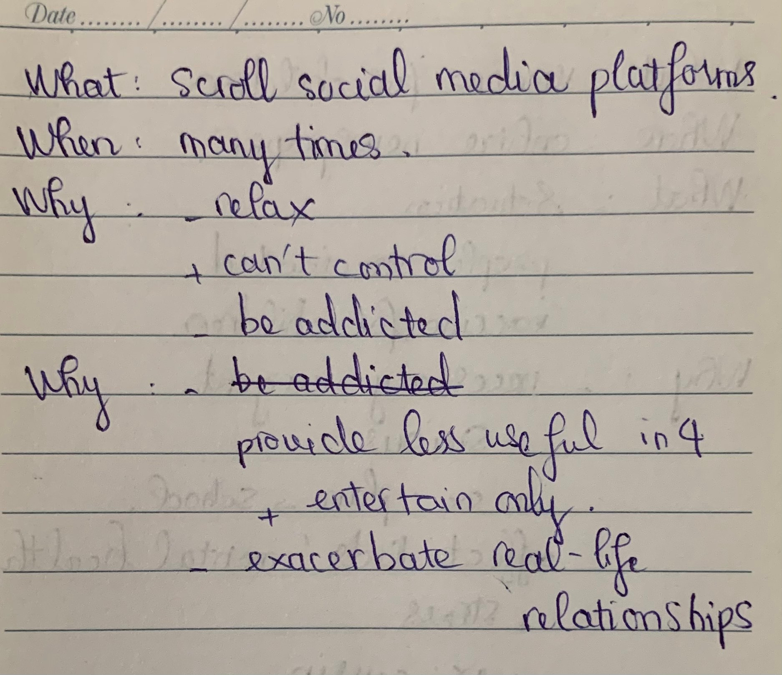
Well, I would like to talk about a thing that I usually do that I think it’s quite time-consuming.
What it is
That is scrolling social media platforms.
When you usually do it
In fact, I admit that the time I use these social media platforms is uncountable. Specifically, when I see a notification on Facebook, I click on this and that leads me to start to scroll the new feed, many times in a day.
Why you do it
Well, I suppose that I have that habit for 2 reasons. The first one is I wanna relax but I can’t control the times I use Facebook or Instagram, which is very time-consuming. As a result, I don’t have enough time for other things. The second reason that I realize is maybe I’m addicted to scrolling these platforms. Precisely, I mean I can’t change that habit although I know that it’s not good for me to do that too much.
And explain why you think it wastes your time
I suppose scrolling too much social media is a waste of my time. The first reason is these platforms provide less useful information. In fact, Fb or Insta are entertaining platforms that help people relax, so we don’t get too much useful information. For example, I scroll for FB watch, videos of film reaction and so on, and that is a way to entertain only. The second reason is too much focusing on social media will cause exacerbation in real-life relationships. Specifically, instead of spending time on FB or Insta to contact online friends, I should spend that quality time on my real-life relationships to enhance our cohesion.
lưu ý bám sát vào cue card để trả lời nhé:
- What it is
  - Browsing social media apps on my phone - an awful that I usually squander a lot of time on / that I will try my best to get rid of >> IELTS TUTOR hướng dẫn Từ vựng topic "social media" IELTS
- When you usually do it
  - Throughout the day I use my phone for hours without even noticing the time. >> IELTS TUTOR hướng dẫn Cách dùng từ "throughout" tiếng anh
  - In the middle of my work, I tend to take small breaks which turn into hours when I surf social networking sites
- Why you do it
  - Check my newsfeed and keep me updated with the latest news and events >> IELTS TUTOR hướng dẫn Diễn đạt "cập nhật tin tức" tiếng anh
  - Keep in touch with my friends and family members
  - Watch comedy videos and movies to unwind and reduce stress after some hours of work
- And explain why you think it wastes your time
  - Main idea 1: It does not have many great benefits except for pure relaxation >> IELTS TUTOR hướng dẫn Cách dùng BENEFIT (động từ, danh từ) & BENEFICIAL
    - Supporting idea: I have to admit that most of the time I spend on social networking sites is for entertainment purposes
    - Supporting idea: These platforms are bombarded with extremely tempting advertisements, and once I get on these sites to check anything, I end up wasting a lot of time. >> IELTS TUTOR hướng dẫn Phân biệt"advertising/advertisement/ads/advert
  - Main idea 2: It distracts me from completing some important tasks of the day and affects my overall productivity

