Travel Weekly

South Pacific: What's new in Fiji, the Cook Islands and Samoa
Anna Selby
Aug 21st 2008

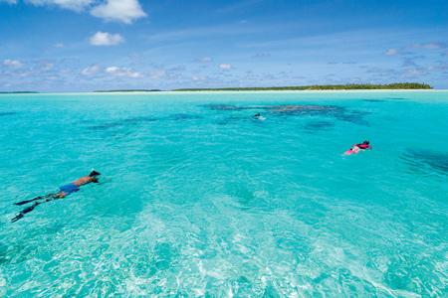

Anna Selby heads to Fiji, the Cook Islands and Samoa to look at new attractions and hotels

For an exotic beach destination, the South Pacific is hard to beat. Think white, sandy beaches, clear, blue water teeming with tropical fish and coral, and top-class resorts - and, with the exception of French Polynesia, everyone speaks English.

Popular for weddings and honeymoons, the islands are just a four-hour flight from Australia and New Zealand and some are stopovers points on routes from the UK.

Fiji
Fiji has one of the best-developed tourism industries in the South Pacific and has dozens of luxury resorts.

On my last visit to island resort Denarau Island five years ago, there was little more than a small port and a mangrove swamp. Now there are five-star resorts, a marina with shops and restaurants, a golf course and a free shuttle bus service. The resorts include a Hilton, Westin and a Sofitel. All are new and have extensive facilities ranging from spas to scuba diving.

The resort's harbour is the main gateway to the Mamanuca and Yasawa Islands, and a starting point for cruises and water sports. Denarau Island is also conveniently placed for the main tourist centre of Nadi Town and the international airport.

Likuliku Resort opened earlier this year in the beautiful Fijian Mamanuca archipelago and is an elegant couples-only resort. There is a top-class restaurant, a spa, a mangrove reserve, a turquoise lagoon and a variety of rooms.

The beach villas are huge with indoor and outdoor bathrooms as well as private plunge pools. Best of all are the over-water bures (bungalows) with thatched roofs, private decks and steps straight down into the lagoon.

If you want to swim with the fish but can't be bothered to go diving, then the glass-bottomed floors in the bungalow are the perfect place to lay back and watch the marine life go by.

Sample product: Turquoise Holidays offers seven nights (including one night free) at Likuliku in a beachfront bure, including all meals, flights from Heathrow to Fiji with Air New Zealand /Air Pacific and return seaplane transfers from Nadi to Likuliku from £2,475 per person, based on two sharing (01494 678 400).

Cook Islands
With a population of 18,000 scattered over 13 inhabited islands, the Cook Islands are tiny compared to Fiji. The two main islands for visitors are Rarotonga, the capital, and Aitutaki.

As well as being island paradises, the Cooks have a fascinating culture. On Rarotonga, the appropriately named Highland Paradise gives a unique introduction to Polynesian life.

A warrior in full Polynesian dress takes you on a tour of the marae (sacred meeting place) and explains how to husk a coconut, weave a basket from pandanus leaves, build an earth oven and perform a sacrifice (cannibalism used to be big here).

There is also a show with local musicians and dancers followed by a traditional Cook Islands feast.

Sample product: Kuoni offers five nights' bed and breakfast at the newly refurbished boutique hotel Little Polynesian, in Rarotonga, from £2,299 twin-share in November, including flights with Air New Zealand from Heathrow and transfers in resort (01306 747 008).

Samoa
Like Rarotonga in the Cook Islands, Western Samoa is one of Air New Zealand's stopovers for those en route to Auckland. Samoa's newest beachfront accommodation, Seabreeze, has just a handful of guest bungalows lining the shore, each with a deck overlooking the ocean and a lagoon.
For a truly Polynesian experience, there is the traditional fale, which is a sleeping platform with a thatched roof and woven blinds for privacy.

Virgin Cove has fales on a beach of pure white sand overlooking a lagoon, surrounded by palm trees and tropical gardens as well as a family-run restaurant.

Sample product: Audley Travel features a week in Samoa staying in Virgin Cove fale from £1,260 per person including all international flights and taxes, transfers, and a fale on a DBB basis. For Seabreeze, prices start from £1,425 per person on a bed-and-breakfast basis (01992 838 000).

Cruises
The best way to get around the South Pacific is by ship. The islands look glorious from the water and you can get to those parts that planes just can't reach. Cruise specialist Noble Caledonia ventured into these waters for the first time this year.

The operator's Lost Islands of Polynesia cruise on board Clipper Odyssey operates from October 30 to November 16 2009 and visits the Society, Tuamotus and Marquesas Islands.

Special offer prices start from £4,995 and include return flights from London (020 7752 0000).

