Đề bài: The tables show the number of research students in Australian universities in 2001 and 2010.
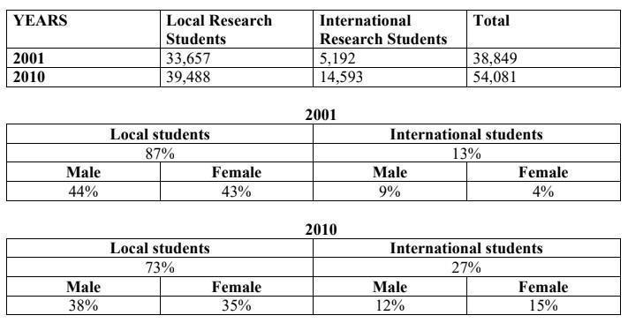
Dàn bài ( 5-7 PHÚT )

Từ vựng biểu đồ có thời gian https://www.tutorspeaking.com/blog/ielts-writing-task-1-ngon-ngu-mieu-ta-xu-huong

Given are the tables illustrating the quantity of students who did research in Australian universities and the gender distribution of national and international research students between 2001 and 2010.
Overall, the total of research students increased considerably over 9 years. Additionally, the proportion of local students who did research witnessed an upward trend, the different pattern can be seen for the one of international students
A more detailed look at the first table reveals that in the period of 9 years, the figure for local students shown a gradual rise from 33,657 to 39,488 pupils in comparison with the triple growth in the data of oversea students, accounting for 14,593 students in the end of the period.. Moreover, the total number of surveyed students in Australia soared by approximately 15,000 students.
Regarding the remaining tables, the proportion of local students decreased gradually from 87% to 73% between 2001 and 2010, as well as saw the equal figures for males and females in both years, at 44% and 43%(2001), 38% and 35%(2010), respectively. By contrast, the percentage of international students went up by 14% in the past 9 years. In 2001, the rate of international male students was 5% higher than the one of female students, but 9 years later, the figure for females exceeded that for males with the growth of 11%.
IELTS TUTOR lưu ý:
  - Overall:
    - There was a strong growth in the total number of research students between 2001 and 2010 >> IELTS TUTOR hướng dẫn Cách dùng danh từ "growth" tiếng anh
    - Significantly more local students enrolled in research courses compared to international students.
  - Body 1: Viết về bảng 1
    - The number of local research students rose slightly from 33,577 to 39,488 during the 9-year-period.
    - There was an almost threefold increase in that of international students, jumping from over 5,000 in 2001 to nearly 14,600 students in 2010. >> IELTS TUTOR hướng dẫn Cách dùng động từ "grow" tiếng anh
    - This resulted in an increase of around 15,000 in the total amount of research students in Australian universities, though by 2010
  - Body 2: Viết về bảng 2+3
    - Viết về Local Students
      - The percentages of male and female local research students stayed equal to each other in the two years surveyed (nêu số liệu) >> IELTS TUTOR hướng dẫn Từ Vựng & Cấu Trúc "line graph & biểu đồ có xu hướng
    - Viết về International students
      - In 2001, the proportion of international research students who were male, which accounted for 9% of the total, was more than double that of females (4%).
      - 9 years later, the figures for female international students increased and overtook that of males, reaching 15% and 12% of the total respectively.

