Link Đề bài:

Transcript Bài Nói Part 1 (Từng câu hỏi bắt buộc phải có Takescript)

Câu hỏi 1: Do you work or are you a student?

1st time:
At the moment, I’m taking a full-time position as an international project manager at HST Systemtechnik. I like this position because I can travel to many different locations and interact with international colleagues and counterparts.

2nd time:
At the moment, I’m taking a full-time position as an International Project Manager at HST Systemtechnik. I like this position because I can travel to many different locations and interact with colleagues and counterparts around the world.

3rd time:
At the moment, I am working as an International Project Manager at HST Systemtechnik. I like this position because it offers a lot of opportunities to travel to many locations and interact with people around the world.
4th time:
At the moment, I’m working as an International Project Manager at HST Systemtechnik, which is a technology provider in the watery industry. I’m really enjoy the tasks I’m doing because I can not only interact with people around the world but also travel to different locations.
Câu hỏi 2: Will you continue doing this job in the future?

1st time:
I plan to go on with this job in the next two years because I think it helps me to improve my soft skills such as my negotiation skills or interaction skills. In addition, it offers a good chance to expand my professional network.

2nd time:
Yes, in short-time, I don’t have any plan to look for a new job because the current position allows me to improve my business skills like negotiation skills, strategic thinking, communication skills. More importantly, it provides good opportunities to expand my professional network.
=> TRANSCRIPT VỚI AUDIO KHÁC NHAU QUÁ NÈ
3rd time:
Yes, in short-time, I don’t have any plan to look for a new job because the current one offers me good opportunities to improve my soft skills such as negotiation skills or interaction skills. In addition, it provides many chances to expand my professional network.
4th time:
Yes, in short-time, I don’t have any plan to look for a new job because I’m enjoying the tasks I”m doing. The current position offers me good opportunities to expand my professional network and improve my skills such as negotiation or communication skills with international partners.
Hình Take note của Part 2:
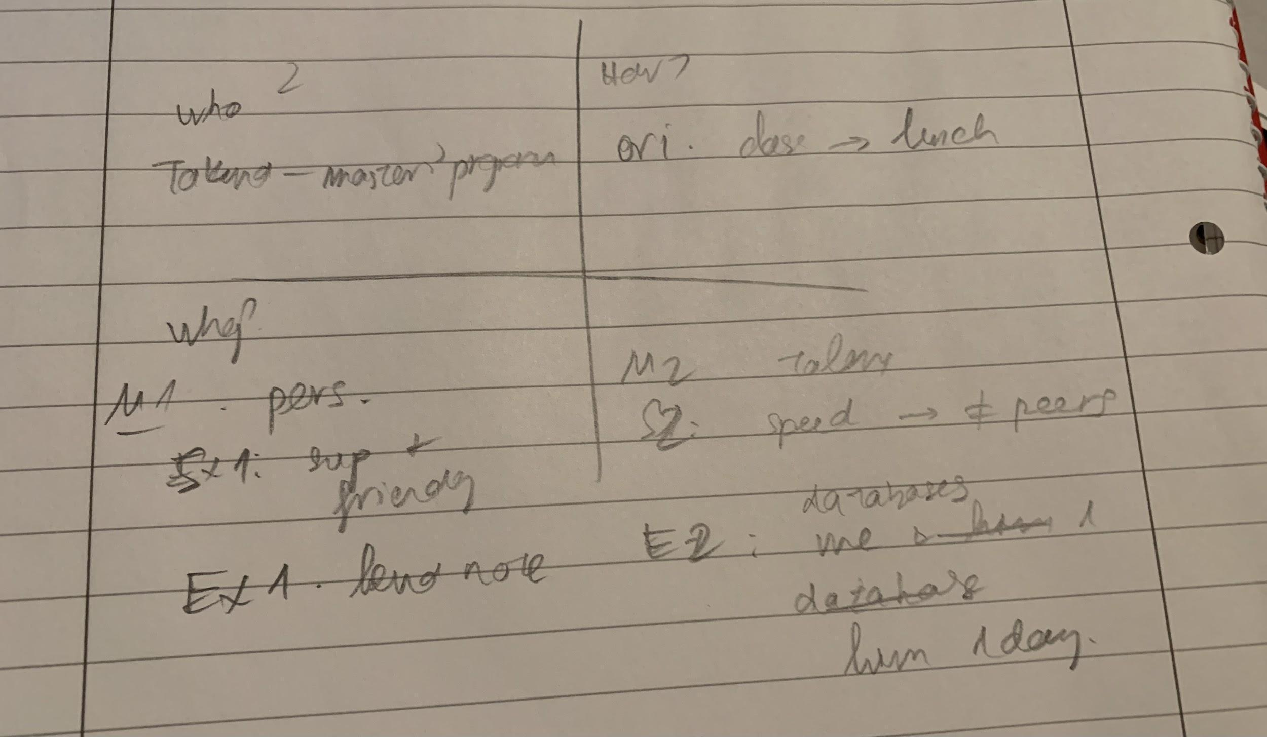

Note lần 4:
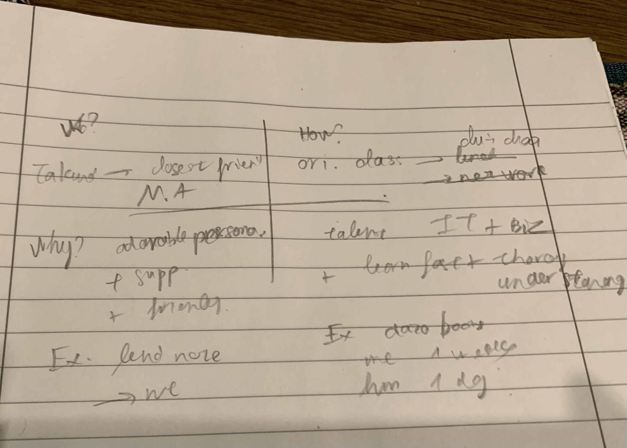
Transcript Bài Nói Part 2 (Sắp xếp theo từng câu hỏi của đề)
Ví dụ:

Describe someone you would like to study or work with
- who this person is
Takunda, closest friend, master’s program
- how you know him/her
orient. Class -> lunch -> network
- why you would like to study or do with him/her
M1: personalities – friendly, supportive, hard-working, well-structured
- S1: save time & efforts, feel comfortable
- E1: took notes + shared to me
M2: talents – good IT proficiencies + business concepts, creativity, lots of experience
- S2: understand lessons faster + more thoroughly
- E2: me 1 week -> him 1-2 days
Thì Transcript sẽ sắp xếp như sau:
- who this person is

1st time:
The person I’m going to talk about is my best friend in my master’s course. His name is Takunda and he’s from Zimbabwe.
2nd time:
The person I’m going to talk about is Takunda. He’s my closest friend in my master’s program.
3rd time:
The person I’m going to talk about is Takunda, who is my closest friend in my master’s program.
4th time:
The person I’m going to talk about is Takunda, who is my closest friend in my master’s program.
- how you know him/her
1st time:
It is at the orientation course and after the classes, we went to have lunch together. In the canteen of the university, I sat next to him and he looked very conservative and a little bit nervous at that time. Therefore, I took initiative about his hometown, his impression about the university, as well as his experience in Germany. He was very friendly and his English was excellent. He’s willing to tell me everything he felt, and think, about the new country, the new classmates, and he was also openly to share his background, his family in his hometown.

2nd time:
The first day I met him was the orientation class of my master’s program in 2017. In the lunch time, we sat next to each other and talked about various topics.
3rd time:
I first met him in the orientation class and we sat next to each other during the lunch time. we talked about various topics like university, campuses, or professors..
4th time:
I firstly met him in the orientation class where we sat next to each other and chitchated about various topics.
- why you would like to study or do with him/her

1st time:
I like working and studying with him because he is a very well-structured person. Before every group work, he made an outline and prepared an agenda. Furthermore, he is also very supportive. He prepared the notes and he usually lent me his notes the other materials in the classes.

2nd time:
There are several reasons why I like studying with Takunda. The first reason is his adorable personalities. He is super supportive and friendly with everyone no matter who they are or where they come from. He is also a hard-working and well-structured student. Thanks to him, I saved a lot of time and efforts, and I also felt very comfortable when I studied with him. He took notes and shared to me after the classes, and it saved me a lot of time to review again after one week.
The second reason why I like him is his special talents. He has a good understanding of business concepts with excellent IT skills. Furthermore, he is very creactive and possess lots of practical experience. Thanks to his knowledge and experience, he can understand the lessons much faster and more thoroughly than the other peers in the class. For instance, when I spent several days to learn about relational databases, he finished the homework within just 1 or two days.

=> transcript với audio nhiều chỗ khác quá nè. Phải làm transcript đúng với audio thì mới feedback đúng được nha
3rd time:
I like studying with takunda because of 2 main reasons. First of all, he has an adorable personality. He is very supportive and friendly with everyone no matter who they are or where they come from. For example, he used to lend his notes before the exam and I think it is a critical factor which helped me pass the exam successfully.
Secondly, he has special talents in IT and business. He has a good understanding of various topics in these fields and he also obtained practical experience in the previous professions. Therefore, he has an amazing learning speed compared to other peers in the class. For instance, while I spent several days to learn about databases, he finished all of the homework and explained to me just within one day. => Nên tập sử dụng đa dạng cấu trúc của mình hơn để tránh lặp từ/ lặp câu nhé. Hiện tại mình chủ yếu dùng câu đơn với đại từ nhân xưng làm chủ ngữ.
4th time:
There are two main reasons why I like working with Takunda. First of all, he has an adorable personality, which is loved by all of the classmates. He’s very supportive and friendly with everyone no matter who they are or where they come from. For example, he used to lend me his notes right before the marketing exam and it helped me pass the exam successfully. Another reason which distinguish him from other peers is his outstanding talents in IT and business. His logical thinking and practical experience enable Takunda to learn and master the theories and lessons much faster and more thoroughly than other classmates. For example, while I spent more than one week to study the databases, Takunda could finish all of the homework just within two days.
Transcript Bài Nói Part 3 (Từng câu hỏi bắt buộc phải có Takescript)
- Which one is more important, salary or job satisfaction?
M: Job satisfaction
S: JS -> commitment + devotion
E: waitress at coffee shop -> supervisor / managers after many years of dedication
1st time:
Personally, I think job satisfaction play more important role than salary because job satisfaction is a critical factory which helps employees to commit to their company and their position. the longer they work in the company, the more likely they get promotion. And as a result, their salary will increase gradually as well.
2nd time:
I personally think that job satisfaction is much more important than salary. Job satisfaction is the foundation of commitment and devotion of employees. Once employees are satisfied with their job, they will try their best and dedicate most of their efforts to achieve outstanding results and satisfy managers. When their efforts are recognized by the management, they can get promoted and receive higher salary. For instance, a waitress at a coffee shop can be promoted into the store manager after many years of service and dedication.
=> sao 2 bản khác nhau quá vậy
3rd time:
M1: JS > Salary
S1: foundation -> commitment & devotion -> promotion
E1: waitress -> sup. / manager af. contributions
Personally I think job satisfaction is more important because it is the foundation of commitment and devotion of employees in all companies. once employees are satisfied with their current position, they will dedicate their time and efforts to fulfil the assigned responsibilities. as a result, once their efforts are recognized by their management team, they will get promoted. And consequently, their salaries can be increased as well. For instance, a waitress at a coffee shop can be promoted to a shop supervisor or manager after many years of dedications and contributions.
4th time:
S: Job sat. > salary
M1: benefit career development
S1: satisfy -> commitment + devotion
E1: willingness of working overtime to meet deadline -> appreciated by managers
M2: avoid negative impacts from job hopping
S2: loyalty is questioned
E2: more difficult questions in interview rounds
In my opinion, salary is not important as job satisfaction because of two main reasons.
Firstly, deciding the job based on job satisfaction will benefit career development. Employees who are satisfied with their job usually devote their time and efforts to fulfil the tasks they are assigned. For example, satisfied employees may be willing to work overtime to meet the deadline, which is usually appreciated by their managers.
Secondly, it also prevent employees from negative impacts of job hopping. If an employee changes his or her job so frequently, their loyalty may be questioned by the new companies. For instance, they may be asked more difficult questions in the interview rounds or they may be requested to take a longer probation period to test their commitment.
- What are the most popular jobs for young people in your country?
M: various jobs – voluntary & manual, tutor, internship
S: depends on educational level, career objectives & financial situation -> each person has to decide which one is suitable
E: 1st year -> manual work, 4th year -> internships
1st time:
I think it depends on the educational level of the students or young people in general. For students who are at the university, they usually take the manual work. For example, many young people in Vietnam are driving sharing motorbikes in their free time to earn the income. For the others who have a little experience or have higher level of ambitions, they take voluntary work or take internship at companies to earn practical experience, which will be very beneficial for their future career.
2nd time:
There are many types of jobs for young people in Vietnam, such as internships, tutors, voluntary or manual jobs. However, since people have different starting points, objectives and ambitions, each individual has to decide which one is suitable for him or herself. For instance, fresh graduate may want to work as an intern in large corporations even without any incentives because it is beneficial for their future career. On the other hand, the 1st year students who have limited skills and knowledge may work in construction sites to afford their monthly expenses.
=> TRANSCRIPT VỚI AUDIO KHÁC NHAU QUÁ NÈ
3rd time:
M: various jobs: tutor / voluntary / internship / manual
S: education level, skills & financial situation
E: tutor - earn exp. & make income
In Vietnam, there are various types of jobs for young people such as tutor, internship, voluntary or manual work. depending on educational level, skills and financial situation, each person can decide which one is suitable for them. for instance, many young people prefer to become a tutor, especially English tutor, because they can earn practical experience and also, make a decent amount of income.
4th time:
various, depends on edu. level
good qualifications: interns or voluntary work in NGO
students: manual work e.g. construction site, coffees shop
THere are various types of job for young people in Vietnam, but it depends on the educational level to decide which one is suitable for them. For the people who have good qualifications, they prefer working in big corporations as an intern or apply for voluntary work in non-government organizations to earn practical experience and a decent amount of income.
On the other hand, students in the universities who are missing skills and knowledge of business, they tend to take the manual work at the construction sites or coffee shops to afford their monthly expenses
- How have people's ways of studying changed?
M: change dramatically – physically to virtually
S: The advancement of ICT -> new educational models, convenient & online
E: more and more e-learning platforms, providing records or interactive methods
1st time:
I think the way people study has change dramatically in the last 10 years. Thanks to the advancement of information technology, the new means of communication and collaboration tools, and of course, the introduction and the widespread of the Internet, people nowadays can study whenever and wherever they want. More and more people register on the online classes to study not only their major areas but also additional or related ones to perfect their skills and find more development opportunities.
2nd time:
The ways people obtain knowledge have changed dramatically in the last decade, mainly from physically to virtually. Thanks to the advancement of information and communication technology, a lot of new educational models have been developed, which are very convenient and available online. For instance, there are many e-learning platforms via which people can learn by watching recording videos or interacting with lecturers directly and virtually.
3rd time:
M: dramatic changes: physical -> virtual
S: advancement of ICT -> when- + wherever + various interaction
E: Q&A -> new way of interaction
In the last decade, the ways that people obtain knowledge have changed dramatically, mainly from physical to virtual. Thanks to the advancement of information and communication technology, many platforms and communication tools have been developed. Therefore, people nowadays can easily access to the course whenever and wherever they are. in addition, they can interact with the lecture and other participants in different ways. for example, students who participate in online courses can post their questions and get the answers from the other peers, and this is a new way of interaction.
⇒ part 3 là có template hết rồi của 7 dạng câu hỏi chính nên mình có thể đọc chỉ cần ráp vào template thôi cho dễ nha https://www.ieltsgeneral.info/blog/tom-tat-cach-tra-loi-7-dang-cau-hoi-ielts-speaking-part-3 vì nếu mỗi câu trả lời 1 kiểu vào thi gặp topic lạ rất dễ mất điểm fluency nha
4th time:
S: physical -> virtual
Past: go to class -> obtain knowledge mainly in classes e.g. questions are answered by teachers in classes
Now: online courses (when + where) -> questions are posted & answers by other students
from my point of view, the ways that people obtain knowledge have changed dramatically, mainly from physical to virtual.
In the past, our grandparents and parents used to go the class everyday and asked questions directly in the classes. if they had any questions at home, they would have to wait until the following days to meet the teachers and ask again. Nowadays, thanks to the the advancement of information and communication technology and the popularity of the Internet, there are more and more online courses and e-learning platforms in which students can watch recording videos and ask questions directly. Therefore, students don’t need to wait until they can meet the teach and get the answer. Instead, they can post their questions on the platform, and other students or the lecturers can see their questions and give their feedback about the answers.

    - Còn sai grammar
      - I’m really enjoy
      - Cách dùng spend ...doing https://www.ieltsdanang.vn/blog/cach-dung-dong-tu-spend-tieng-anh
    - Grammar Range & Accuracy 6.5 —> sai lỗi lặt vặt nhiều thiếu động từ, thêm s…
    - Pronunciation 7 —> âm cuối thỉnh thoảng thiếu questioned
    - Lexical resource 6.5-7.0 —> chưa paraphrase nhiều các từ như important, like...chưa đa dạng cấu trúc dùng nhiều mệnh đề quan hệ https://www.suabaiieltswriting.com/blog/khong-phai-luc-nao-cung-nen-dung-menh-de-quan-he-tieng-anh
    - Fluency & Coherence 6.5—> part 2 ậm ờ nhiều, part 3 ậm từ nhiều, chỉ có câu cuối fluency khá ổn

