Reggae Sumfest 2019 - A Success

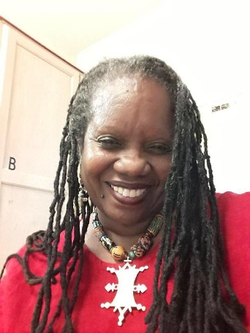

by
Ms. Fabian Burrell

The world-renowned Reggae Sumfest held at Catherine Hall Entertainment Complex lived up to its reputation of being the greatest show on earth. This event showcased Jamaica's music legends right alongside local talents. Buju Banton, Beres Hammond, Spragga Benz, Spice, Chronixx, Beenie Man, Koffee, Elephant Man, Jah 9, Etana, Dalton Harris, and Bounty Killer
shared their artistry before 20,000 plus fans.

Thanks to a media colleague, I was able to attend as a returning media professional, from previous Sumfest festivals and I immediately noticed a significant change. To begin with, the performances usually staged over three nights were performed in two nights. Friday night was Festival Night 1 and featured Dancehall with 18,000 patrons. Saturday night was Festival Night 2 and featured Reggae, and with the Buju factor amassed 20,000 plus patrons. The lineup of Jamaican artists like Beres Hammond, Buju Banton, Beenie Man, Bounty Killer, and others delivered electric performances. Their global appeal left no one wanting the "obligatory" USbased singers line Celine Dion, R. Kelly, Common and Jennifer Hudson usually headlining this event.

Lady English, Radio host for the English Connection Media show on 99 Jams WUJM "The Burg" 99.1FM shared her opinion, "Reggae Sumfest 2019 was the best staging ever! StarKist Foods heir, Josef Bogdanovich bought the production in 2016 with the motto “our music, our festival”! He said the event did not need international artists to bring in the crowd and he has proved the naysayers wrong! This was my 4th visit."

Many event-goers came out to see 2011 Grammy winner Buju 'Gargamel' Banton whose recent release from prison on December 8, 2018, is still a hot topic. His inimitable guttural sound was as rich and vibrant as ever. When the notes for "I Wanna Rule My Destiny," rang out the crowd roared in unison. When he segued into "Not An Easy Road," he stopped and said, "no disrespect, if I continue in this slidey shoes, I goin' drop." He then took off his shoes and performed barefoot for the remainder of the show. His songs were as relevant today as they were 20 years ago when he first came on the scene. Many hail him as the Bob Marley of today.
Buju spent eight years, six months, twenty-seven days, thirteen hours, five minutes, and twenty-six seconds in prison on a drug charge. While incarcerated he earned a Masters Degree in Music Business Management from New York University. He noted in a report on Youtube, "I was not troubled (molested) in prison.” That period though, gave him a chance to reflect on what was happening in the world and I expect he will surely pen some songs from this experience.

Notable performances by; Dancehall icons Beenie Man and Bounty Killer brought the house down. I am hopeful that their soundclash dueling may be an indication that their warring is a thing of the past.

Teenage phenom Koffee won the hearts of Sumfest die-hard reggae fans with her conscious lyrics and innocence. Koffee, who got added to the lineup of Dancehall artists on Friday nightperformed like a seasoned professional. She has been making impressive moves since she first performed at Rebel Salute in January 2018 at the invitation of the legendary reggae artist Coco Tea. She interviews intelligently and is mature beyond her years. All who have watched her perform encouraged her to remain humble and not "skin out" which is the styling of some female Dancehall artists. She is living proof that you can choose to be respectful, maintain standards, and still rise in this competitive field. She is one to watch as she ascends to the top of the reggae fraternity.

As "Energy God" Elephant Man belted out "What a Mighty God We Serve" with a Bible in his hand, many in the audience speculated about having a gospel night. His performance roused the crowd who seemed to have settled into late-night fatigue.

The event originally scheduled to end at 5:30 a.m. went overtime until the profanity of one of the artists forced the closure. Patrons were a bit disgruntled as they were forced to leave the venue after the police command shut down the Dancehall night at 8:27 a.m. with seven acts still left to perform. "... with the profanity increasing they finally had to do something about it" according to Superintendent of Police, Gary McKenzie.

If you plan on attending Reggae Sumfest 2020, make your travel plans early, so you are close to the venue. Wear comfortable clothing and shoes that can handle rough terrain as it is standing room only, except in the VIP sections.

Thanks to the many sponsors including Red Stripe, Grace Foods, Caribbean Airlines, Iberostar Hotels & Resorts, Half Moon Hotel, Knutsford Express and Downsound Entertainment. We must commend them for their encouragement and support of the culture.

