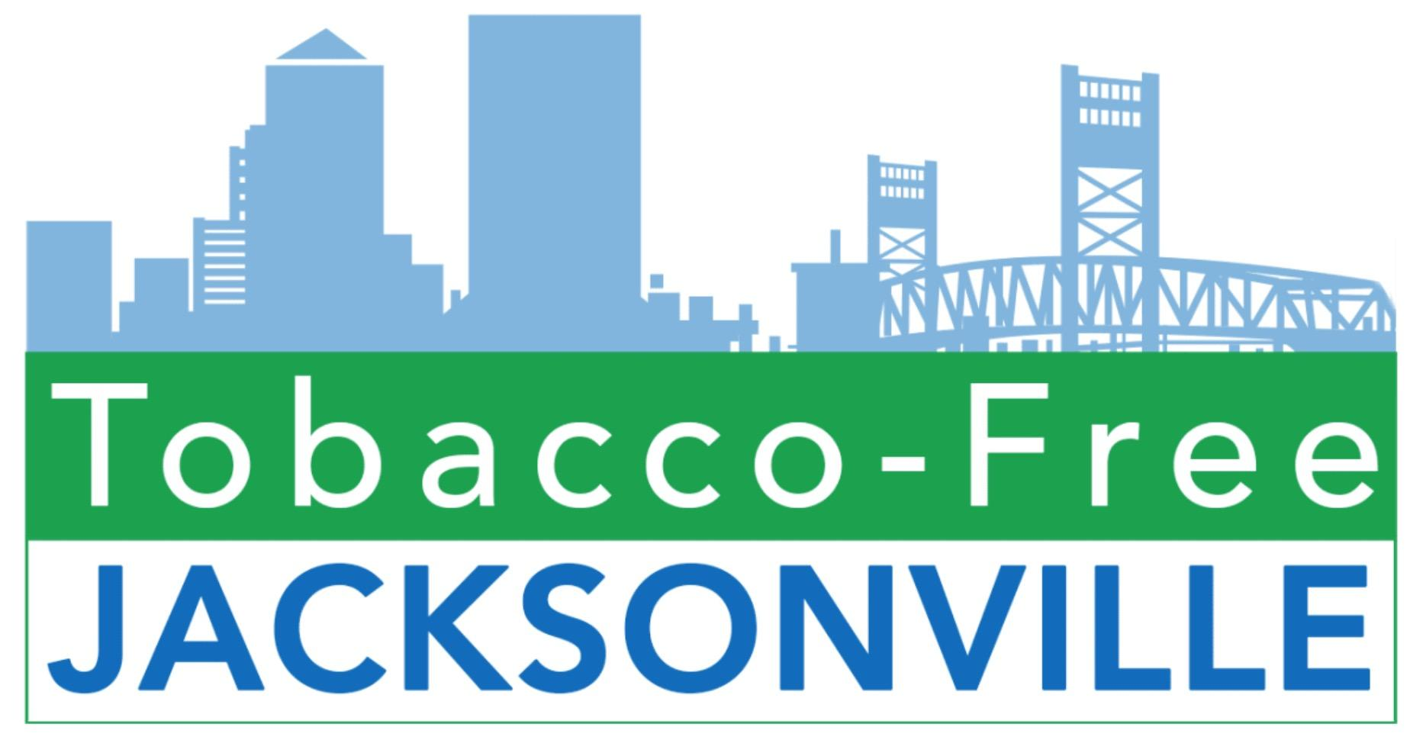
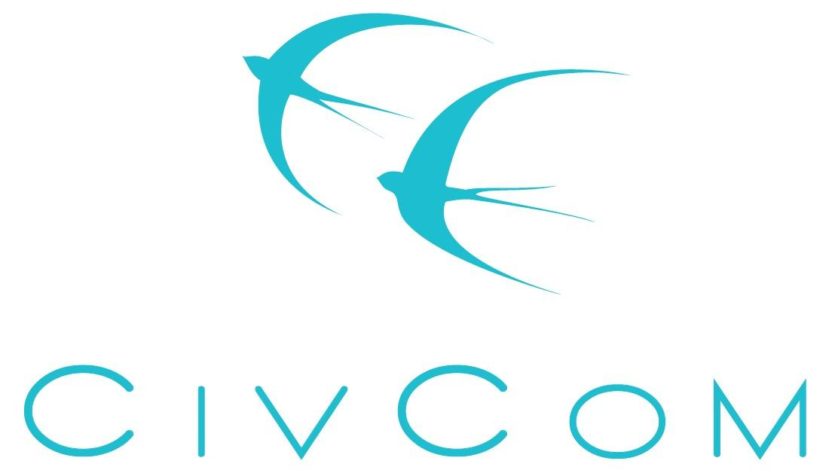
Public Health Internship – Tobacco Prevention & Control

Purpose: Tobacco related disease is single handedly the largest cause of preventable death, not just in the United States, but worldwide. Tobacco products are engineered to addict users to nicotine and are predatorily marketed to young populations. Ninety percent of tobacco users are addicted to nicotine before age 18. Tobacco-Free Jacksonville, Inc. is seeking a college student to serve as a tobacco prevention & control policy intern. This position will contribute to a variety of local initiatives designed to prevent addiction and save lives.

The intern will be responsible for helping conduct assessments of smoke-free housing and tobacco retail environments, review tobacco prevention policies, help provide awareness of tobacco related issues at community events, contribute to social media posts when relevant, write blog posts/newsletter articles, and more. The intern will assist Tobacco-Free Jacksonville policy advocacy committee promote statewide grassroots advocacy efforts on tobacco prevention and control related bills through the Florida Legislative Session. This is a great opportunity for a public health or political science student interested in Northeast Florida public health issues.

Location: This is a virtual internship and may require commuting within the Jacksonville area. Specific days are flexible based on class schedules.
Our Mission: Tobacco-Free Jacksonville is the community partnership of adults and youth working together to prevent youth tobacco use and youth exposure to second-hand smoke whereby youth conceive and carry out tobacco prevention. The purpose of the Tobacco-Free Jacksonville Coalition, Inc. is to promote a tobacco-free atmosphere for Duval County residents, to improve the health of Duval County residents and all Floridians though:
- Significantly reducing tobacco use through prevention, education, cessation and policy promotion.
- Decreasing environmental tobacco smoke through education and policy promotion.
Tobacco-Free Jacksonville Coalition is a resource for public education on the health effects of tobacco and smoking prevention. Tobacco-Free Jacksonville Coalition supports legislative actions against tobacco.

Qualifications:
- Currently enrolled as a college student, or as a masters or doctoral program student in environmental sciences, social sciences, public health, education, communication, or a similar field
- Knowledge of quantitative and qualitative research and evaluation methods
- Strong written and oral communication skills
- Creative initiative for the design and presentation of research findings
- Desire to support Tobacco-Free Jacksonville, Inc.’s mission and programs
- Experience with and/or enthusiasm for working with Health Education/Environmental Health/Tobacco Prevention programs
- Commitment to serving low-income communities
- Self-starter who likes to learn and contributes well to a team
- Must not use tobacco or vaping products

Training: Tobacco-Free Jacksonville, Inc. staff will provide general training about the organization, its mission and history. The project timeline will be planned and structured through a partnership on this Tobacco Prevention & Control Policy Internship. While Tobacco-Free Jacksonville, Inc. has clear goals for this position, your personal and professional goals will be essential to this unique project and considered in each step.
Commitments: 10-16 hours per week
Compensations & Benefits: This unpaid internship is a great resume builder! This internship is an opportunity to learn from non-profit professionals through a meaningful project with immediately applicable results, as well as to get involved in an important public health initiative for Jacksonville and the First Coast Area. Contributing to Tobacco-Free Jacksonville, Inc.’s goal of preventing tobacco use and exposure to secondhand smoke is rewarding and exciting. Interns will learn new skills in a professional, but modern work environment and gain valuable work experience. Increased depth of knowledge about tobacco control issues and policy solutions at the local, state, and national level will enhance the experience of the internship. Upon successful completion of projects and work plans, interns may request recommendations or references from Tobacco-Free Jacksonville, Inc. to assist them in gaining future positions, employment, or advanced degrees. This project may be used as an internship, practicum or thesis project if requested.

Application Process: If you are interested in applying, please send a cover letter and resume
to Kim Mraz, Tobacco Policy Manager, at kim@civcom.com.

Additional Information: For more information, please visit www.TobaccoFreeJacksonville.org. Civic Communications is the state of Florida grantee responsible for Duval County's Tobacco Prevention Program, which administers and supports Students Working Against Tobacco and Tobacco-Free Jacksonville, Inc.

