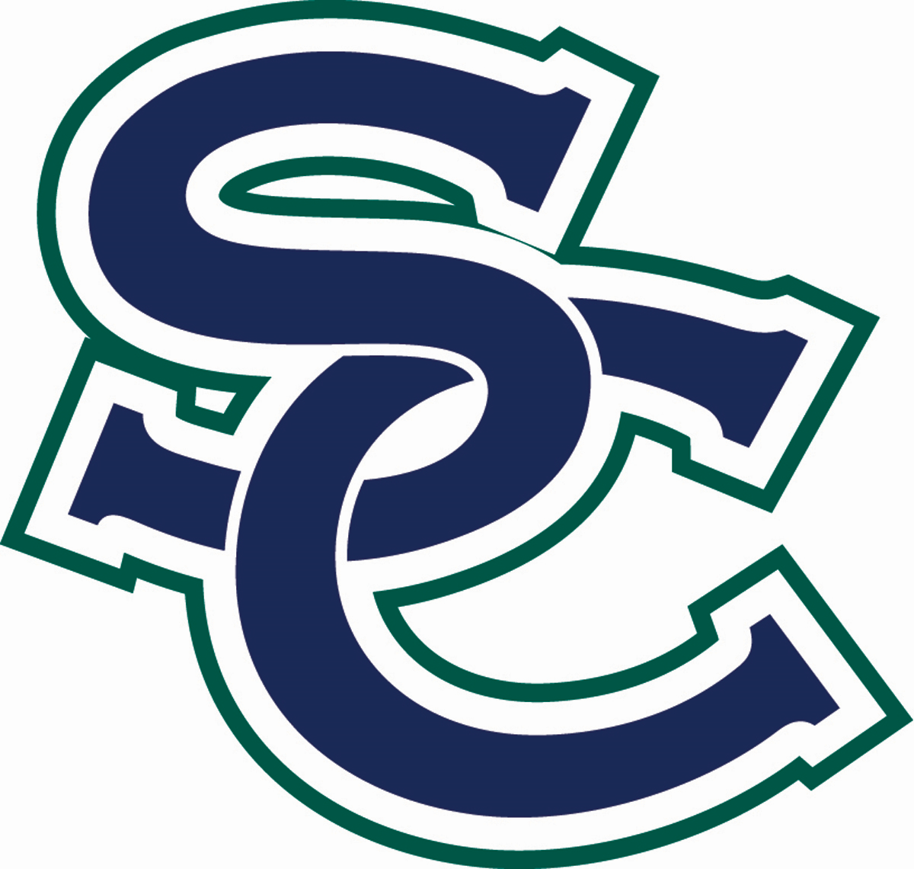
2022-2023 South County High School Common Syllabus

South County holds itself in high regard, and each teacher, content area, and separate course will abide by the following standards for all students.

ORCHESTRA - Concert Orchestra (923815), Symphonic Orchestra (923915), Philharmonic Orchestra (923917), Chamber Orchestra (923916)
Marci Swift, Director 703-446-1985 mlswift@fcps.edu
Office Hours: M-F 7:30-8:00AM; M/W 3:00-4:00PM

Digital Learning Consent
At South County High School, our teachers will use a variety of digital resources to support student learning and promote communication and collaboration with students and families. Some of the digital resources your child may use this year will require your consent before they can be used. You can find more information about approved digital resources in FCPS here: https://www.fcps.edu/resources/technology/digital-resources.

Parents, please access Parental consent web form for digital resources to provide your consent for the digital resources that will be used this year.

Course Description

One Year Course 1 Credit (Fees required)
Objective Performance in Orchestra
Prerequisite Audition with Director of Orchestra (Advanced Level Only)

Course Objectives

Students will learn how to produce characteristic tone quality on their instrument, develop skills in note and rhythm reading and demonstrate the ability to perform with proper intonation, articulation, balance, blend and musicianship through participation in orchestra. Please note, rehearsals and performances outside of normal school hours will be required as part of this course.

Materials/Texts Required

Required Materials Instrument and bow in good working condition, rosin, tuning app, metronome,
shoulder rest (violin, viola), end-pin stop (cello, bass)
Suggested Materials Music stand, practice mute, extra set of strings
Software Used Schoology, Zoom, Sight Reading Factory

Grading Scale

A (93-100) = 4.0
A- (90-92) = 3.7
B+ (87-89) = 3.3
B (83-86) = 3.0
B- (80-82) = 2.7
C+ (77-79) = 2.3

C (73-76) = 2.0
C- (70-72) = 1.7
D+ (67-69) = 1.3
D (64-66) = 1.0
F (0-63) = 0.0

Gradebook Information
All teachers will be using a rolling (cumulative) gradebook, which allows for progress towards a final mark that captures the total picture of student grades, regardless of length of quarter or number of assignments in each quarter. A rolling gradebook allows for flexibility and equitable grading practices given the uncertainty of schedules & likelihood of distance learning for some or all students during the 2022-23SY.
- Cumulative - Grades from each quarter carry over and build upon the previous quarter
- Quarter grades are a snapshot of a student’s current progress in the course and demonstrate performance to that date, not just the quarter.
- Final grades are determined by a combination of all assignments and assessments throughout the year, regardless of the quarter the work was completed.
Grade Breakdown for Orchestra:
- 10% - Rehearsal/Class Etiquette – All students are expected to participate properly during all classes. Students must have their instrument and other materials available as instructed.
- 40% - Individual Performance Assessments (IPAs) - All assessments will be assigned via Schoology. IPAs will be completed in SmartMusic, Flipgrid and Schoology. IPAs will be video and/or audio. Students may use their school issued laptop or personal recording device to submit.
- 30% - Ensemble Performance Assessments (EPAs) – As per FCPS Regulation 3866, all rehearsals and concerts are considered part of the course requirements for orchestra. All students are required to participate in all Orchestra Concerts throughout the school year.
- 20% - Classwork and Written Assignments - All students will be required to complete written classwork during class time. These assignments include, but are not limited to music theory, dictation and musical listening, and critical music analysis. Any work not completed during class time may be completed by the next class period for full credit.
A 55 is the minimum grade with an assignment that has been turned in with reasonable effort as determined by the CT.

Teachers are expected to grade assignments and post grades within seven school days after the due date with the understanding that major projects/papers may require additional time to ensure quality feedback.

FCPS requires teachers to record a minimum of 9 grades over the course of a quarter. Teachers must also make sure that they
have entered at least 2 large and small assessments per category per quarter.

Comment Codes for SIS

NTI (Not Turned In) - Student has not yet turned in the assignment. This comment carries a score of 50. The comment is removed when the assignment is turned in. If a student never turns in the assignment, the grade earned will
be a 50%.
LA (Late) - The student handed in the assignment late. There is a 10% penalty for late work. All late work must be
turned in within two weeks of the due date. There will be no late work accepted the last week of the quarter.
AB (Absent) - The student was not present in class, and the missing work must be completed. This comment code carries no penalty and can be changed to a grade or NTI if the assignment does not get turned in.
EXC (Excused) - The student has been excused from doing this assignment. There is no penalty associated
with this code.
NYG (Not Yet Graded) - The student has turned in the assignment, but the assignment has not yet been graded. This comment code is removed when scored.

Enrichment Activity
At South County High School, students will no longer be afforded the opportunity to earn extra credit for tasks that are not related to the curriculum. We will allow students to participate in Enrichment Activities. Enrichment activities are for a student who has completed an activity during the course of study that is beyond the required work in the classroom in order to further his or her understanding of a concept. It is counted as a separate grade and ties to a skill in that content area. Students will not be given extra points or grades for activities such as bringing in classroom materials, providing parent signatures, participating in fundraising/charitable events or participating in non-curricular activities. Enrichment Activities should always benefit a student. If a student does poorly on the optional Enrichment Activity, no grade should be entered.

Late Work Policy

Teachers expect students to complete and turn in assignments even when late. Students have two weeks from the due date to turn in late work.
- If a student does not turn in an assignment, the placeholder NTI (Not Turned In) should be entered into the grade book.
- There is a 10% penalty associated with late assignments.
- If a student has been given multiple opportunities to complete work and has not done so, a 50% will be entered into the gradebook. For major assessments, parent contact must also be made.

Make Up Work Policy
Students have one school day for each excused absence to make up missed work for full credit.

Retakes of Summative/Major Assessments
A student has up to 10 school days to retake a summative assessment.
- For summative/major assessments, one new opportunity to demonstrate proficiency shall be provided to any student who scores below an 80% on the summative assessment and who completes corrective action determined by the collaborative team. For students that score below an 80%, complete the corrective action, and retest, can earn up to an 80% on the retake.

Final Exam

- A student who has earned an A at the end of the year for a course can be exempt from taking the final exam and/or final assessment. Students enrolled in courses that have a culminating project/activity (i.e. a portfolio project) that lasts over the course of multiple units or quarters will still be required to complete the final assessment.

South County High School Honor Code
The South County Honor Code is based on and reflects the fundamental beliefs that:
- Every student has the right to learn in an academic environment free from any form of intellectual dishonesty;
- Honesty and integrity of all members of the school community are crucial in sustaining academic excellence.
The functions of the South County Honor Code are to:
- Communicate the meaning and importance of intellectual honesty to all members of the school community
- Explain and support the highest standards of conduct in academic and co-curricular affairs; and
- Educate, identify, and sanction those who do not follow these standards.
The Honor Council is the faculty panel charged with supporting the Honor Code should a student appeal the decision made by the administrator.
South County High School Honor Code Guidelines

Technology/Cell Phone Expectations
No cell phone use, headphones, or use of smart watches during class time, Advisory, and Stallion Time. No exceptions.

Cell phones, smart watches, and headphones may be used on campus before the first bell, after the last bell, during passing periods, and during lunch. Students are expected to have their cell phones silenced and stored at the beginning of class and not accessed
during all instructional periods. Students are also not permitted to wear headphones during instructional time. Students are also
not permitted to text, make phone calls, or use their smart watches during instructional time. Cell phones and headphones may be stored in a locker, backpack, pencil bag, etc. during classes.

FCPS & SCHS Cell Phone Policy

Syllabus Acknowledgement Form
CLICK AND COMPLETE BY 9/9/2022

